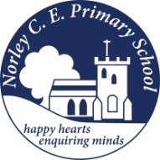
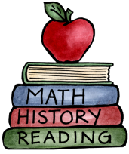
Class: 3 – Railways |  | Date to hand in: Tuesday 31st March
Choose tasks to complete for your homework this half term.
To be completed at least 3 times a week:  - 10 minutes spelling.  - 10 minutes times tables practice.  - 10 minutes (or more) reading.  - 10 minutes discussing what you’ve read. | Build a model steam train. |  | Create a timetable for a train. Provide a map to show where the train stops.
Write a comparison between modern trains and steam trains. Draw pictures to help you illustrate the difference. | Create a board game based upon the first railways, trains or about the industrial revolution. |  | Draw a grid referenced map showing a train station, a factory, a mine and a house.
Use the word RAILWAY to write an acrostic poem. | Design a postcard with a railway themed picture on. Don’t forget to write on the back as though you have travelled by steam train to a holiday destination (e.g. Blackpool). |  | Plan a journey. Record where you will set off from, which stops you will make and what your destination will be. Calculate how much your ticket will cost you.

