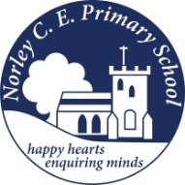
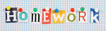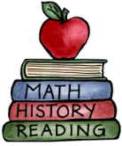
Class: Four |  | Hand in date: Friday 13th February 2026
Choose at least ONE task from each of the coloured columns to complete for your homework this half term.
Greek Persuasive Poster  Create a persuasive poster for your very own Greek restaurant.  Think about the features of persuasive writing and add as many of the features as you can remember. | Labyrinth  Design your own Labyrinth. It could be made of straws, string, wood or whatever you like. |  | Greek Alphabet  Find out about the Greek alphabet and present your findings in an exciting way.
Ancient Greek A-Z  Think about presenting your work in the best way possible. What could you do on the border? You could add an illustration to each or some of the letters along with small pictures linked to your sentences. | Greek Food  Make some Greek food, maybe a whole menu, take pictures of the food, maybe even as you prepare it. Look at the menu. How it is different to traditional English food? Design your own Greek menu. |  | Pythagoras  Who was Pythagoras? How is he linked to maths? What is Pythagoras’ theory? Present your findings – use diagrams to explain what you have learnt.
Spartan Family  Write a diary extract from the viewpoint of a family member in Sparta or in Ancient Greece. Try to write about your feelings about daily life. | Shield or Helmet?  Make a Spartan helmet or design and make a shield. |  | Greek Travel  Make a travel brochure for Greece, focusing on its ancient history. Include monuments and buildings with a special interest for tourists.

