
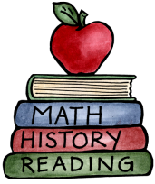
Class: 3 – Industrial Revolution |  | Date to hand in: Friday 13th February
Choose tasks to complete for your homework this half term.
To be completed at last 3 times a week:  - 10 minutes spelling.  - 10 minutes times tables practice.  - 10 minutes (or more) reading.  - 10 minutes discussing what you’ve read. | Make a collage of the changes that happened between the 18th century and the 21st century. |  | Create a timetable or schedule to show the average day of a factory worker- including what food they would have and how much.
Write a diary entry for how you would feel if you worked in a factory/mine during the Industrial Revolution. | Create a video documentary explaining about life during the Industrial Revolution. |  | Create a puzzle or a quiz about the working conditions in factories.
Write a guide for tourists to inform them about an industrial town and persuade them to travel there. | Design or create your own factory and invention.  Don’t forget to write a paragraph to explain what it produces and why. |  | Design a flag for a new industrialised town. Write a paragraph to explain your design choices.

