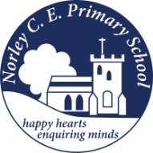

Class: Two |  | Date to hand in: Friday 13th February 2026
Choose at least one task from each of the coloured columns.
Create a fact file about an animal that lives in the Polar Regions. | Create a collage of your favourite polar animal. |  | Have a look on Google Earth.  Find the North and South Pole. What can you see, what does it look like?
Create your own polar animal and write a character description to tell everyone about it. | Make up your own sea shanty to perform to the class if you wish. |  | Carry out your own ice experiment at home. Place three ice cubes (or more) in different places around your home and predict which ice cube will melt the fastest. Record your investigation and take photos if you can!
Design a poster on the different things you would see in the Polar Regions. | Find out about the life of an Inuit. Where do they live? What do they do? How do they survive? |  | Find out three facts about Earnest Shackleton.

