
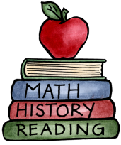
Class: 3 – Going Places-World War II |  | Date to hand in: Thursday 18th December
Choose tasks to complete for your homework this half term.
To be completed at last 3 times a week:  - 10 minutes spelling.  - 10 minutes times tables practice.  - 10 minutes (or more) reading.  - 10 minutes discussing what you’ve read. | Create a collage of the London sky, during the blitz. |  | Create a graph comparing the size of armies from different nations.  Don’t forget to label them on a map.
Research what school life was like for children who were living during World War II and write a diary entry to show what you have learnt. | Design or make an air raid shelter that would keep people safe. |  | Create top trump cards for the main leaders of each of the major nations involved in World War II. Use biographical information to decide on key attributes.
Write a newspaper article about 1 day during the Battle of Britain. | Design or create your own model tank, plane or gas mask. |  | Find out about food rations in World War II and create a menu using those ingredients. Don’t forget to include how much it would be to make.

