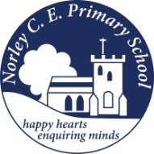
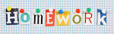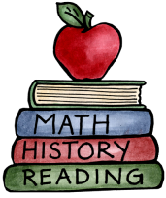
Class: 2 |  | Date to hand in: Thursday 18th December 2025
Choose at least one task from each of the coloured columns.
Make your own medieval banquet menu. What would it include? Would it be healthy? | Design your own crown. |  | Which materials could a castle be made from and why?
Write 5 laws you would have made as a medieval King or Queen. | Go on an autumn walk and collect some different natural materials to create a collage. |  | Find out 3 facts about the King.
Choose a person from ‘The little People Big Dreams’ collection and write about their life. | Imagine you are a jester, make up or find a joke to share with the class. |  | Research the castles owned by the royal family. What are they called. Where are they located?

