
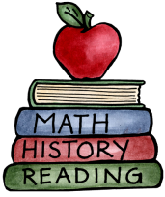
Class: Four |  | Hand in date:
Choose at least ONE task from each of the coloured columns to complete for your homework this half term.
Story writing  Write a story about the day that an asteroid landed in the middle of your town or village. How imaginative can you be?  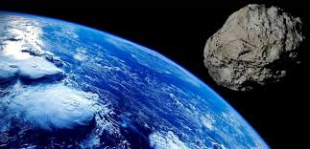 | Spacesuit  Create a new spacesuit for the astronauts at NASA. Make sure you label all the different parts with the materials that you would use. Be as creative as possible! |  | Mummy!  Mummify a banana or an apple! Take some pictures.  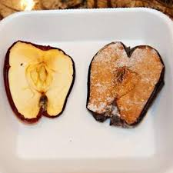
Space Game  Make a simple game about Space e.g. snap, uno, snakes and ladders, top trumps etc.  Make sure your game has some educational value. | Space food  Design a set menu for a meal in space. You will need to research what astronauts eat. Have a go at making some space food. |  | Map  Create a map showing the key places in Ancient Egypt. You could create a  tea stained map.
Astronaut Diary  Write a series (2 or more) of diary entries from the perspective of an astronaut.  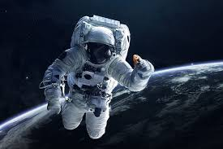 | Egyptian Collage  Create a collage of pictures or photos from Egypt to show and talk through to the class of famous sites that you would like to visit.  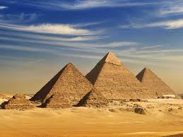 |  | Timeline  Use a computer to create an Ancient Egyptian timeline.  