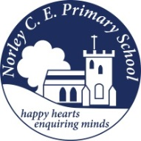

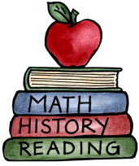
Class: One |  |  | Due in Friday 24th Oct
Four tasks to complete for your homework this half term.
Class 1 Bear  Each term everyone will have the chance to take the Class Bear home. Please fill in his diary using writing, pictures or photographs.  We will then share your adventure with the whole class the following week. | Maths  We have been singing lots of rhymes with 5 in, ask your child to share a rhyme… cakes, frogs and dinosaurs to name a few!  Please can you find as many ways as you can to make 5?  Can you show this creatively? | Reading and Phonics  Please share/read your reading book every night and the following morning it can be changed. Letters and sounds will be given out to practise and learn at home.  You also have some tricky words you can practise at home. Here are this half terms:  I, no, go, to, the, into |  | Topic  This term our topic is ‘Once upon a time in Class 1.’  We have been sharing some traditional fairy stories. Can you describe your favourite traditional story in a creative way?

