

SAFEGUARDING
A GUIDE FOR PARENTS
Working together to keep our children safe

The safety and wellbeing of our children is paramount and we will do all that we can to ensure that their time at Ravensbury is as happy and healthy as possible.
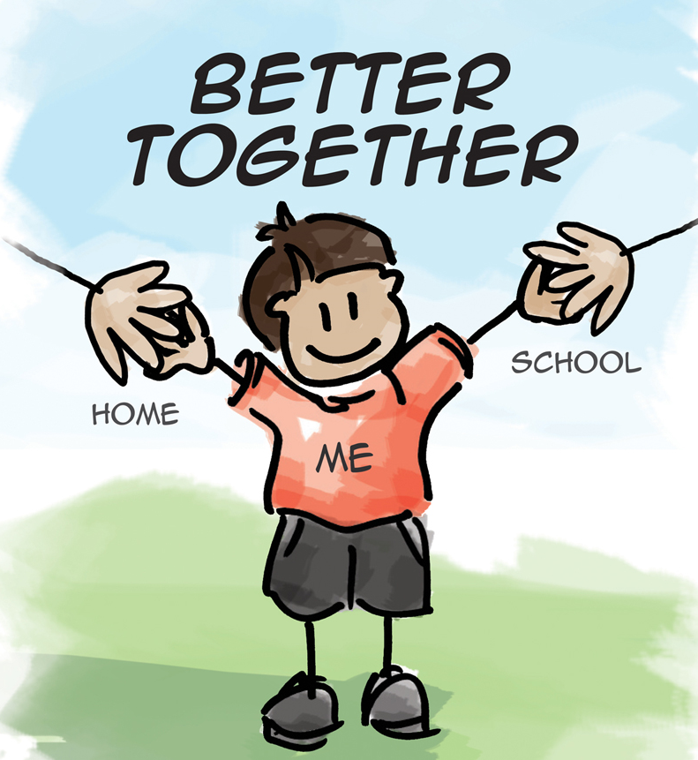

Headteacher: Mrs M Hughes
Ravensbury Community School
Tartan Street
Clayton
Manchester
M11 4EG
T: 0161 223 0370
E: admin@ravensbury.manchester.sch.uk
W: www.ravensbury.manchester.sch.uk

Safeguarding in Education

What does safeguarding mean?
Every child has the right to be safe from harm and danger. It is everyone’s responsibility to ensure every child is free from fear and able to learn and develop in safe, secure environments. Safeguarding covers all aspects of keeping children safe within their school environment. Safeguarding concerns also include attendance, behaviour, bullying, health and safety and E-safety.

Why am I being given this information?
All parents and carers who join our school will be given this leaflet. This leaflet explains what to do if you are worried about any child or young person.

How you can work in partnership with us
Children will get the most out of their education when we all work together on every issue. This means that both school and home have to have good communication links. Please let us know about anything that might affect your child. We will do all we can to help. Let us know if your child has a medical condition or has had an accident. Also, please let us know if your child will not be coming into school by ringing us on the first day they are absent. If you move house or out of the area and don’t need your place at our school please let us know this, too. If your contact details change please inform the school.

What can you expect from us?
- We aim to provide a safe environment in which your child can learn. We make every effort to comply with safeguarding legislation and guidance.
- We will take good care of your child while they are with us. We will talk to you about anything we see that we are worried about.
- We will keep accurate up to date records.
- If your child transfers to another school we will share important information with them that will help to support your child’s move.
- We will contact you if your child is absent and you haven’t let us know why.
- We will respond promptly to any problem you tell us about.
- Our staff will offer support and assistance whenever you need it.

Are you concerned about a child?
It is important to take action straight away if you think a child you know is being harmed. You Could: Talk to a designated person at school, phone the local children’s services department or the police. Please remember that these cases are quite rare and that you may never have a child disclose something like this to you, but it is important you know what to do should this type of disclosure happens.

Types of abuse:
- Neglect
- Domestic violence/abuse

As a parent you have a duty of care to protect your child from every form of abuse including exploitation and sexual abuse. Please talk to your child about these forms of abuse when you feel they are mature enough to understand these types of harm. You know your child better than anyone. And you'll know when they're ready and how much detail to go into.
- Emotional abuse
- Physical abuse
- Sexual abuse
- Online abuse
- Grooming
- Child Exploitation
- Female Genital Mutilation

Why do we keep concerns on file?
The Designated Safeguarding Leads (DSL) at school are trained under Manchester City Council to make judgements using a strict threshold criteria and if the concerns do not meet the threshold this could be the reason for keeping the concern on file. Concerns can often be something small and do not warrant intervention from Children’s Services, however, over a period of time, a collection of small concerns can build a worrying picture. It is when we receive a number of ‘small concerns’ that we may contact Children’s Services for advice and to share information based on them. Therefore, even the smallest concern can help the DSL to gain the information to build a picture that may warrant investigating by Child Protection Services

E-Safety

The internet is amazing and has changed all of our lives. Children can play, learn, create and connect - opening up a whole world of exciting possibilities but to children, online life is real life. Parents/carers and teachers need to be active in protecting children from unwanted influence and content online such as bullying, contact from strangers or the possibility of them seeing inappropriate content.
You might wonder if what they are doing is safe. Talking to your child – openly and regularly – is the best way to help keep them safe online. Parent information guides on a range of Apps and online sites accessed by children are available from school.

Here are some top tips to help...
- Talk to your child about what they’re up to online.
- Ask them about how they stay safe online. What is OK and not OK to share?
- Ask them if they know where to go for help, where to find the safety advice, privacy settings and how to report or block on the services they use.
- Watch Thinkuknow films and cartoons with your child.
- Keep up-to-date with your child’s online activity.
- Set boundaries in the online world, just as you would in the real world.
- Keep all equipment that connects to the internet in a family space.
- Use parental controls on devices that link to the internet, such as the TV, laptops, computers, games consoles and mobile phones.
- Set limits on the time spent on all these devices.

Manchester’s Early Help Strategy

We know that parenting can be one of the most difficult jobs and at times we may need some help or support.
We know that if we get that help or support early enough it can stop problems from getting worse and reduce the need for involvement from Children’ Services.
Manchester has established the Early Help Hub to provide advice and support for a range of areas such as:
- parenting,
- health & wellbeing,
- finance,
- housing,
- young carers etc.
You can find information by searching the internet for Manchester Early Help for Parents or by making an appointment with Parent Support Advisor Ann Roberts. She can do an Early Help Assessment with you and then refer to the Early Help Hub for any advice or support you may require to get back or track.

Operation Encompass

What is Operation Encompass?
Operation Encompass, is designed to provide early reporting to schools on domestic abuse incidents which have occurred outside of school, which might have an impact on a child attending school the following day. Our school is part of this initiative. It is run in partnership with Manchester Safeguarding Board and Greater
Manchester Police. The police will share information with the school. We will be informed simply that there was an incident and the name of the child. By sharing this information the parents affected by domestic abuse will know that they can approach the school.

Safeguarding Team
Ann Roberts (PSA)
Maureen Hughes (Headteacher)
Louise Thewlis (Deputy Headteacher)
Jo Wendt (SENCO)

Useful Telephone Numbers and Information
School: 0161 223 0370
Police: 101 or 999
Manchester’s Children’s Services: 0161 234 5001
Email: mcsreply@manchester.gov.uk
Multi-Agency Safeguarding Hub (MASH) Helpline: 0161 219 2895
Early Help Hub: North 0161 234 1973
NSPCC helpline (24hr): 0800 8005000 or visit their website www.nspcc.org.uk
Mind: 0300 123 3393 or visit their website www.mind.org.uk
Samaritans: 08457 90 90 90 or visit their website www.samaritans.org
ChildLine: 0800 11 11 or visit their website www.childline.org.uk
ThinkuKnow: visit their website www.thinkuknow.co.uk

If you’re worried about the age limit on the sites your child is using please look at this website www.net-aware.org.uk

We will always do what we believe to be in the best interest of the child to ensure their health and safety.

Further information can be found in our Safeguarding Policy which is available on the school website.

