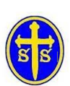  WHOLE SCHOOL ENVIRONMENT PROJECT! |  | Complete any or all of these fun challenges with your families!  Please send your photos to science@oxtonstsaviours.wirral.sch.uk
S  Question, experiment, test and observe | Yummy Yoghurt Makers!  In developing countries like Bangladesh, education is especially important. However, with no national provision, families have to pay to send their children to school. Making and selling yoghurt is one way that families can generate an income for school fees. Investigate how to make the tastiest yoghurt from milk. Did the different types of milk make different types of yoghurt? Which flavours work best? | 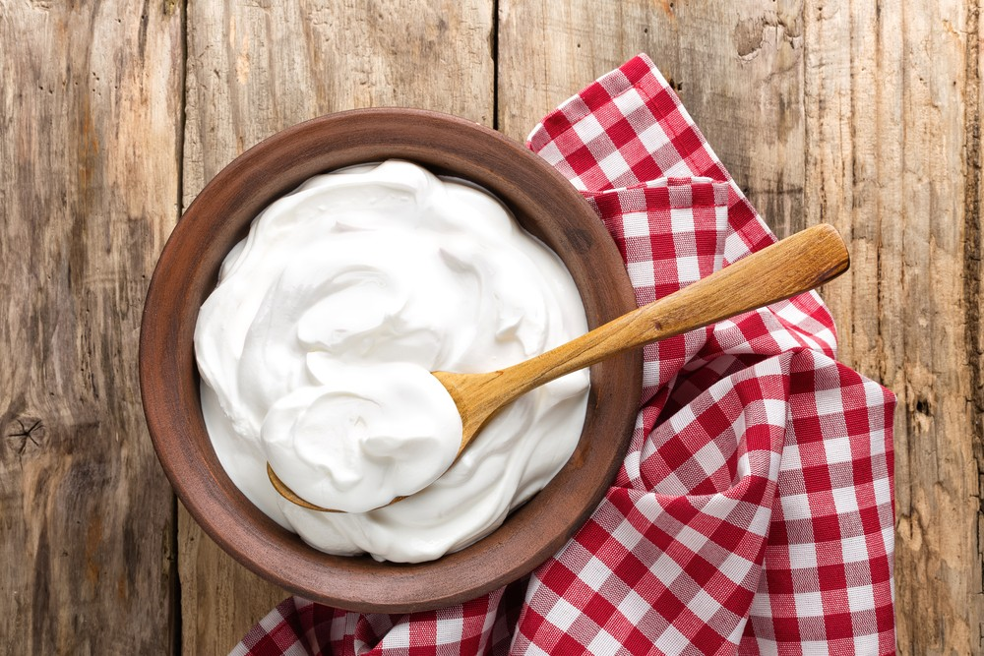
 | Full instructions: https://practicalaction.org/schools/yummy-yoghurt-makers/
T | What flora is around us?  Identifying a plant is of interest to all plant lovers, whether we are talking about houseplants, outdoor plants, or the ones you find on your walk. By knowing what we are looking at, we’ll be able to identify the needs of particular plants and successfully care for them. However, there are so many species to identify so, with permission of your adults, why don’t you download one of these free apps to learn more about plants?  PlantNet iNaturalist PlantSnap | 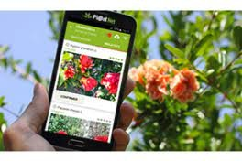
Process and
connect
information
E  Invent, evaluate and improve | Oil spill challenge!  Clean up an “oil” from a simulated oil spill disaster that includes feathers to represent marine life, to increase your understanding of an oil spill disaster and the environmental consequences.  Oil spill: container, vegetable oil (amount depends on the container, use a 1:4 oil to water ratio), cocoa powder: to mix with oil and make it look like crude oil, bird feathers. Methods to clean up: cotton balls, sponge, plastic spoons, washing up liquid, plastic cups to put soap and cotton balls in. | 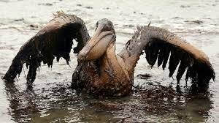
A  Explore and express | Can plastic waste become an element of art?  The problems related to the use (and abuse) of plastic are well known. While experts warn that, at this rate, by 2050 there will be more plastic than fish in the sea, some people have found a way to reuse the offending material in a very creative way. Indeed, better: making something beautiful out of it.  Create a sculpture completely out of recycled plastic! It could be a plant, an animal, a cartoon character or even something abstract. | 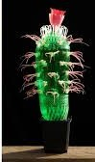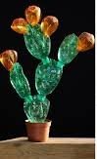
M  Use tools and structures | Weather predictions!  Try to find three different weather forecasts for your area. Listen to weather reports on the radio, watch them on the television and read them in newspapers. Collect information for a week about the predicted temperatures and the predicted rainfall.  Keep a record of what the weather is actually like on the day and note whether it was different or similar to the predicted weather.  If a weather prediction was very different from the weather that you experienced in reality, explain why this could have happened. | 