
Science Policy
June 2021

Contents
- Curriculum Statement
- Teaching and Learning
- Assessment
- Planning and Resources
- Organisation
- EYFS
- KS1 and KS2
- Equal Opportunities
- Inclusion
- Health and Safety
- Role of the Subject Leader
- Parents

1. Curriculum Statement

Intent
The 2014 national curriculum for science aims to ensure that all pupils:
- develop scientific knowledge and conceptual understanding through the specific disciplines of biology, chemistry and physics.
- develop understanding of the nature, processes and methods of science through different types of science enquiries that help them to answer scientific questions about the world around them.
- are equipped with the scientific skills required to understand the uses and implications of science, today and for the future. We understand that it is important for lessons to have a skills-based focus, and that the knowledge can be taught through this.

At Oxton St. Saviour’s Primary, we encourage children to be inquisitive throughout their time at the school and beyond. The Science curriculum stimulates and excites children’s curiosity about the world they live in and promotes respect for the living and non-living things. We believe science encompasses the acquisition of knowledge, concepts, skills and positive attitudes. Throughout the programmes of study, the children will acquire and develop the key knowledge that has been identified within each unit and across each year group. The key knowledge identified by each year group is informed by the national curriculum and builds towards identified phase ‘end points’ in accordance with NC expectations.
Key skills are also mapped for each year group and are progressive throughout the school. These too ensure systematic progression to identified skills end points which are in accordance with the Working Scientifically skills expectations of the national curriculum. The curriculum is designed to ensure that children are able to acquire key scientific knowledge through practical experiences; using equipment, conducting experiments, building arguments and explaining concepts confidently. The school’s approach to science takes account of the school’s own context, ensuring access to people with specialist expertise and places of scientific interest as part of the school’s commitment to learning outside the classroom. Children are encouraged to ask questions and be curious about their surroundings and a love of science is nurtured through a whole school ethos and a varied science curriculum which takes our pupils beyond the National Curriculum to promote their science capital in as many diverse ways as possible.

Implementation
Teachers create a positive attitude to science learning within their classrooms and reinforce an expectation that all pupils are capable of achieving high standards in science. Our whole school approach to the teaching and learning of science involves the following;

- Science is taught weekly in units by the class teacher, following the school’s long term plan.
- Existing knowledge is checked at the beginning of each topic, as part of the KWL strategy (What I know, What I would like to Know and What I have Learned); KS2 use a carousel of activities to elicit this information. This ensures that teaching is informed by the children’s starting points and that it takes account of pupil voice, incorporating children’s interests.
- Through our planning, we involve problem solving opportunities that allow children to apply their knowledge, and find out answers for themselves. Children are encouraged to ask their own questions and be given opportunities to use their scientific skills and research to discover the answers. This curiosity is celebrated within the classroom. Planning involves teachers creating engaging lessons, involving high-quality resources to aid understanding of conceptual knowledge. Teachers use precise questioning in class to test conceptual knowledge and skills, and assess pupils regularly to identify those children with gaps in learning, so that all pupils progress. Tasks are selected and designed to provide appropriate challenge to all learners, in line with the school’s commitment to inclusion.
- We build upon the knowledge and skill development of the previous years. As the children’s knowledge and understanding increases, they become more proficient in selecting, using scientific equipment, collating and interpreting results, they become increasingly confident in their growing ability to come to conclusions based on real evidence.
- Working Scientifically skills are embedded into lessons to ensure that skills are systematically developed throughout the children’s school career and new vocabulary and challenging concepts are introduced through direct teaching.
- Teachers demonstrate how to use scientific equipment, and the various Working Scientifically skills in order to embed scientific understanding. Teachers find opportunities to develop children’s understanding of their surroundings by accessing outdoor learning and workshops with experts.
- Children are offered a range of extra-curricular activities, visits, trips and visitors to complement and broaden the curriculum. These are purposeful and link with the knowledge being taught in class.
- Regular events, such as STEM fortnight and project days or themes eg. Wild June allow all pupils to come off-timetable, to provide broader provision and the acquisition and application of knowledge and skills. These events often involve families and the wider community.
- Throughout each topic, key knowledge is reviewed by the children, checked by the teacher and consolidated as necessary.

Impact
The approach at Oxton St. Saviour’s results in a fun, engaging, high-quality science education, that provides children with the foundations and knowledge for understanding the world.
The impact of our curriculum is measured through:
- Continuous assessment of learning through focussed questioning, the level of support required and pupil’s engagement throughout lessons.
- Adaptation of lessons based on continuous assessment, evidence for which can be seen in the children’s books and teacher’s planning.
- Each science lesson beginning with a recap of substantive and disciplinary knowledge from previous lessons.
- Carrying out ‘pupil voice’ to demonstrate progression of learning, understanding and vocabulary.
- Displays showing the engaging activities, skills and learning.
- Monitoring of children’s work by the subject leader and staff.
- Providing ongoing CPD based on the outcomes of monitoring.

2. Teaching and Learning

The science curriculum is mapped to ensure alignment with the national curriculum content and programme of study. Key knowledge relates directly and builds towards the achievement of end of phase (KS1, lower KS1 and upper KS2)
‘end points’, informed by the National Curriculum statements. Key skills are also mapped so that these are developed systematically and align directly to the specified working scientifically statements as outlined in the NC for each phase.

In each lesson, the LI is shared at the beginning and children are then guided through a range of learning opportunities. The LI is reviewed by children at the end of the lesson. The LI is subsequently used by the teacher during the assessment and review work of children’s work and is used to identify individual target areas. A working wall will be used to support and celebrate learning throughout each unit of work. This will also be used to support the acquisition of key knowledge and will support the accurate use of an extended specialist vocabulary.

At Oxton St. Saviour’s Primary School, science is good when:

- We apply our ‘working scientifically skills’ to solve problems, explore, observe and investigate.
- We ask questions and work together to discover the answers.
- Science has a wow factor and promotes a sense of awe and wonder.
- Our learning is enhanced by outdoor learning, specialist visitors and access to quality resources.
- We are involved in creating and carrying out investigations and can share and explain our ideas and conclusions.

Science Principles Poster
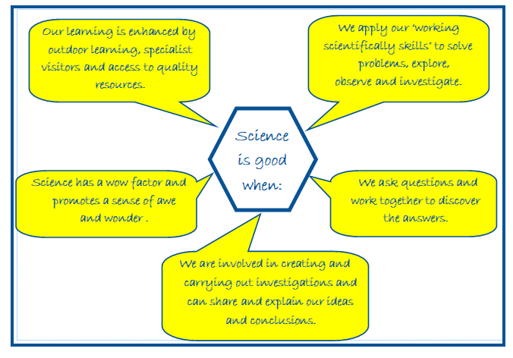
These posters are on display on the working wall in science and referred to throughout the coverage of each science topic.

To ensure excellence across the school in the teaching and learning of science:

- Children are encouraged to ask their own questions and be given opportunities to use their scientific skills and research to discover the answers. This curiosity is celebrated within the classroom.
- Teachers ask a range of questions which enable all children to take part, listening carefully to answers and taking learning forward, using open and closed questions and allowing children time to think.
- Planning involves teachers creating engaging lessons, involving high-quality resources to aid understanding of conceptual knowledge.
- Teachers use precise questioning in class to test conceptual knowledge and skills, and assess pupils throughout lessons to identify those children with gaps in learning, so that all pupils make progress.
- New vocabulary and challenging concepts are introduced through direct teaching. This is developed through the years, in-keeping with the topics.
- Working scientifically skills are embedded into lessons and these focus on the key features of scientific enquiry, so that pupils learn to use a variety of approaches to answer relevant scientific questions. These types of scientific enquiry include: observing over time; pattern seeking; identifying, classifying and grouping; comparative and fair testing (controlled investigations); and researching using secondary sources. Pupils are given opportunity to seek answers to questions through collecting, analysing and presenting data.
- The key knowledge for each topic and across each year group is mapped across the school and checked at the end of each science topic.
- Teachers demonstrate how to use scientific equipment, and the various Working Scientifically skills in order to embed scientific understanding.
- Teachers find opportunities to develop children’s understanding through learning outside the classroom.
- Science lessons provide a quality and variety of subject specific language to enable the development of children’s confident and accurate use of scientific vocabulary and their ability to articulate scientific concepts clearly and precisely. Children are encouraged and assisted in making their thinking clear, both to themselves and others, and teachers ensure that pupils build secure foundations by using discussion to probing and remedying their misconceptions.

In Early Years, Science is taught through child-led learning in the provision and through some adult-directed activities. The children experiment and observe changes in seasons, states of matter. They learn vocabulary related to changes and discuss what they can hear, see and smell when experimenting.

3. Assessment

As part of the introduction to each new science topic, teachers review what the children know already and identify what they would like to learn. This informs the programme of study so that it takes account of children’s starting points as well as their specific interests.

Lessons are planned to ensure that key knowledge is developed over time, over the course of each science block and in the correct sequence. Key knowledge is reviewed by the children and rigorously checked and consolidated by the teacher at the end of each unit of work.
Lessons within each unit are also planned to ensure the systematic development of the key identified skills across the school.
By the end of each key stage, pupils are expected to know, apply and understand the matters, skills and processes specified in the relevant programme of study as set out in the National Curriculum. These are set out as statutory requirements. We also draw on the non-statutory requirements to extend our children and provide an appropriate level of challenge.

Children receive effective feedback through teacher assessment, both orally and through written feedback in line with the LI. Children are guided towards achievement of the main objective through the use of carefully planned activities and questioning. Areas of difficulty are identified by the children and teachers when reviewing and assessing work.

Ongoing assessment also includes:
- Observing children at work, individually, in pairs, in a group, and in classes.
- Exit tickets / hinge questions to identify learning needs
- Questioning, talking and listening to children
- Considering work/materials / investigations produced by children together with discussion about this with them.

In Early Years, we assess the children’s Understanding of the World according to the Development Matters statements. We assess their knowledge of the Natural World by observing the scientific vocabulary the children use when experimenting and how they are able to talk about changes.

4. Planning and Resources

Teachers use the plans developed in school plus a range of resources to inform lesson content, specialist vocabulary and key knowledge and to ensure an appropriate emphasis on skills through practical experiences and approaches.

Key knowledge and skills, in line with the National Curriculum are mapped on the whole school ‘Science Knowledge and Skills Progression Map’ and this shows the key knowledge and skills of each unit and how they build through the school. The school’s own context is also considered and opportunities for learning outside the classroom, including the use exploration of the pond and wildlife area.

High-quality science resources to support the teaching of all units and topics from EYFS to Y6, are used consistently and maintained by the subject leader. These are kept in a central store and are labelled and easily accessible to all staff. As well as these, the EYFS classes have a range of resources for easy access to children during exploration. The class bookshelves and school library contain a rich and varied supply of science topic books to support children’s individual research.

5. Organisation

Within the academic year, children study science in units, as outlined in the overall curriculum framework overview. This allows children to enhance their scientific knowledge and develop working scientifically skills through focused daily learning, throughout the duration of each block. This model also promotes the achievement of a greater depth of understanding by the end of a unit.

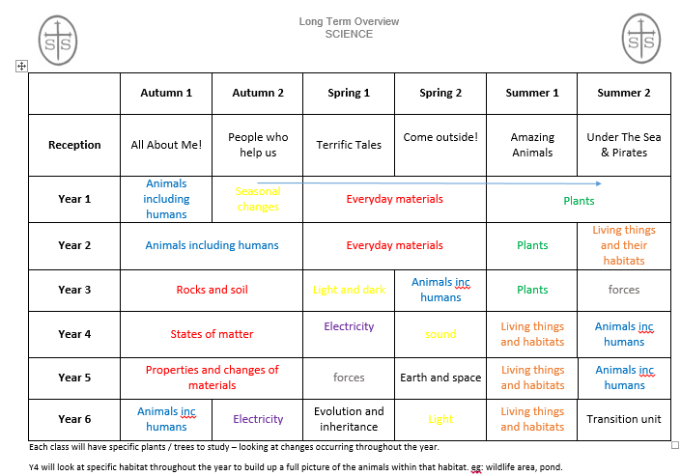

6. EYFS

The teaching of science in EYFS is in accordance with the EYFS national framework. Children are guided to make sense of the Natural World and Community through opportunities to explore, observe and find out about people, places, technology and the environment. Weekly ‘Flavour School’ provides children with food experiences where they learn about the senses, tastes, flavours whilst developing more confidence and curiosity to try new foods.
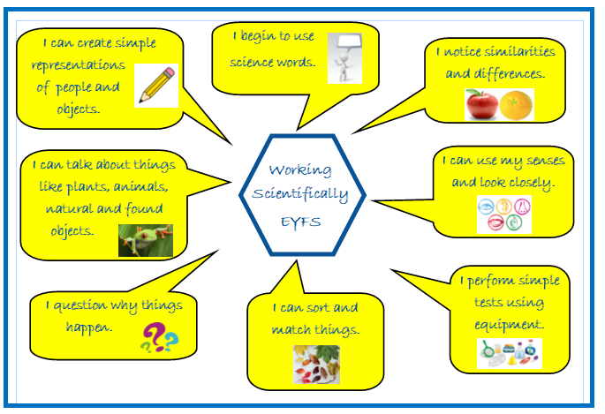

7. KS1 and KS2

Key stage one:

The principal focus of science teaching in key stage 1 is to enable pupils to experience and observe phenomena, looking more closely at the natural and humanly-constructed world around them. At Oxton St. Saviour’s, children are encouraged to be curious and ask questions about what they notice. Their understanding of scientific ideas is supported through the use of different types of scientific enquiry so that children can answer their own questions, including observing changes over a period of time, noticing patterns, grouping and classifying things, carrying out simple comparative tests, and finding things out using secondary sources of information. Children are supported to begin to use simple scientific language to talk about what they have found out and communicate their ideas to a range of audiences in a variety of ways, including wider school forums such as science week. Most of the learning about science is done through first-hand practical experiences, and children are also to begin to use appropriate secondary sources, such as books, photographs and videos.
‘Working scientifically’ is described separately in the National Curriculum programme of study, but is always taught through and clearly related to the teaching of substantive science content in the programme of study. The knowledge and skills progression maps outline how the specific skills of each unit progressively build between years and towards the overarching ‘end point statements’. Throughout the notes and guidance, examples show how scientific methods and skills might be linked to specific elements of the content.
Opportunities are provided for the children to read and spell scientific vocabulary at a level consistent with their increasing word reading and spelling knowledge at key stage 1.
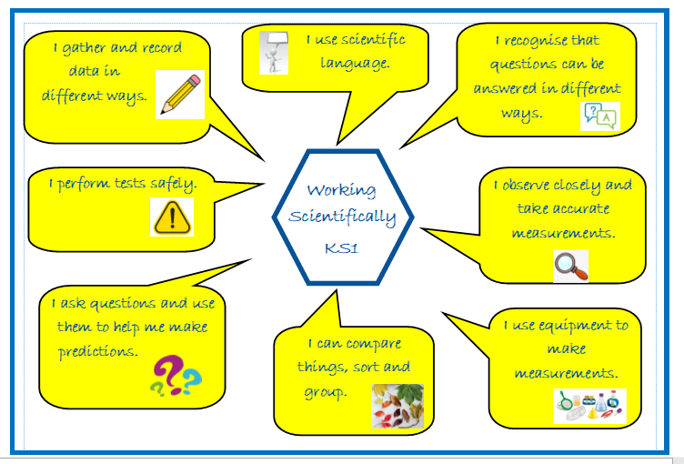

Lower Key Stage two:
The principal focus of science teaching in lower key stage 2 is to enable pupils to broaden their scientific view of the world around them. They do this through exploring, talking about, testing and developing ideas about everyday phenomena and the relationships between living things and familiar environments, and by beginning to develop their ideas about functions, relationships and interactions. Children are encouraged and supported to ask their own questions about what they observe and make some decisions about which types of scientific enquiry are likely to be the best ways of answering them, including observing changes over time, noticing patterns, grouping and classifying things, carrying out simple comparative and fair tests and finding things out using secondary sources of information. They draw simple conclusions and use some scientific language, first, to talk about and, later, to write about what they have found out.

As in KS1, ‘Working scientifically’ is described separately in the National Curriculum programme of study, but is always taught through and clearly related to the teaching of substantive science content in the programme of study. The knowledge and skills progression maps outline how the specific skills of each unit progressively build between years and towards the overarching ‘end point statements’. Throughout the notes and guidance, examples show how scientific methods and skills might be linked to specific elements of the content.
Opportunities are provided for the children to read and spell scientific vocabulary correctly and with confidence, using their growing word reading and spelling knowledge.

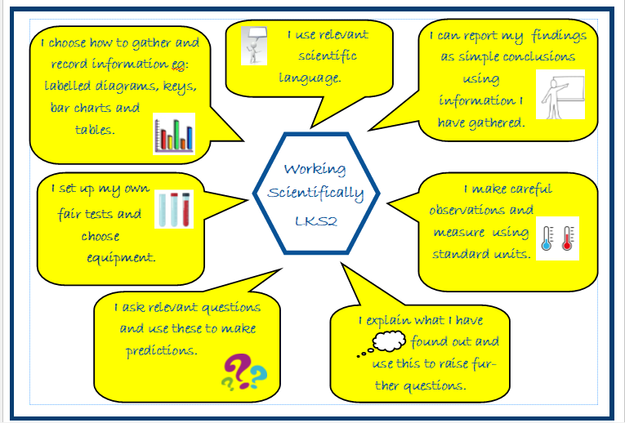

Upper Key Stage two:
The principal focus of science teaching in upper key stage 2 is to enable pupils to develop a deeper understanding of a wide range of scientific ideas. At Oxton St. Saviour’s, children do this through exploring and talking about their ideas; asking their own questions about scientific phenomena; and analysing functions, relationships and interactions more systematically. At upper key stage 2, they encounter more abstract ideas and begin to recognise how these ideas help them to understand and predict how the world operates. Children are also supported to begin to recognise that scientific ideas change and develop over time. The school curriculum provides opportunities for children to select the most appropriate ways to answer science questions using different types of scientific enquiry, including observing changes over different periods of time, noticing patterns, grouping and classifying things, carrying out comparative and fair tests and finding things out using a wide range of secondary sources of information. Children learn to draw conclusions based on their data and observations, use evidence to justify their ideas, and use their scientific knowledge and understanding to explain their findings.

‘Working and thinking scientifically’ is described separately at the beginning of the programme of study, but must always be taught through and clearly related to substantive science content in the programme of study. Throughout the notes and guidance, examples show how scientific methods and skills might be linked to specific elements of the content.
Opportunities are provided for the children to read, spell and pronounce scientific vocabulary correctly.
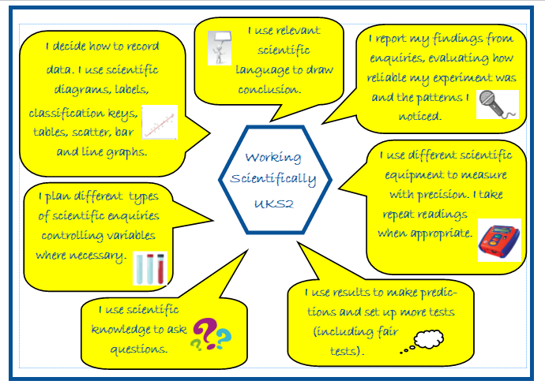

8. Equal Opportunities

At Oxton St. Saviour’s Primary school, we are committed to providing a teaching environment which ensures all children are provided with the same learning opportunities regardless of social class, gender, culture, race, special educational need or disability. Teachers use a range of strategies to ensure inclusion and also to maintain a positive ethos where children demonstrate positive attitudes towards others.

9. Inclusion
Science teaching considers the needs of different individuals and groups for learners and tasks are designed and differentiated as appropriate to ensure an appropriate level of challenge. Supporting adults are also deployed effectively to ensure focussed support where this is necessary.

Teachers use a range of inclusion strategies, including paired work, open questions and direct, differentiated questioning and the activation of prior knowledge and contextual learning. This support the inclusion and motivation of all learners ensuring that optimum progress is made throughout each part of the lesson.

10. Health and Safety
  - Staff members will act in accordance with the school’s Health and Safety Policy at all times.
  - Accidents will be reported following the procedure outlined in the school’s Accident Reporting Procedure Policy.
  - A risk assessment will be carried out by teachers before conducting an experiment or undertaking practical activities (referring to CLEAPSS where appropriate).
  - All pupils will be shown how to correctly use equipment and will be monitored by staff members whilst using equipment.
  - All pupils will be made aware of how they are expected to behave, ensuring that they show respect to other people and the environment.
  - Pupils are made aware of the personal safety protocols and equipment needed when using different equipment or carrying out different tasks.
  - Any ‘new’ experiments or activities which a teacher has not used in the classroom before will be trialled prior to being performed with pupils.
  - At the beginning of any experiment, the teacher will outline the purpose of the experiment to the class, and all hazards and safety precautions will be thoroughly outlined.

11. Role of the Subject Leader

The subject leader’s responsibilities are:
- To ensure the high profile of the subject and provide a strategic lead and direction for science in the school.
- To maintain and ensure use of the central supply of science resources, in accordance with those specific to each year group and topic
- To support colleagues in their teaching of science and support the CPD of others
- To ensure progression of the key knowledge and skills identified within each unit and that these are integral to the programme of study and secure at the end of each age phase.
- To monitor books and ensure that key knowledge is evidenced in outcomes
- To monitor planning and oversee the teaching of science
- To lead further improvement in and development of the subject as informed by effective subject overview
- To ensure that the science curriculum enables the progress and raises the attainment of all pupils, including those who are disadvantaged or have low attainment
- To ensure that the science curriculum take account of the school’s context, promotes children’s pride in the local area and provides access to positive role models from the immediate and wider local area to enhance the science curriculum.
- To ensure that approaches are informed by and in line with current identified good practice and pedagogy; to attend regular opportunities for CPD.
- To establish and maintain existing links with external agencies and individuals with specialist expertise to enrich teaching and learning in science.
- To organise an annual whole-school STEM fortnight, in accordance with the national theme, ensuring a focus on practical and investigative activities.

12. Parents

Parental input is highly valued and parents are regularly invited and welcomed into school to share their own expertise with the children. The school will actively seek to establish collaboration with parents and carers who are able to support the teaching and learning of science at Oxton St. Saviour’s.

The support that parents and carers provide in supporting their children at home with topic based homework is also recognised and valued. When these are set, Science homework tasks will be well communicated and have a clear purpose and will often provide children with the means to consolidate or extend their classroom work.

Specific opportunities for parents to take part in science activities at the school, including science week, will be communicated. Special events will also be organised to involve families in scientific activities.

Date of Policy: July 2022
Policy Review Date: July 2023

