Key vocabulary
circuit | A complete path that an electric current can flow around. It flows from the battery, through wires and devices before returning to the battery. If the circuit is not complete the electric current cannot flow.
circuit symbol | A symbol used to represent various electronic components or functions in a diagram of a circuit.
circuit diagram | A visual representation of an electrical circuit using symbols to represent the electrical components.
cell | A single electrical energy source.
battery | A device consisting of one or more cells.
switch | An electrical component that can make or break an electrical circuit. When a switch is open (off), there is a gap in the circuit and electricity cannot flow around the circuit.
voltage | Volts are a measure of the energy of a flow of electricity. Mains electricity carries a voltage of 210-240 volts. A typical cell in school has 1.5 volts.

Switch turned off (open).
This breaks the circuit so it is not complete and electricity cannot flow. The bulb will turn off.


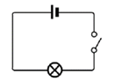
© ECM Education Consultants 2019
Electricity – Year 6
Significant scientists
Nicholas Tesla  (1856-1943)  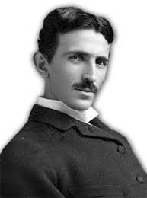 | Nicholas Tesla was a Serbian-American engineer and physicist. He invented the first alternating current (AC) motor and developed AC generation and transmission technology. He worked for Thomas Edison when he first moved to New York.
Peter Rawlinson  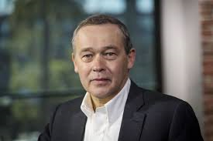 | Peter Rawlinson is a British engineer based in California. He is working on the development of electric vehicles, providing clear vision for a next-generation product.

Circuit symbols
cell | 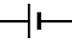
battery | 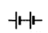
wire | 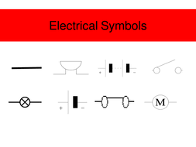
bulb | 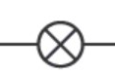
buzzer
motor
switch | 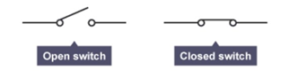

Adding more cells to a circuit makes a bulb brighter:
The bulb in this circuit will be brighter.

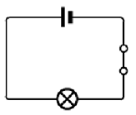  If you use a battery with a higher voltage, the bulb would also be brighter. | 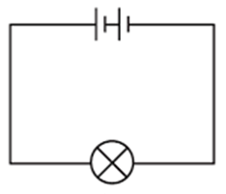

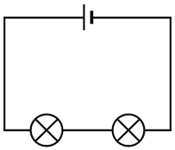
Adding more bulbs to a circuit will make each bulb less bright.
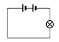 | 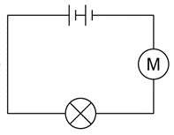
If we add a motor into a circuit with a single bulb, the bulb will be less bright.
If we then add more motors to the circuit, each motor will spin more slowly.

