
Knowledge organiser – United Kingdom
What will we be learning?
- Comparing the countries of the UK.
- The UK’s major cities.
- Physical characteristics of the UK.
- The UK’s landscape and people.
- Industries in the UK.
- Energy sources in the UK.
Key facts
Some of the UK’s major cities:

Aberdeen, Belfast, Birmingham, Bristol, Cambridge, Cardiff, Edinburgh, Glasgow, Leeds, Liverpool, London, Manchester, Newcastle, Norwich, Nottingham, Oxford, Sheffield.
Key knowledge
The United Kingdom includes England, Scotland, Wales and Northern Ireland.
Each country in the UK has a capital city: London (England), Edinburgh (Scotland), Cardiff (Wales) and Belfast (Northern Ireland).
The UK has many physical features, including mountain ranges, rivers and coastlines.
There are a number of ways power is generated in the UK. Energy can be generated at gas-fired power stations, by nuclear power and by burning coal. There are also renewable power options that use the wind, sun or water to generate energy.
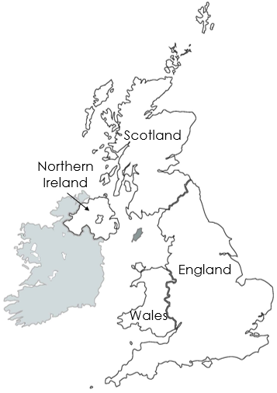

Place names | Geographical terms and processes | Locational terms
Great Britain  Greater London  London Array  North Sea  UK – the main cities, counties and regions | coastline  development  economy  energy source  industry  landmark  sustainable development | offshore  onshore  scale bar
Glossary
economy: the wealth and resources of a place
development: how places and communities change
industry: the production of goods (such as cars) or services (such as tourism or entertainment)
sustainable development: change that respects the natural environment and doesn’t harm future generations

