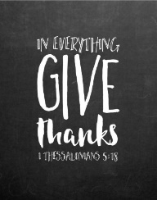
HARVEST – A season for change.
HAERFEST – In sael fore awendan


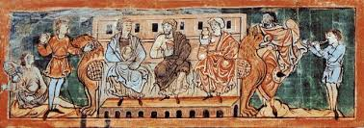

The children in Mrs Foulds’ class (5JF) would love you to join them to share their class assembly, to celebrate the learning they have made and to give thanks for the Harvest.
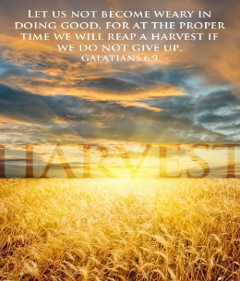
Date: Friday 11th October 2019
Time: 9:00am
Where: The school hall

HARVEST – A season for change.
HAERFEST – In sael fore awendan



The children in Mrs Foulds’ class (5JF) would love you to join them to share their class assembly, to celebrate the learning they have made and to give thanks for the Harvest.
Date: Friday 11th October 2019
Time: 9:00am
Where: The school hall

