Computing Long Term Plan

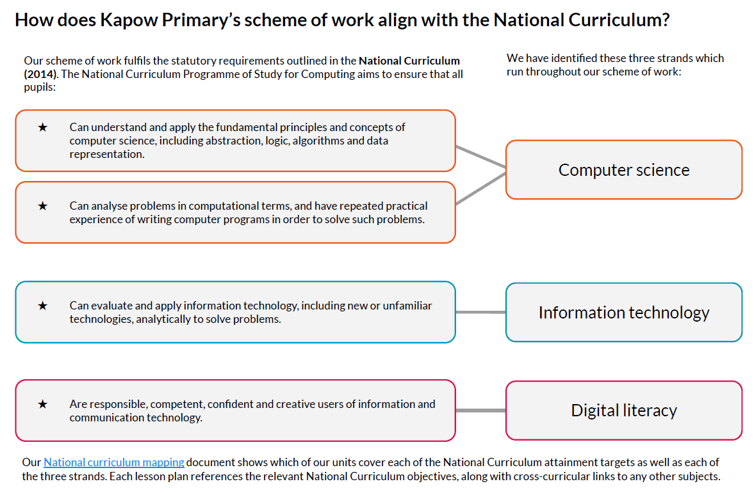

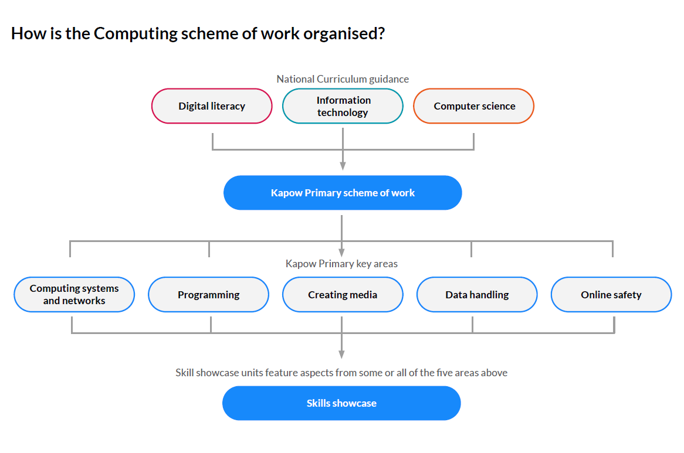

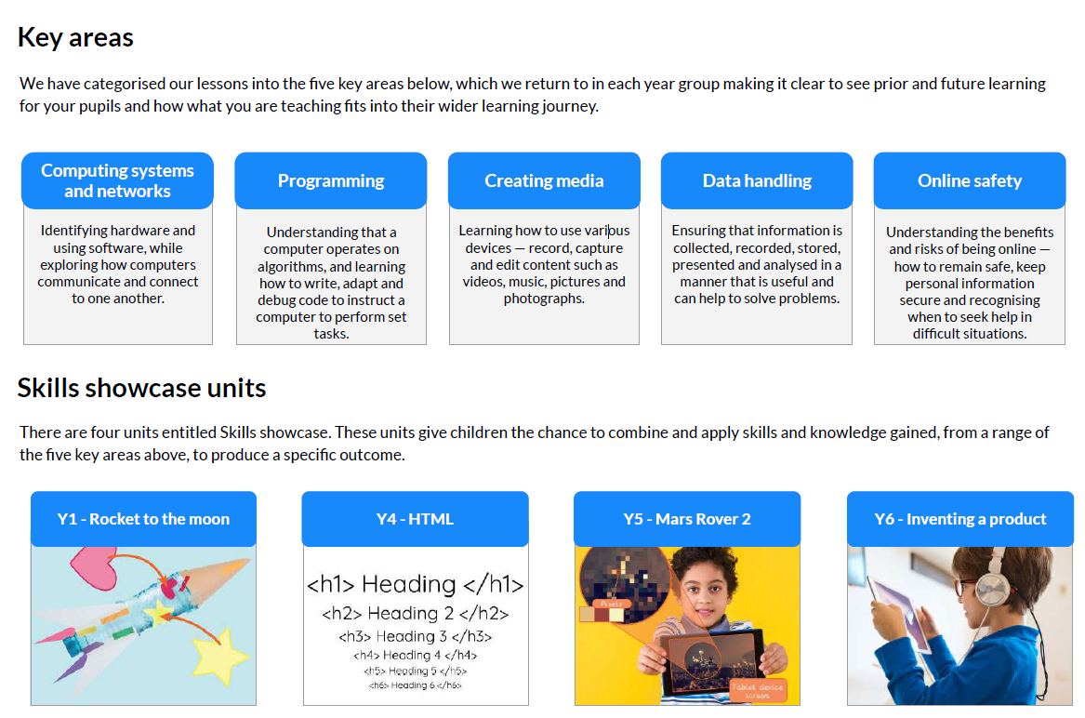

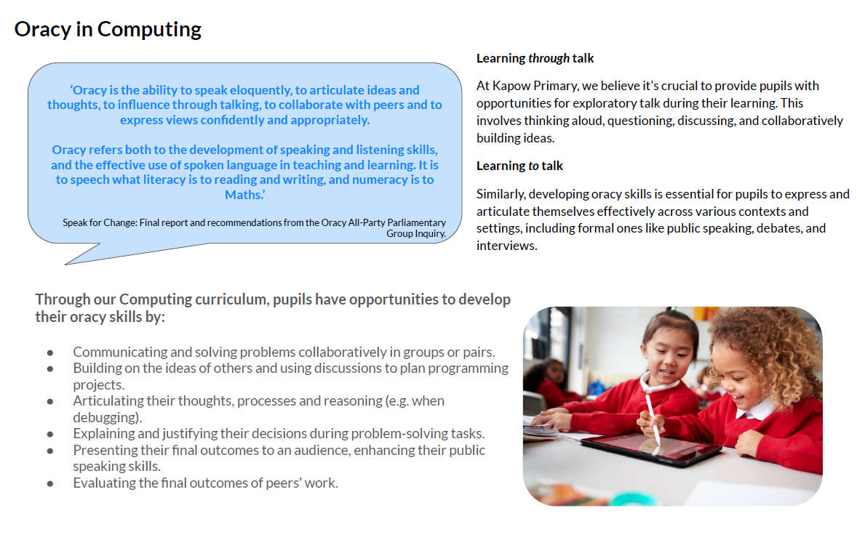

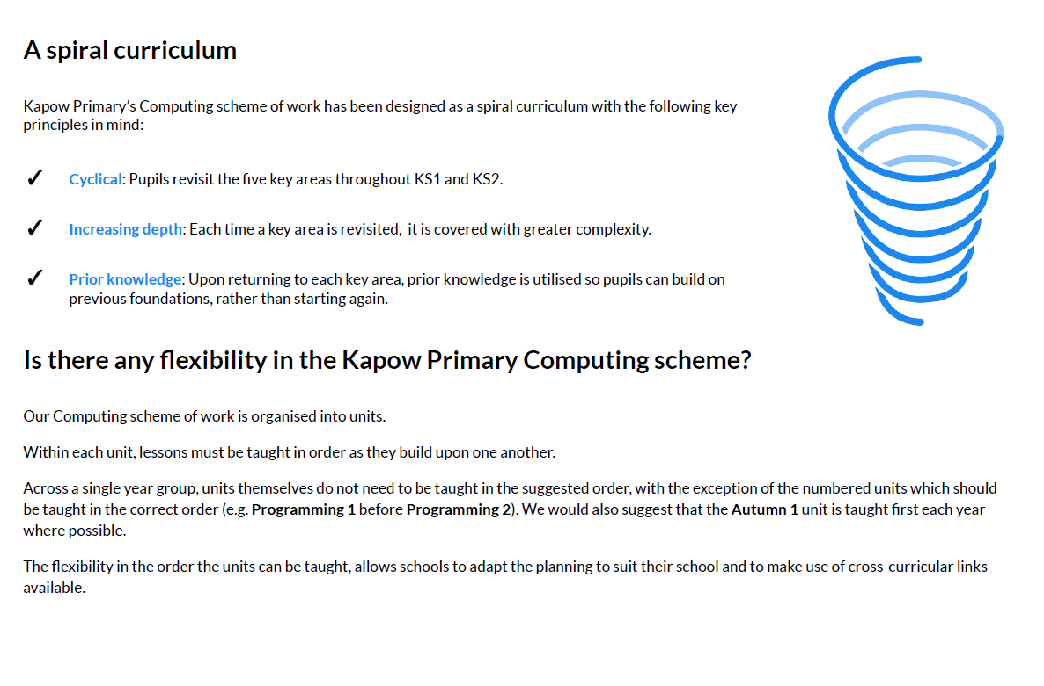

St Mary’s Mixed Age Long Term Plan

|  |  |  |  |  |  |  |
| --- | --- | --- | --- | --- | --- | --- |
|  | Year 1 / 2 | | Year 3 / 4 | | Year 5 / 6 | |
|  | Cycle A | Cycle B | Cycle A | Cycle B | Cycle A | Cycle B |
| Autumn 1 | Computing systems  and networks  Improving mouse  skills | Programming  Option 1: *New* Bee-  Bots | Computing systems  and networks  Emailing  Option 2: Microsoft Office 365 | Computing systems  and networks  Networks and the internet | Programming  **BBC micro:bit**  Option 1: *New BBC | Programming  **Music**  Option 1: *New*  Programming: Music |
| Autumn 2 | Programming  Algorithms  unplugged | Creating media  Digital imagery | Programming  **Scratch**  Option1: *New* Scratch | Data handling  Comparison cards databases | Data handling  Mars Rover 1 | Creating media  **Stop motion**  **animation**  Option 1: Stop motion  studio |
| Spring 1 | Skills showcase  Rocket to the moon | Data handling  Introduction to data | Creating media  **Video trailers**  Option 1: Using devices other than iPads , | Computing systems  and networks  Journey inside a computer | Skills showcase  Mars Rover 2 | Computing systems  and networks  Search engines |
| Spring 2 | Computing systems  and networks  What is a computer? | Programming  **Introduction to block**  **coding**  Option 1: MakeCode | Creating media  **Website design**  Option 2: Microsoft Office 365 | Computing systems  and networks  **Collaborative**  **Learning**  Option 1: Google | Computing systems  and networks  Bletchley Park and the  history of computers | Data handling  Big data 1 |
| Summer 1 | Programming  Algorithms and  debugging | Creating media  **Stop motion**  Option 1: Using  tablets | Programming  **Further coding with Scratch**  Option 1: *New* Further coding with Scratch | Data handling  Investigating weather | Computing systems  and networks  Exploring AI | Data handling  Big data 2 |
| Summer 2 | Computing systems  and networks  Word processing | Data handling  International space  station | Programming  **Computational thinking**  Option 1: *New* Computational  Thinking  3216yuikl;: | Skills showcase  HTML | Skills showcase  Inventing a product | Programming  Introduction To  Python |