Time  (Approx) | Monday | Tuesday | Wednesday | Thursday | Friday
8:40 – 8:50 | Name Writing | Maths | Reading | Fine Motor | Writing
8:55 | Register | Register | Register | Register | Register
 | Morning Prayer | Morning Prayer | Morning Prayer | Morning Prayer | Morning Prayer
9:00 – 9:40 | Phonics   | Phonics | Phonics | Phonics | Phonics
10:30 – 10:45 | Snack Time | Snack Time | Snack Time | Snack Time | Snack Time
10:45– 11:05 | Drawing Club   | Drawing Club | Drawing Club | Drawing Club | Drawing Club
 | Readers | Readers | Library | Readers | Readers
 | Before Lunch Prayer | Before Lunch Prayer | Before Lunch Prayer | Before Lunch Prayer | Before Lunch Prayer
11:45 – 12:30 | Lunch | Lunch | Lunch | Lunch | Lunch
12:30 | Register | Register | Register | Register | Register
 | After Lunch Prayer | After Lunch Prayer | After Lunch Prayer | After Lunch Prayer | After Lunch Prayer
 | Mindfulness & Teeth | Mindfulness & Teeth | Mindfulness & Teeth | Mindfulness & Teeth | Mindfulness & Teeth
 | Dough Disco/ Squiggle | Dough Disco/ Squiggle | Dough Disco/ Squiggle | Dough Disco/ Squiggle | Dough Disco/ Squiggle
From  12:45 |   Topic (UTW) | 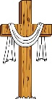  RE | Math  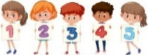 | Math | Math
From  12:45 |   Expressive Art  & Design | Math | Forest School  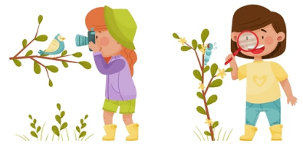 | 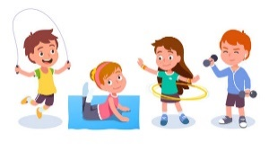  PE | PSHE  
From  12:45 | Math |   Gardening |  |   Cooking
2:30 | Tidy up | Tidy up | Tidy up | Tidy up | Tidy up
2:35 – 2:45 | Whole Class Shared Reading | Whole Class Shared Reading | Whole Class Shared Reading | Whole Class Shared Reading | Outside
2:45 – 3:15 | Collective Worship | Class Liturgy of the Word | Zones of Regulation | Hymn Practice | Celebration Assembly
 | Home Time Prayer | Home Time Prayer | Home Time Prayer | Home Time Prayer | Home Time Prayer
3:15 - 3:20 | Home Time | Home Time | Home Time | Home Time | Home Time
Reception Timetable – Spring Term

