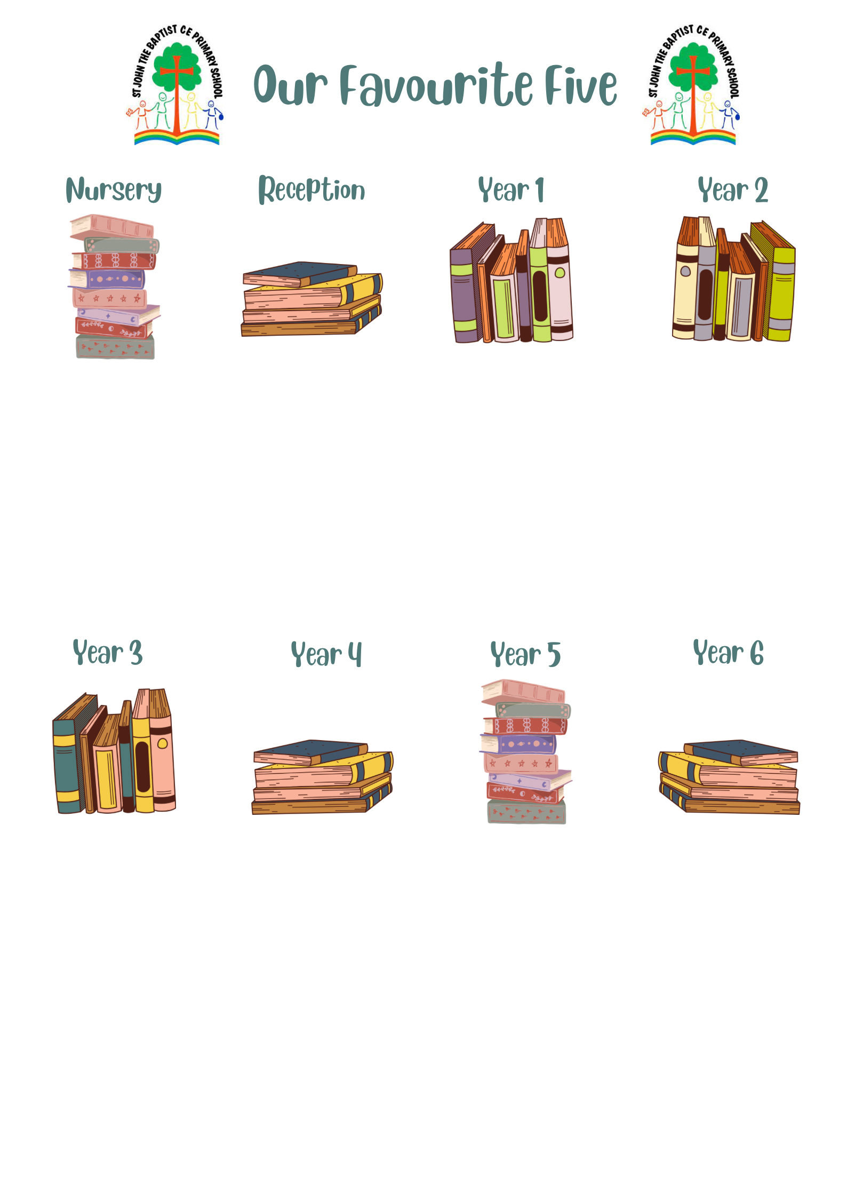
The Enchanted Wood - Enid Blyton
Dogger - Shirley Hughes
Tree - Britta Teckentrup
The Tiger Who Came to Tea - Judith Kerr
Looking after our Planet- Katie Daynes
The Singing Mermaid - Julia Donaldson
Oi Frog! - Kes Gray
The Blue Penguin - Petr Horáček
Five Minutes Peace - Jill Murphy
What a Waste - Jess French

We’re Going on a Bear Hunt - Michael Rosen
Owl Babies - Martin Waddell
The Gruffalo - Julia Donaldson
Peace at Last - Jill Murphy
Love Our Earth - Jane Cabrera
The Last Bear
The Highland Falcon Thief
Roman Diary, The Journal of Iliona
The Chronicles of Narnia, The Lion, the Witch and the Wardrobe
The Boy at the Back of the Class
Where the poppies grew
How to catch a star
Charlotte’s Web
Mr Tiger, Betsy and the Blue Moon
The Wild Way Home
The Creakers
The Journey
Interstellar Cinderella
Leaf
The Great Paper Caper
Dougal’s Deep-Sea Diary
I am Seed that grew the tree
Guy Fawkes and the Gunpowder plot

Our Favourite Books…
Coming to England-
Into the Volcano
Skellig
The Nowhere Emporium
The Ancient Egypt Sleepover
Flotsam

Journey to the River Sea
Can You See Me?
Clockwork
Letters from the Lighthouse
The Arrival

