Whole School Approach to Mental Health and Well-being Strategy
A whole school approach is about developing a positive ethos and culture – where everyone feels that they belong. It involves working with our families and making sure that our whole school community is welcoming inclusive and respectful. We maximise children’s learning through promoting good mental health and wellbeing across our school community. Through the curriculum early support for pupils, strong staff pupil relationships, committed leadership and a commitment from everybody.
Statement
At St John’s we prioritise a whole community approach to mental health and wellbeing. We recognise that the mental health and emotional wellbeing of all our children, staff, parents, carers and governors is fundamental to our school. This is the golden thread which underpins our ethos, culture and daily life in school.
Aims
- Create a supportive environment where all have a sense of belonging and feeling safe.
- Promote positive mental health and wellbeing in our school community.
- Empower everyone at St Johns to develop their personal wellbeing and resilient strategies.
- Increase awareness and openness around mental health and mental ill health
- Provide support to identify need at an early stage and enable appropriate intervention this could include a referral to specialist support.
A Whole School Approach
Our whole school approach at St Johns is built upon the eight principles.

All staff have a responsibility to promote positive health and wellbeing. They need to understand the risk and protective factors for themselves and the children in their care. Everyone should take responsibility for identifying early need and know how to access further support.

Key Members of our School Community
Wellbeing Wonders – Jo Thompson, Julia Jones, Nikki Champman, Jo Casswell, Sarah Dougal, Susie Arnold.
SLT – Susie Arnold, Ann Nixon, Lee Mullen, Sarah Dougal
Senior Mental Health Lead – Sarah Dougal
Governors – David Hopkins, Julia Jones, Teresa Anger
Wellbeing Ambassadors – pupils in school with responsibility to promote positive wellbeing
Safeguarding Lead/SENCO – Susie Arnold, Sarah Foster
Learning Mentor – Bonnie Fielding
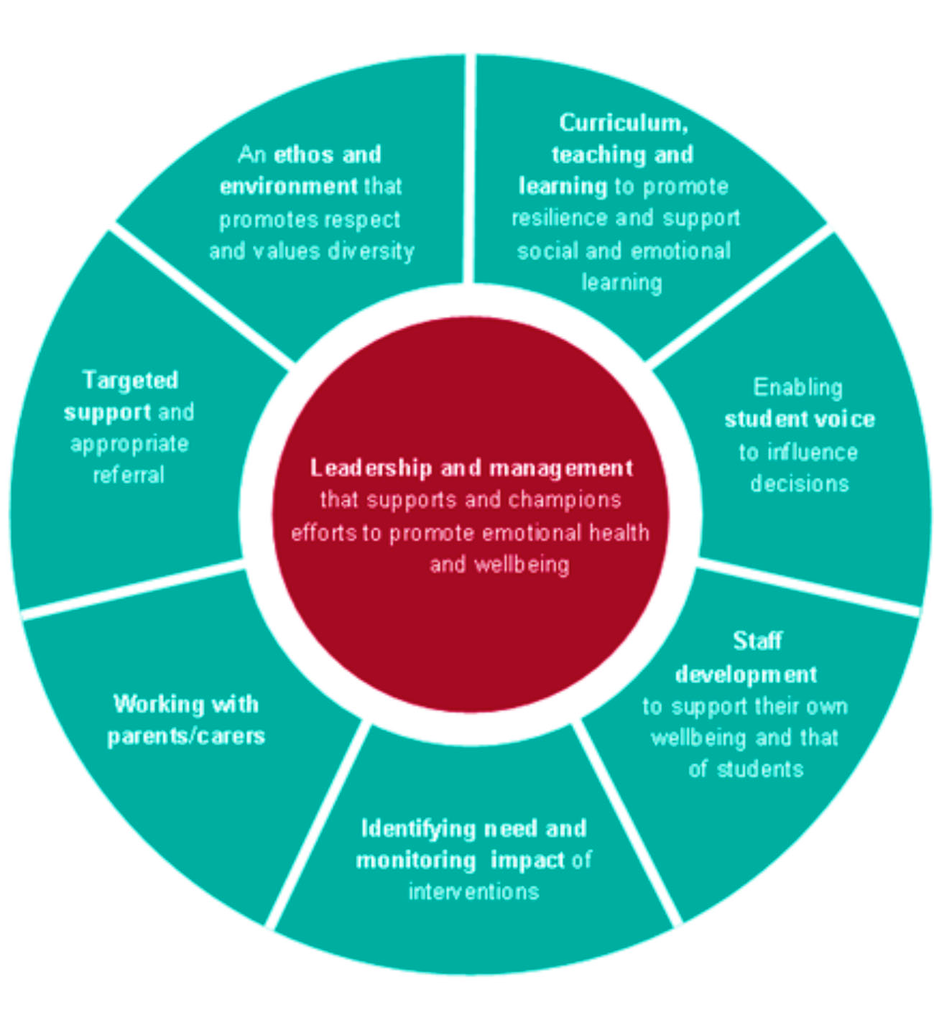

Leadership and management
Support from the senior leadership team is essential to promote and embed emotional health and wellbeing. Leadership and Management champions the eight principles created by Public Health England.

School ethos and environment
The environment and Ethos of St Johns is to value and welcome every member of the community.

Staff voice – The Cross

Curriculum, teaching and learning
Quality teaching and a good curriculum allow children to gain the skills they need to make good academic progress and benefit their health and wellbeing.
- Curriculum – PSED association progression plans followed, curriculum, PD strategy overview and aspects of PSED around safety and wellbeing progression map.

Student voice
At St Johns we value our children’s opinions. It is important to us that they feel involved in decisions that impact on them and they feel part of the school and wider community. We achieve this through;

- Pupil Voice – Parliament, Surveys, Emotional check in’s – daily ones, progressive approach for an emotional check in – from early years to KS2.
School Parliament

Staff development, health and wellbeing
Staff at St Johns are our most valuable resource, we encourage them to take responsibility for their own wellbeing. Staff are passionate about CPD and supporting our children. Staff training is essential in promoting staff health and wellbeing and an essential principal of the whole-school approach.
Staff Wellbeing Guarantee
Staff Wellbeing Charter

Identifying Need and Monitoring Impact of Interventions
We recognise the importance of monitoring the impact of any support that is put in place. We work closely to support the children’s and families according to their needs.
Inclusion Team Referral
Learning Mentor Role

Working with Parents and Carers
At St Johns we value the support from our parents and careers and understand the vital role they play in supporting our children’s mental health and wellbeing. Some of the opportunities we offer are…
- Parents and Carers – open door approach, visual and approachable at opening and closing times of schools.
- Parents and Carers – coffee morning with guest speakers
- Open Afternoons where parents and carers are welcome
- Showcase Events where parents and carers are welcome
- PTA who meets regularly
- Weekly Newsletter
- Parent Surveys

Useful Organisations

Targeted Support and Appropriate Referral
It is important for us as a school to ensure that support is given to all our children and families. We recognise that, at times, some families may need more support than others with their mental health and wellbeing.

- Targeted support identified through inclusion team – 1 to 1 light touch, check in’s with, alongside 1 to 1 work with SEMH programs.
- Play Therapy with internal teacher who is a play therapist.
- Mental Health in children and young people trained one at KS1/KS2 through the inclusion team.

This is signposted through our learning mentor, Inclusion team and the wellbeing champions.

Appendix

- The Cross

- Staff Well-Being Guarantee

- Penistone St John’s Staff Well-Being Charter Statement

- Inclusion Team

- Learning Mentor

- Useful Organisations

- School Parliament

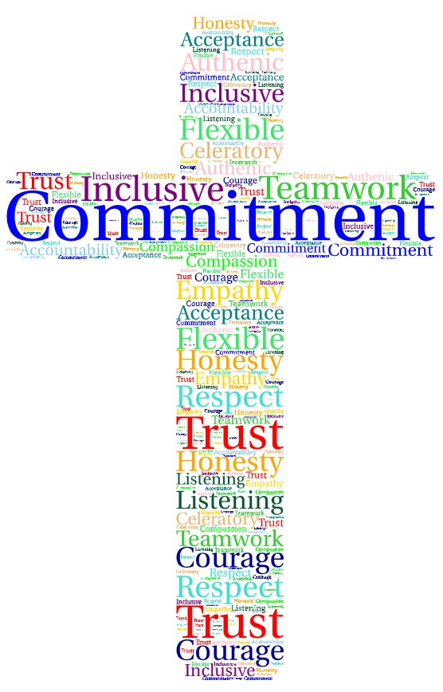
At St Johns we believe in

Staff Well-Being Guarantee
St Johns promotes and supports the well-being of all our staff through;
- Charter Implementation and Impact  - Wellbeing team meets half termly  - Staff Wellbeing Champions highlight campaign of the month at briefings.  - Well-being is on SLT agenda weekly  - Well-being is on Governors termly agenda  - Staff well-being is part of staff induction process  - Role of Well-being Governor  - Charter embedded and shared with all | - Culture and Ethos  - Bi annual formal staff survey  - Weekly briefing for informal staff voice  - Well-being Wonders  - Shout Out Walls  - Hug in a Mug  - Culture of kindness  - Supervisions is part of school practice  - Realistic expectations of own self
- Organisation Structure  - Regular timetabled supervisions (where appropriate)  - Appraisal  - Debrief of staff who are handling distressing cases linked to policy  - Wellbeing display  - Discretionary day off  - CPD – Clinics responsive to staff interests and needs | - Accessing Support  - Training linked to wellbeing  - Governor’s training  - Open conversations about mental health and well-being  - All staff know the school procedures for asking for and arranging time off  - Graduated support – universal, targeted and specialist support  - All staff know how to access professional external support – hub of help and information on wellbeing board in staff rooms.  - Culture of seeking support when needed
- Workload and Work-life Balance:
There is no clear definition of what work-life balance is as it differs for everyone; we have diverse lives, life choice and personalities – it is a personal choice as to what suits individuals. Everyone is entitled to a work life balance where work life and personal life should be complementary not competing priorities. This Charter actively promotes and supports all staff to create and maintain a sustainable and thriving way of life.

Penistone St John’s Staff Well-Being Charter Statement
Introduction
This Charter sets out Penistone St John’s commitment to the well-being of all its staff. We are committed to providing a healthy working environment, improving the quality of working lives for all staff and recognising that staff are our greatest asset. It is essential that all staff feel a sense of value and belonging, which promotes staff engagement, performance and achievement.
It is understood that all staff have commitments outside their working live which can also impact on well-being. This Charter aims to support the school’s mission and core values, ensuring every member of staff is treated fairly, equally and professionally at all times.

Rationale – Why is well-being a priority for your school?
We care about our staff and recognise how much they give to our children and our families. We want them to feel valued and supported and invested in. Our aim is for staff to manage stress better through developing healthy coping strategies.
We understand that staff needs will vary and aim to provide relevant support at the right time. Mindful of our statutory responsibilities and duty of care to our staff, we value the importance of retaining our high-quality team. This will lead to increased productivity, engagement and job satisfaction for all. As well as reduce levels of sickness and presenteeism.

Legislation / Duty of Care:
School has a duty of care to ensure the health, safety and welfare of all the staff and to have measures in place to mitigate as far as possible factors that could harm the physical and mental well-being of staff, which includes work-related stress. This extends to those factors which are work-related and within the school’s control.
Legislation that will be considered when promoting positive mental, physical and emotional wellbeing, including, but not exclusively:
- The Health and Safety at Work Act 1974
- The Equality Act 2010
- Working Time regulations
- Employment Rights Act 1996
- Employment Relations Act 1999
- Stress Risk Assessment

Aims
- Staff team shared values – highlighted in word art
- Clear practices embedded to ensure all staff feel heard, valued and empowered to fulfil their role to the best of their ability and deliver a high-standard of education to the children; staff enjoy sustainable and fulfilling roles / careers; effective and sustainable work-life balance
- Embedded and sustainable well-being practices that positively impacted on all staff
Engagement from all stakeholders

Objectives of this Charter
- Ensures School promotes and supports health and well-being of its staff, building a positive health and safety culture; comply with statutory requirements
- Shared document that is developed by and belongs to all staff
- Supports the promoting and sustainability of staff well-being
- Enables all staff to know what support is available and how to access it
- Enables everyone to have a ‘voice’ in developing and sustaining practices; all staff know their
- role and responsibility within this
- Encourages staff as individuals to accept responsibility for their own mental, physical and
- emotional well-being
- Recognise the importance of promoting a healthy work-life balance for all staff; those excessive hours of work can be detrimental to health and effectiveness
Enables any hazards that could lead to poor staff health and well-being to be identified and reduced where possible.

This Charter is developed for all staff, by all staff and is embedded into the daily school life.

Key People
- Mental Health Champions – Sarah Dougal, Julia Jones
- Member of SLT – Susie Arnold, Sarah Dougal
- Well-being Wonders
- Governor - David Hopkin

Roles and Responsibilities:
The Governing Body
- Actively support the development of the Well-being culture within school, recognising and promoting the importance of prioritising staff mental, emotional and physical well-being
- Ensure this Charter is reviewed regularly to adapt to changing needs and legislative frameworks
- Provide fair and consistent support for staff where needed
Headteachers / SLT:
- Encourage all staff to take responsibility for their own well-being and have access to regular health and well-being training, support and resources
- Provide a safe and healthy environment for all staff at work where everyone is treated fairly and equally
- Create a culture of openness where there are opportunities to discuss concerns, where any problems or needs are quickly identified, and support is given. Stress and mental health issues are not seen as weaknesses.
- Support staff to carry out their roles effectively, ensuring they have the necessary skills and training; ensure there are clear lines of communication
- Work with the Governing Body to ensuring that the impact of policies and practices consider workload.
- Provide regularly opportunities to collect, listen to and respond to staff voice

Staff:
- Play an active, professional part in school life, sharing their ideas, views and feelings
- Take responsibilities for their own well-being, engaging in training, support and resources that may be relevant to them.
- They will seek support or help if required, recognise the importance of good communication from both parties.
- Raise any concerns or issues at the earliest possible moment to enable effective support to be engaged.
- Support their own and colleague’s well-being by respecting the health and safety requirements in the workplace

Staff Well-Being Guarantee
St Johns promotes and supports the well-being of all our staff through:
- Charter Implementation and Impact
Wellbeing team meets half termly
Staff Wellbeing Champions highlight campaign of the month at briefings.
Well-being is on SLT agenda weekly
Well-being is on Governors termly agenda
Staff well-being is part of staff induction process
Role of Well-being Governor
Charter embedded and shared with all
- Culture and Ethos
Bi annual formal staff survey
Monthly briefing for informal staff voice
Well-being Wonders
Shout Out Walls
Hug in a Mug
Culture of kindness
Supervisions is part of school practice
Realistic expectations of own self
- Organisation Structure
Regular timetabled supervisions (where appropriate)
Appraisal
Debrief of staff who are handling distressing cases linked to policy
Wellbeing display
Discretionary day off
CPD – Clinics responsive to staff interests and needs

- Accessing Support
Training linked to wellbeing
Governor’s training
Open conversations about mental health and well-being
All staff know the school procedures for asking for and arranging time off
Graduated support – universal, targeted and specialist support
All staff know how to access professional external support – hub of help and information on wellbeing board in staff rooms.
Culture of seeking support when needed

- Workload and Work-life Balance:
There is no clear definition of what work-life balance is as it differs for everyone; we have diverse lives, life choice and personalities – it is a personal choice as to what suits individuals. Everyone is entitled to a work life balance where work life and personal life should be complementary not competing priorities. This Charter actively promotes and supports all staff to create and maintain a sustainable and thriving way of life.
_____________________________________________________________
Measuring Impact
Feedback from staff
Lower absence rates
Retention rates
Staff uptake on CDP
Flexible working requests
Data: support services, stress, referrals etc.
Well-being and attainment of pupils
Reputation of school (recruitment)
Better place to work and learn

ADDITIONAL DOCUMENTATION
- Support Guidance for staff experiencing Mental Health Needs
- How school regularly reviews and addresses any potential work-related causes of mental ill health
- Understanding personal and professional triggers
- How school supports staff experiencing mental health difficulties / needs
- Signposting: what is available internally and externally
- Reasonable adjustments
(including Menopause: https://www.cipd.co.uk/knowledge/culture/well-being/menopause#gref)
(https://www.cipd.co.uk/Images/line-manager-guide-to-menopause_tcm18-95174.pdf)
- Return to work support
- Support Networks and Organisations (*)
- PAPYRUS HOPELINEUK – 08000684141 (suicide prevention)
- NAPAC – 08088010331 (National Association People Abused in Childhood)
- Samaritans – 116 123
- 24-hour domestic Violence Helpline 08082000247
- Family Rights Group – 08088010366
- Beat – Eating Disorders Support www.beateatingdisorders.org.uk
- Hub of hope - Hub of Hope
Inclusion Team
The Inclusion team meets fortnightly to discuss any support needed to enable all children to access school life.
Members of the Inclusion Team
- Susie Arnold – Headteacher DSL
- Sarah Foster – SENCO Deputy DSL
- Bonnie Fielding – Learning Mentor Deputy DSL
- Sarah Dougal – PP Lead, Senior Mental Health Lead
- Rebecca Swift – Behaviour Lead
The seven pillars of inclusion are:
- Access.
- Attitude.
- Choice.
- Partnerships.
- Communication.
- Policy.
- Opportunities.

The team will work with staff to support children - meeting need through evaluating, allocating resources and or giving guidance and strategies.
They will monitor the children and adjust needs accordingly.

Learning Mentor
Mrs B Fielding


The Learning mentor mainly work with pupils on a one-to-one basis. They help to develop coping strategies, enhance motivation, raise aspirations and encourage re-engagement with learning.
They take account of a range of complex underlying issues that may impact negatively on learning and achievement, such as:
- bereavement
- low self-esteem
- low aspirations
- mental health issues
- relationship difficulties
- bullying
- peer pressure
- family issues or concerns.
They also work closely with teachers, parents, social workers, local government workers, careers advisers and fellow learning mentors. They help the people they look after and construct new ways of developing relationships in the community.

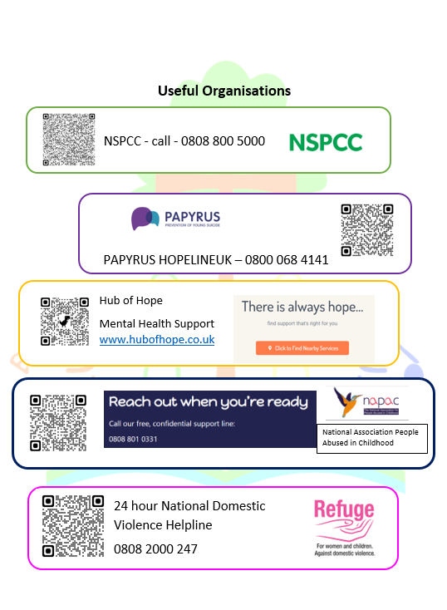

Head of school Parliament – 1 pupil Y6 (Elected)
Deputy Head of school Parliament – 1 pupil Y6 (Elected)

Ministry of Worship
1 lead pupil (Y6)
1 deputy pupil (Y5)
1 staff support member (A Stott and G Webb)
2 pupils per class (elected)
Meeting every half term – see calendar

Ministry of Environment
1 lead pupil (Y6)
1 deputy pupil (Y5)
1 staff support member (J Jones)
2 pupils per class (elected)
Meeting every half term – see calendar

Ministry of Community
1 lead pupil (Y6)
1 deputy pupil (Y5)
1 staff support member (A Nixon)
2 pupils per class (elected)
Meeting every half term – see calendar

Ministry of Wellbeing and Behaviour
1 child from each Y2 and Y6 class
1 staff support member (R Swift)
Ministry of Sport
1 lead pupil (Y6)
1 deputy pupil (Y5)
1 staff support member (W Heath and B Thompson)

Senior Chamber – Members from previous year Community, Environment and Worship. Giving advice and support to above when necessary

2 Clerks of the Parliament – Y6 (Elected)
Health and Safety
Education and Curriculum

