Year 5 Homework Menu: Autumn 1
Year 5 spelling words to practice
Handwriting
Choose 5 of your spelling words and write them in a sentence using your neatest cursive handwriting.
Choose one activity per week from the grid below. Be as creative as you can and show off your uniqueness!
SCIENCE  Plan and conduct a scientific enquiry into water resistance that acts between moving surfaces. | GEOGRAPHY  Research and create a fact file based on a natural disaster of your choice. Include sections that outline information such as location, duration, impact on the land, impact on the people, and recovery.
DIVERSITY  Create a piece of artwork that reflects your identity. Be as creative as you like! | FRENCH  Create cue cards for the subjects you learn in school. Include pictures as prompts to help you remember them.


Mastering our times tables is essential for future success in maths!
Log into your TT Rockstars account and practise your times tables at least once each week.
https://ttrockstars.com/
We will take part in regular competitions both in school and against the rest of the country.
Your teacher will keep check on the website to watch your score improve!

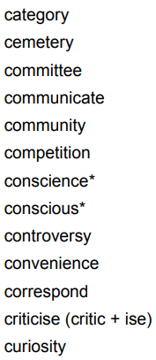
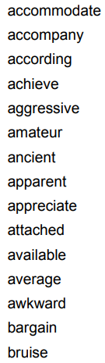
FREE CHOICE
It’s always important to have some freedom in what you do…
If you have been learning about something really exciting in school and want to do some further research or produce a piece of work about it, then that would be fantastic!
Make sure you share it with your teachers and class mates.





At St John’s, we learn to read so that we can read to learn!
Spend 20 minutes reading each day. This could be independently, with a family member or friend, or even reading to your pet at home! All reading is good reading.
Find a calm and peaceful place, a book you love and transport yourself to another world.
You could take a photo of yourself reading or write a book review once you have finished – you teacher would love to see it!

Challenge: can you write a setting description which includes some of these words?
GRAMMAR

Use the BBC bitesize website to develop your understanding of using a range of fronted adverbs.
Type Using adverbs - BBC Bitesize into google to find the website.

