Year 1 Homework Menu: Autumn term

**History- Remembrance**

Can you spot a poppy?

Watch a remembrance service. Think about the reasons we remember.

**Geography- Where do I live?**

Make a map of where you live!

Include all of the human and physical features of your

surroundings.

Choose one activity per week from the grid below. Be as creative as you can and show off your uniqueness!

|  |  |
| --- | --- |
| **Maths**  To help your child with their Maths learning you can access Numbots online, log in details have been sent home. Let your class teacher know if you need these sending again. You could also download the White Rose – 1 minute maths app for some quick, interactive Maths fun.  Later in the year your child will be learning how to tell the time.You could support your child’s learning by introducing the language used such as “half past, quarter past, quarter to” etc. | Zavala-Venegas, Cristina / Spanish Reading/ Lectura en español  **Phonics**  At St John’s, we learn to read so that we can read to learn! Your child has daily phonics lessons but it’s important that this valuable learning continues at home. What can you do to help at home?   1. Listen to your child read the same *Read Write Inc*. Storybook again and again. 2. Encourage them to use ’Special Friends’, ‘Fred Talk’, ‘read the word’. 3. Discuss the story and encourage their storyteller voice.   Please continue to access phonics links on Class Dojo |
| **SCIENCE**  Look at the 5 senses below:  sight smell touch hearing taste  Go on a senses hunt!  Use your senses to find things that would fit into each group.  Take photographs of the things you find… | **RE**  This term we are learning about stories from the Bible.  We will be learning about the parable of the Lost Son, the story of Jonah and the Christmas story.  Can you retell one of the stories from the Bible to your grown up?  Can you draw a picture of your favourite part of the story? |

|  |  |  |
| --- | --- | --- |
| the | we | pull |
| a | go | full |
| do | so | he |
| to | by | me |
| today | my | she |
| of | here | house |
| said | there | our |
| says | where | friend |
| are | no | school |
| were | love | put |
| was | come | push |
| is | some | you |
| his | one | your |
| has | once | they |
| I | ask | be |

Here are some common exception words – words that are spelled without using the normal phonics rules – that children in England are expected to be able to spell by the end of Year 1. We call these “red words”

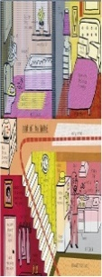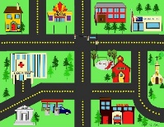

**Handwriting**

Choose 5 of the words above to practise each week!

