Cavendish Community Primary School EYFS Curriculum
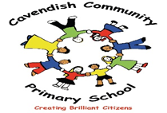

Version 5.0
Overarching Principles | Unique Child: Every child is unique and has the potential to be resilient, capable, confident and self-assured  Positive Relationships: Children flourish with warm, strong and positive partnerships between all staff and parent/carers. This promotes independence across the EYFS curriculum. Children and practitioners are not alone – embrace each community.  Enabling environments: Children learn and develop well in safe and secure environments where routines are established and where adults respond to their individual needs and passions and help them build on their learning over time.  Learning and development: Children learn and develop at different rates. We must be aware of children who need greater support than others.  PLAY: At Cavendish Community Primary School, we understand that children learn best when they are absorbed, interested and active. We understand that active learning involves other children, adults, objects, ideas, stimuli and events that aim to engage and involve children for sustained periods. We believe that Early Years education should be as practical as possible, and therefore we are proud that our EYFS setting has an underlying ethos of learning through play. Play is essential for children’s development across all areas. Play builds on children’s confidence as they learn to explore, to relate to others around them and to develop relationships, set their own goals and solve problems. Children learn by leading their own play, and taking part in play that is guided by adults. – The Cavendish EYFS Team  We will ensure that children learn and develop well and are kept healthy and safe at all times.
Characteristics of Effective Learning | Playing and Exploring – Children investigate and experience things and ‘have a go’. Children who actively participate in their own play develop a larger store of information and experiences to draw on which positively supports their learning.  Active Learning – Children concentrate and keep on trying if they encounter difficulties. They are proud of their own achievements. For children to develop into self-regulating, life-long learners they are required to take ownership, accept challenge and learn persistence.  Creating and Thinking Critically – Children develop their own ideas and make links between these ideas. They think flexibly and rationally, drawing on previous experiences which help them to solve problems and reach conclusions.
Curriculum Goals | - To become a confident communicator who can listen carefully in various situations, hold a conversation with friends and adults, ask relevant questions and use new vocabulary to explain feelings and ideas.  - To become an independent individual who can follow the school rules, set simple goals and persevere to achieve them, select resources, manage their own personal needs and know how to stay fit and healthy.  - To become a fantastic friend who can be kind, caring and helpful, show empathy and respect to others, work and play co-operatively whilst considering others’ ideas and feelings.  - To become an amazing athlete who can show strength, balance and co-ordination when playing, move confidently and safely in a variety of ways, and use a range of equipment.  - To become a talented tool-user who can hold a pen effectively, use a range of tools (for example scissors, cutlery, paintbrushes, tweezers) safely and with confidence.  - To become a brilliant bookworm who can show a love for reading, use new vocabulary to talk about what they have read or has been read to them, read words and simple sentences (using single sounds or diagraphs they have learned).  - To become a wow writer who can write letters that are formed correctly, write words and simple sentences (using single sounds and diagraphs they have learned) that can be read by others.  - To become a master of maths who can show a deep understanding of numbers to 10, recognise patterns within the number system, subitise, compare quantities and recall number bonds.  - To become a compassionate citizen who can help to look after their community and care for the environment, know some reasons why Manchester is special and have an awareness of other people’s cultures and beliefs  - To become an exceptional explorer who can show curiosity about the world around them, understand how to read and draw a simple map, understand some differences between times and places.  - To become a proud performer who can perform a song, poem or dance to an audience, retell stories with expression and confidence, play a range of percussion instruments correctly and with good rhythm.  - To become a dynamic designer who can choose and safely use the resources they need to make their creations, talk about what they have made and how they have made it.
 | Autumn 1 | Autumn 2 | Spring 1 | Spring 2 | Summer 1 | Summer 2
Overarching theme | All About Me | Festivals | People Who Help Us | Life Cycles | Under the Sea | Holidays
Celebrations and Events | Harvest Festival  Sukkot  Grandparents Day | Diwali  Christmas  Hanukah | Lunar New Year | Eid al-Fitr  Easter Bonnet Parade | Endangered Species Day  World Turtle Day | Eid-al Adha
First-hand experiences | Factory Theatre  Panto in school  Cavendish Park  Forest School  Book Club  Visit from Rabbi |  | Tour of main school  Forest School  Book Club  Chicks in school  Allotment visit  Chorlton Water Park  Visits from people who help us |  | Mosque visit/visit from Iman  Church visit/visit from Vicar  Forest School/Forest school festival  Book Club  Formby/Talacre Beach
Parental involvement | Stay and Play  Reading Workshop  Maths workshop | Nativity performance  Stay and Play  Parent’s Evening | Stay and Play | Parent’s evening  Stay and Play | Forest School Showcase | End of year celebration performance  Stay and Play

“Teaching should not be taken to imply a “top down” or formal way of working. It is a broad term that covers the many different ways in which adults help young children learn. It includes their interactions with children during planned and child-initiated play and activities: communicating and modelling language; showing, explaining, demonstrating, exploring ideas; encouraging, questioning, recalling; providing a narrative for what they are doing; facilitating and setting challenges. It takes account of the equipment adults provide and the attention given to the physical environment, as well as the structure and routines of the day that establish expectations. Integral to teaching is how practitioners assess what children know, understand and can do, as well as taking account of their interests and dispositions to learn (characteristics of effective learning), and how practitioners use this information to plan children’s next steps in learning and monitor their progress.” Ofsted Early Years Inspection Handbook

Cavendish Community Primary School
Reception Curriculum Overview for Communication and Language
Educational Programme for Communication and Language | The development of children’s spoken language underpins all seven areas of learning and development. Children’s back-and-forth interactions from an early age form the foundations for language and cognitive development. The number and quality of the conversations they have with adults and peers throughout the day in a language-rich environment is crucial. By commenting on what children are interested in or doing, and echoing back what they say with new vocabulary added, practitioners will build children's language effectively. Reading frequently to children, and engaging them actively in stories, non-fiction, rhymes and poems, and then providing them with extensive opportunities to use and embed new words in a range of contexts, will give children the opportunity to thrive. Through conversation, story-telling and role play, where children share their ideas with support and modelling from their teacher, and sensitive questioning that invites them to elaborate, children become comfortable using a rich range of vocabulary and language structures.
Planning around a quality text | 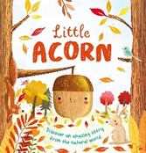  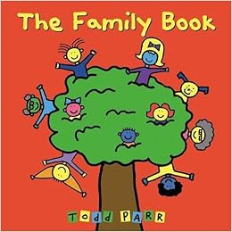  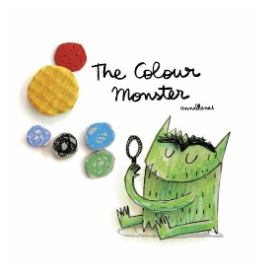 |  | 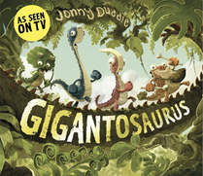  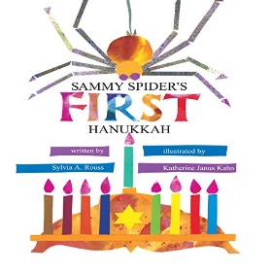  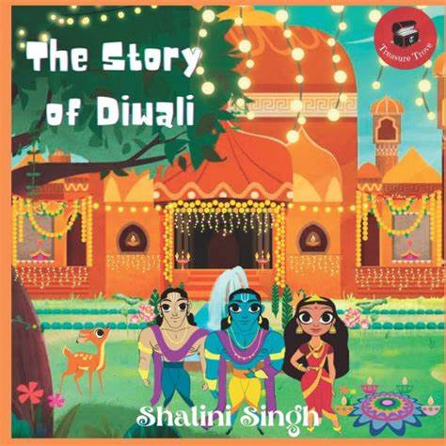  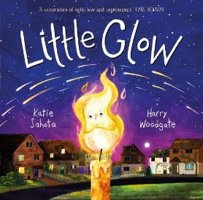  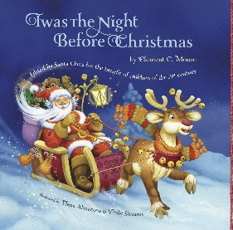 | 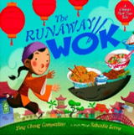  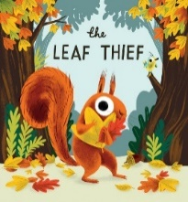  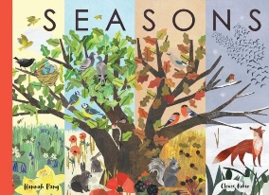  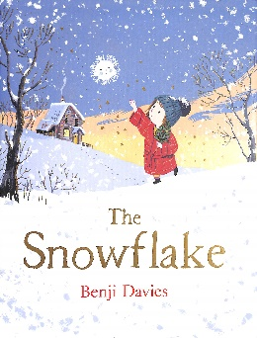  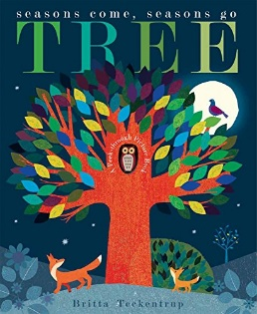  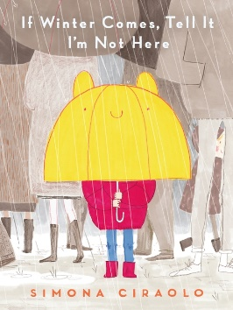 |  | 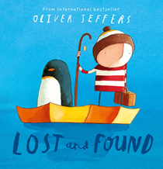  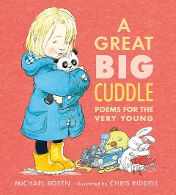  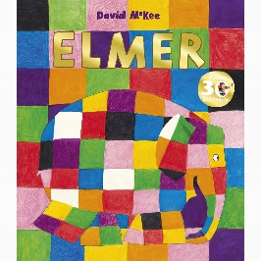  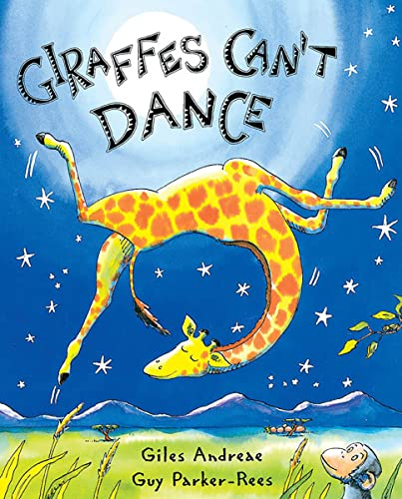  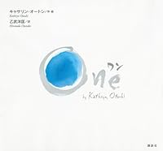 | 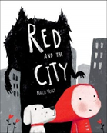  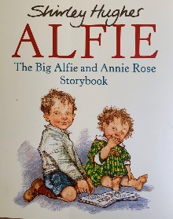  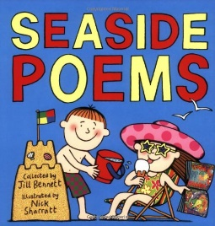  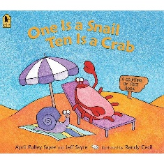 |  |  | 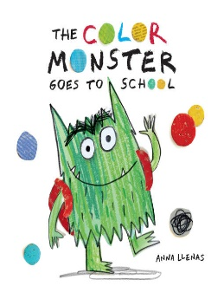  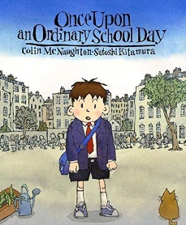  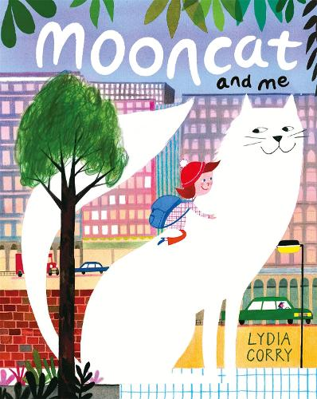
Term | Autumn 1 | Autumn 2 |  |  | Spring 1 | Spring 2 |  | Summer 1 | Summer 2
Every practitioner should: | - Work out how developed child’s communication and language skills are based on observation and knowledge of typical child development.  - Assess gaps and provide appropriate opportunities for language development.
Ongoing Communication and Language skills developed throughout the year | Learning new vocabulary and its meaning.  Using new vocabulary in a range of contexts.  Using new vocabulary and sentence types in conversations and discussions – with teachers and peers.  Learning new rhymes, poems and songs – some of which I can recite.
Communication and Language:  Listening, Attention and Understanding  Speaking | -connect one idea or action to another using a range of connectives including ‘and’  The Colour Monster  - engage in story times, developing vocabulary  Little Acorn  -use new vocabulary in different contexts  My Dad is a Grizzle Bear  - listen carefully to rhymes and songs, paying attention to how they sound.  Superhero Gran  - join in with whole class activities and concentrate for the duration.  -follow a routine instruction (put your book away, sit on the carpet)  -respond to a peer’s request and reply.  -listen carefully and understand why listening is important  -develop social phrases |  | -ask questions when instructions are not understood  -use vocabulary linked to new learning in science, maths, music  -offer ideas in small group contexts  -use full sentences to express complete ideas  -speak in whole class situations  - answer ‘how’ questions  Sammy’s spider’s first Hannukah  The story of Diwali  ‘Twas the night before Christmas  Little Glow  -learn rhymes/rhyming, poems and songs  Gigantasaurus | -conduct a simple back and forth conversation, paying attention to peer/adult and responding appropriately  -show attentive listening skills at input times e.g during phonics and quick to act on instruction  -ask questions when don’t know what a word means  Runaway Wok  -discuss which category a word is in for example, ‘A cabbage is a vegetable. It’s a bit like a sprout but much bigger.’  The Snowflake  -use non-fiction books to extend knowledge of the world and illustrate a current topic/theme’  Tree:seasons come seasons go |  | -ask questions to find out more and check understanding of what was said, in a variety of contexts  -listen to and talk about stories to build familiarity and understanding  Lost and Found  -use complete sentences in my everyday talk  -offer small explanations that demonstrate my understanding on a topic/theme/ story  -answer why questions  One | -use speech to organise simple activities and problems/conflicts  Seaside and Sea Sound Poems  -articulate my ideas and thoughts in well-formed sentences  -use recently modelled language independently, across everyday contexts and all areas of learning  Red and the City |  |  | -listen to and talk about selected non-fiction, developing a deeper familiarity with new knowledge and language  -describe events in some detail, understanding that it is important to get things in the right order using sequencing words  Mooncat and Me  -retell a story, once developed a deep familiarity with the text, using some exact repetition and some of my own words  The Colour Monster goes to School
Communication and Language expectations | Listening, Attention and Understanding ELG Children at the expected level of development will: • Listen attentively and respond to what they hear with relevant questions, comments and actions when being read to and during whole class discussions and small group interactions; • Make comments about what they have heard and ask questions to clarify their understanding; • Hold conversation when engaged in back-and-forth exchanges with their teacher and peers.  Speaking ELG Children at the expected level of development will: • Participate in small group, class and one-to-one discussions, offering their own ideas, using recently introduced vocabulary; • Offer explanations for why things might happen, making use of recently introduced vocabulary from stories, non-fiction, rhymes and poems when appropriate; • Express their ideas and feelings about their experiences using full sentences, including use of past, present, and future tenses and making use of conjunctions, with modelling and support from their teacher.
The Reception Year provides the foundation for communication and language skills children will build upon in Year one. | In Y1-6 children continue to build on the oral language skills developed in the Early Years Foundation Stage. Children will develop their competence in spoken language and listening to enhance the effectiveness of their communication across a range of contexts and to a range of audiences. They should therefore have opportunities to work in groups of different sizes – in pairs, small groups, large groups and as a whole class. Pupils should understand how to take turns and when and how to participate constructively in conversations and debates. Teachers will pay attention to increasing pupils’ vocabulary, ranging from describing their immediate world and feelings to developing a broader, deeper and richer vocabulary to discuss abstract concepts and a wider range of topics, and enhancing their knowledge about language as a whole.  National Curriculum, 2014

Reception Curriculum Overview for PSED

Educational Programme for PSED | Children’s personal, social and emotional development (PSED) is crucial for children to lead healthy and happy lives, and is fundamental to their cognitive development. Underpinning their personal development are the important attachments that shape their social world. Strong, warm and supportive relationships with adults enable children to learn how to understand their own feelings and those of others. Children should be supported to manage emotions, develop a positive sense of self, set themselves simple goals, have confidence in their own abilities, to persist and wait for what they want and direct attention as necessary. Through adult modelling and guidance, they will learn how to look after their bodies, including healthy eating, and manage personal needs independently. Through supported interaction with other children, they learn how to make good friendships, co-operate and resolve conflicts peaceably. These attributes will provide a secure platform from which children can achieve at school and in later life.
 | Autumn 1 | Autumn 2 | Spring 1 |  | Spring 2 |  | Summer 1 |  | Summer 2
Text, pictures, songs from Think Equal | 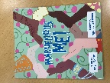  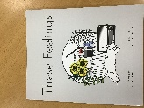  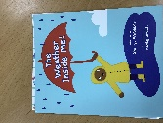  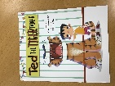 | 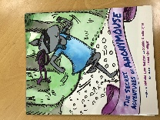  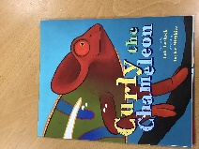  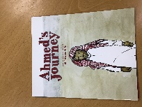  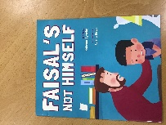 |  | 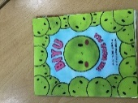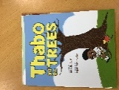  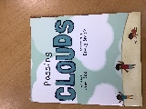  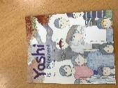 |  | 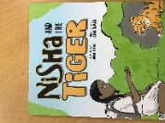  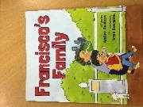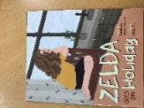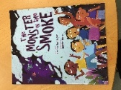 |  | 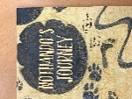  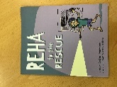  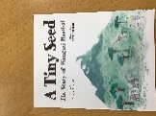 |  | 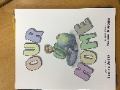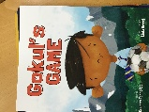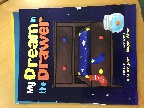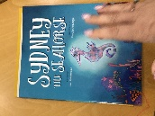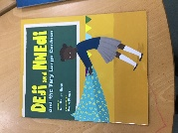
Managing self  Self-regulation  Building relationships
  I understand how it feels to belong and that we are similar and different
  I can start to recognise and manage my feelings
  I enjoy working with others to make school a good place to be
  I understand why it is good to be kind and use gentle hands
  I am starting to understand children’s rights and this means we should all be allowed to learn and play
  I can identify something I am good at and understand everyone is good at different things
  I understand that being different makes us all special
  I know we are all different but the same in some ways
  I can tell you why I think my home is special to me
  I can tell you how to be a kind friend
  I know which words to use to stand up for myself when someone says or does something unkind
  I understand that if I persevere I can tackle challenges
  I can tell you about a time I didn’t give up until I achieved my goal
  I can set a goal and work towards it
  I can use kind words to encourage people
  I understand the link between what I learn now and the job I might like to do when I’m older
  I can say how I feel when I achieve a goal and know what it means to feel proud
  I understand that I need to exercise to keep my body healthy
  I understand how moving and resting are good for my body
  I know which foods are healthy and not so healthy and can make healthy eating choices
  I know how to help myself go to sleep and understand why sleep is good for me
  I can wash my hands thoroughly and understand why this is important especially before I eat and after I go to the toilet
  I know what a stranger is and how to stay safe if a stranger approaches me
  I can identify some of the jobs I do in my family and how I feel like I belong
  I know how to make friends to stop myself from feeling lonely
  I can think of ways to solve problems and stay friends
  I am starting to understand the impact of unkind words
  I can use Calm Me time to manage my feelings
  I know how to be a good friend
  I can name parts of the body
  I can tell you some things I can do and foods I can eat to be healthy
  I understand that we all grow from babies to adults
  I can express how I feel about moving to Year 1
  I can talk about my worries and/or the things I am looking forward to about being in Year 1
  I can share my memories of the best bits of this year in Reception
Reception ELGs for PSED |  | Self-Regulation ELG Children at the expected level of development will: • Show an understanding of their own feelings and those of others, and begin to regulate their behaviour accordingly; • Set and work towards simple goals, being able to wait for what they want and control their immediate impulses when appropriate; • Give focused attention to what the teacher says, responding appropriately even when engaged in activity, and show an ability to follow instructions involving several ideas or actions.  Managing Self ELG Children at the expected level of development will: • Be confident to try new activities and show independence, resilience and perseverance in the face of challenge; • Explain the reasons for rules, know right from wrong and try to behave accordingly; • Manage their own basic hygiene and personal needs, including dressing, going to the toilet, and understanding the importance of healthy food choices.  Building Relationships ELG Children at the expected level of development will: • Work and play cooperatively and take turns with others; • Form positive attachments to adults and friendships with peers; • Show sensitivity to their own and to others’ needs.
The Reception year provides the foundation for PSHE skills children will build upon in Y1-6. |  | In years 1-6 the children will continue the Jigsaw programme to become Cavendish Brilliiant Citizens, showing the school values: kindness, respect, responsibility, positivity, equality and courage.

Reception Curriculum Overview for Physical Development
Educational Programme for Physical development | Physical activity is vital in children’s all-round development, enabling them to pursue happy, healthy and active lives. Gross and fine motor experiences develop incrementally throughout early childhood, starting with sensory explorations and the development of a child’s strength, co-ordination and positional awareness through tummy time, crawling and play movement with both objects and adults. By creating games and providing opportunities for play both indoors and outdoors, adults can support children to develop their core strength, stability, balance, spatial awareness, co-ordination and agility. Gross motor skills provide the foundation for developing healthy bodies and social and emotional well-being. Fine motor control and precision helps with hand-eye co-ordination, which is later linked to early literacy. Repeated and varied opportunities to explore and play with small world activities, puzzles, arts and crafts and the practice of using small tools, with feedback and support from adults, allow children to develop proficiency, control and confidence.
Term | Autumn 1 | Autumn 2 | Spring 1 | Spring 2 | Summer 1 | Summer 2
Reception Physical Development:  Fine Motor | - use a range of tools (pegs, paintbrushes, scissors, pencils, crayons) competently, safely and confidently  - cut straight lines with scissors  -draw circles, horizontal/vertical lines  -use a knife and fork to cut food at lunch time  -draw simple pictures which can be recognised  Penpals F2 Units 1-6  Review and consolidation of dots, straight lines and crosses, circles, waves, loops and bridges, joined straight lines  Letter formation of GPCs: s, a, t, p, i, n, m, d, g, o, c, k, e, u, r taught during phonics session | -form all of the letters in my first name correctly  - position some letters correctly on a line  - move from the four finger and thumb grip to a tripod grip  Penpals F2 Units 7-12  Review and consolidation of angled patterns, eights, spirals, left-to-right orientation  Letter formation of GPCs: h, b, f, l, j, v, w, x, y, z taught during phonics session | -use scissors to cut out a simple shape, independently  -can form recognisable letters for the full alphabet  -develop posture for writing  Consolidation of letter formation for all letters, previously taught through phonics sessions, now taught in groups where letters have same traits  Penpals F2 Unit 13-17 – Long legged Giraffes | -write my first and second name, forming the letters correctly  -move from tripod grip to mature dynamic tripod grip  Consolidation of letter formation for all letters, previously taught through phonics sessions, now taught in groups where letters have same traits  Penpals F2 Unit 18 – 14 one armed robots | -can form all letters correctly  -develop dynamic tripod grip  Consolidation of letter formation for all letters, previously taught through phonics sessions, now taught in groups where letters have same traits  Penpals F2 Unit 25- 31 – Curly caterpillars | -position all letters correctly on a line  -embed mature/dynamic tripod grip  Consolidation of letter formation for all letters, previously taught through phonics sessions, now taught in groups where letters have same traits  Penpals F2 Units 31-36 – zig zag robots
Gross Motor | Introduction to P.E –  To move around safely in space.  To follow instructions and stop safely.  To stop safely and develop control when using equipment.  To follow instructions and play safely as a group.  To follow a path and take turns.  To work co-operatively with a partner. | Gymnastics –  To copy and create shapes with your body.  To be able to create shapes whilst on apparatus.  To develop balancing and taking weight on different body parts.  To develop jumping and landing safely.  To develop rocking and rolling.  To copy and create short sequences by linking actions together. | Dance –  To explore different body parts and how they move.  To explore different body parts and how they move and remember and repeat actions.  To express and communicate ideas through movement exploring directions and levels.  To create movements and adapt and perform simple dance patterns.  To copy and repeat actions showing confidence and imagination.  To move with control and co-ordination, linking, copying and repeating actions. | Fundamentals –  To develop balancing.  To develop running and stopping.  To develop changing direction.  To develop jumping.  To develop hopping.  To explore different ways to travel using equipment. | Ball Skills –  To develop rolling and tracking a ball.  To develop accuracy when throwing to a target.  To develop dribbling with hands.  To develop throwing and catching with a partner.  To develop dribbling a ball with your feet.  To develop kicking a ball to a target. | Games –  To aim when throwing and practise keeping score.  To follow instructions and move safely when play tagging games.  To learn to play against a partner.  To develop co-ordination and play by the rules.  To explore striking a ball and keeping score.  To explore striking a ball and keeping score.
End of reception PE and Gross motor expectations (including ELG)
  Children show good control when running and stopping, changing direction when running, jumping and landing and hopping and landing.
  Children can negotiate space safely with consideration for others.
  Children play ball games with consideration and understanding of the rules.
  Children use ball skills with competence and accuracy and persevere when trying new challenges.
  Demonstrate strength, balance and coordination when playing.
  Move energetically, such as running, jumping, dancing, hopping, skipping and climbing.
  Children combine movements, selecting actions in response to the task and apparatus.
  Children create sequences using shapes, balances and travelling actions including using apparatus.
  Children can confidently and safely use a range of large and small apparatus.
  Children can use movement skills with developing strength, balance and coordination showing control and grace.
  Children are confident to try new challenges and perform in front of others.
  Children can follow instructions involving several ideas or actions.
  Children play games honestly and safely with consideration of the rules and can keep score.
  Children play co-operatively, take turns and encourage others.
  *Negotiate space and obstacles safely, with consideration for themselves and others.
End of reception fine motor expectations |  | Fine Motor Skills ELG Children at the expected level of development will: Hold a pencil effectively in preparation for fluent writing – using the tripod grip in almost all cases. Use a range of small tools, including scissors, paint brushes and cutlery. Begin to show accuracy and care when drawing.
The Reception Year provides the foundation for physical development skills children will build upon in Year one and beyond. |  | Children should master basic movements including running, jumping, throwing and catching, as well as developing balance, agility and co-ordination, and begin to apply these in a range of activities. Children should participate in team games, developing simple tactics for attacking and defending. Children should perform dances using simple movement patterns. All schools must provide swimming instruction either in key stage 1 or key stage 2. In particular, pupils should be taught to: swim competently, confidently and proficiently over a distance of at least 25 metres. Use a range of strokes effectively. Perform safe self-rescue in different water-based situations.

Reception Curriculum Overview for Literacy
Educational Programme for Literacy | It is crucial for children to develop a life-long love of reading. Reading consists of two dimensions: language comprehension and word reading. Language comprehension (necessary for both reading and writing) starts from birth. It only develops when adults talk with children about the world around them and the books (stories and non-fiction) they read with them, and enjoy rhymes, poems and songs together. Skilled word reading, taught later, involves both the speedy working out of the pronunciation of unfamiliar printed words (decoding) and the speedy recognition of familiar printed words. Writing involves transcription (spelling and handwriting) and composition (articulating ideas and structuring them in speech, before writing).
Planning around a quality text | 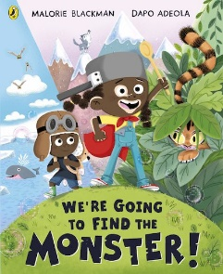  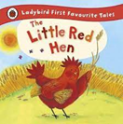 | 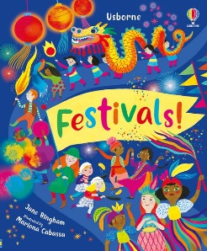  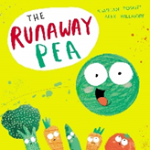 | 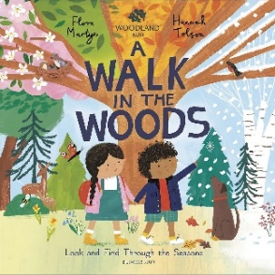  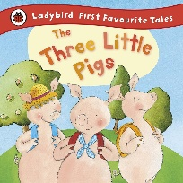 | 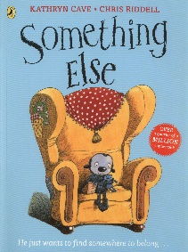  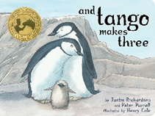 | 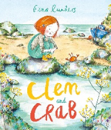  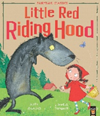 | 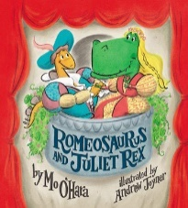  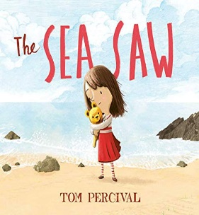
Term | Autumn 1 | Autumn 2 | Spring 1 | Spring 2 | Summer 1 | Summer 2
Comprehension (developing a passion for reading) | -recount simple stories  -answer why questions  -recognise labels in my classroom environment  -talk about my favourite stories and know books are written  -know what an author is | - use the correct vocabulary to name text related concepts (character, setting, beginning, middle and end)  -sequence three or more events from a story  -provide simple reasons for actions and events  -know what an illustrator is | -understand story ‘middles’ e.g problem, event and how they are solved at the end  -show interest in non-fiction books linked to own interests  -verbally retell main events of a well-known story  -know what a blurb is | -begin to reason and explain events, answering ‘how’ questions  -begin to imagine and speculate – ‘what if’ questions.  -peruse books for pleasure and choose books independently  -relate some stories to own experiences  -know what a contents page is | -recount simple stories, looking for patterns and be able to talk about what happened before  -use a contents page | -retell stories in my own words, using recently introduced vocabulary  -use an index page
Word Reading | -read individual letters by saying the sound for them  -blend sounds into words, so I can read short words made up of known letters | -read some letter groups that each represent one sound and say sounds for them  -read a few common exception words matched to the school’s phonics programme | -read simple phrases and sentences made up of words with known letter-sound correspondences, and some common exception words | -reread books to build up confidence in word reading, fluency, understanding and enjoyment | -say a sound for each letter of the alphabet and at least 10 digraphs | -read words that are consistent with phonic knowledge  -read aloud simple sentences and books that are consistent with phonic knowledge, including common exception words
Writing  Physical and technical development  Developing communication and meaning (mastery in bold) | Children have the opportunity to practise their writing skills through a range of activities such as composing, talking, mark-making, dictation and transcription, guided writing, independent writing
 | -write learned graphemes (s, a, t, p, I, n, m, d, g, o, c, k, e, u, r) lower case and upper case  -start to position letters correctly on a line  -sit correctly with good posture when sitting at a table to write  -write simple vc -write CEW’s the, I  -continue to orally rehearse simple sentences supported by adults  -use letters for labels  Begin to  -use some of their print and letter knowledge in their early writing.  -write some or all of their name  -write some letters accurately  -spell words by identifying the sound, then writing the sound with letter/s  -form lower-case letters correctly | -write learned graphemes (h, b, f, ff, l, ll, ss, j, v, w, x, y, z,) lower case and upper case  -use capital letters correctly for my name, I, and beginning of sentences  - move from the four finger and thumb grip to a tripod grip  -begin to form 0-9  -write cvc words  - attempt to write CEW’s he, she, is, to, go, of, as,  Continue to:  -use some of their print and letter knowledge in their early writing. For example: construct captions or simple sentences, writing the initial and end sounds in words  -write some or all of their name  -write some letters accurately  -spell words by identifying the sound, then writing the sound with letter/s  -form lower-case letters correctly  -re-read what they have written to check that it makes sense | -write learned graphemes (zz, qu, ch, sh, th, ng)  -form lower case correctly  -beginning to use full stops and letter spacing  -write short sentences with words with known sound-letter correspondence  - form ‘long-legged giraffe’ letters correctly  - attempt to write CEW’s we, are, you, into, be, me, his, no, so, has  Embed:  -form lower-case letters correctly  -spell words by identifying the sound, then writing the sound with letter/s  -re-read what they have written to check that it makes sense  -write short sentences with words with known sound-letter correspondences | -write learned graphemes (ai, ee, igh, oa, oo, ar)  -position all letters correctly on a line  -form capital letters correctly  -re-read what I have written to check that it makes sense  -move from tripod grip to mature dynamic tripod grip  -form ‘one armed robot letters’ correctly  -develop formation of 0-9  - attempt to write CEW’s her, my, by, our, says, they, said, was, were, put, all, there, like  -use plausible phonetical spelling  of unfamiliar words in my writing  Further embed:  -form lower case letters correctly  -write short sentences with words with known sound-letter correspondence  -spell words by identifying the sounds and then writing the sound with letter/s  -form lower case letters and some capital letters correctly | -write learned graphemes (or, ur, ow, oi, ear)  -use full stops and letter spacing  -develop dynamic tripod grip  -form ‘curly caterpillar’ letters correctly  - attempt to write CEW’s here, where, today, when,  -use a full stop  -use finger spaces  -write short sentences without support  Non-negotiable:  -form lower case letters correctly  -write short sentences with words with known sound-letter correspondence  -spell words by identifying the sounds and then writing the sound with letter/s  -form lower case and capital letters correctly  -write short sentences with words with known sound-letter correspondences using a capital letter and full stop | -write learned graphemes (air, ure, er)  -embed mature/dynamic tripod grip  -form ‘zig-zag monsters’ letters correctly  -securely form 0-9  - attempt to write CEW’s one, once, your, love, house  -extend a short sentence using ‘and’  -read my sentence out loud to an adult  -know an adult will be able to read and understand writing produced  Continue to:  -form lower-case and capital letters correctly  Write short sentences with words with known sound-letter correspondences using a capital letter and full stop
End of Reception ELGs for Literacy | Comprehension ELG Demonstrate understanding of what has been read to them by retelling stories and narratives using their own words and recently introduced vocabulary; Anticipate – where appropriate – key events in stories; Use and understand recently introduced vocabulary during discussions about stories, non-fiction, rhymes and poems and during role-play.  Word Reading ELG Say a sound for each letter in the alphabet and at least 10 digraphs; Read words consistent with their phonic knowledge by sound-blending; Read aloud simple sentences and books that are consistent with their phonic knowledge, including some common exception words.  Writing ELG Write recognisable letters, most of which are correctly formed; Spell words by identifying sounds in them and representing the sounds with a letter or letters; Write simple phrases and sentences that can be ready by others.
Where are they going?  The Reception Year provides the foundation for literacy skills the children will build upon in Year 1  Year 1 Expectations | Writing Composition: Understand what a sentence is and recognise sentences in my own writing. Say sentences out loud orally before writing them down. Create a sequence of sentences to create their own text. Re-read sentences carefully to spot any mistakes. Identify mistakes in their sentences when they are orally read to them. Discuss what they have written to an adult and a peer.  Vocabulary, Grammar & Punctuation: Understand the use of capital letter and full stop and use them accurately. Create question sentences and use a question mark to punctuate correctly. Mark statement and command sentences with an exclamation mark. Understand that nouns are objects, people, and places. Use capital letters for proper nouns: people, places, days of the week and I. Understand the job of an adjective and start to identify them in sentences. Begin to use adjectives to create simple noun phrases. Use talk to organise events and experiences. Write in the present tense To be able to use the conjunctions “and”, “but” and “because” to create compound sentences. Discuss word meaning of new words.  Reading summary: Use the 40 graphemes to decode words accurately. Make simple inferences about the characters and about events. Predict what might happen next from repetitive phrases and/or from what has already been read. Discuss the significance of the title. Identify the events/points from the text. Explain what has just been read to them orally. Answer simple retrieval questions by finding the information in non-fiction and fiction texts.

Reception Curriculum Overview for Mathematics

Educational Programme for Mathematics | Developing a strong grounding in number is essential so that all children develop the necessary building blocks to excel mathematically. Children should be able to count confidently, develop a deep understanding of the numbers to 10, the relationships between them and the patterns within those numbers. By providing frequent and varied opportunities to build and apply this understanding - such as using manipulatives, including small pebbles and tens frames for organising counting - children will develop a secure base of knowledge and vocabulary from which mastery of mathematics is built. In addition, it is important that the curriculum includes rich opportunities for children to develop their spatial reasoning skills across all areas of mathematics including shape, space and measures. It is important that children develop positive attitudes and interests in mathematics, look for patterns and relationships, spot connections, ‘have a go’, talk to adults and peers about what they notice and not be afraid to make mistakes.
Term | Autumn 1 |  | Autumn 2 | Spring 1 | Spring 2 |  | Summer 1 | Summer 2
Picture books and rhymes used to enrich mathematics | 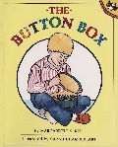  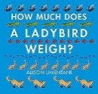  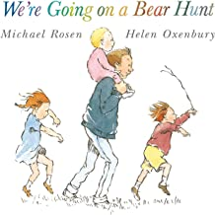  One finger one thumb, Two Little Dickie Birds  1,2,3,4,5 once I caught a fish alive.  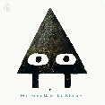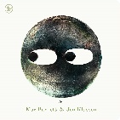 |  | Grand Old Duke of York, Hokey Cokey  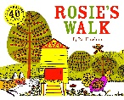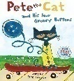  5 little men in a flying saucer  1, 2, 3, 4, 5 once I caught a fish alive  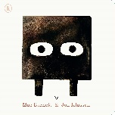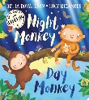  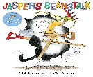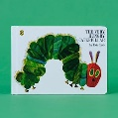 | 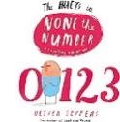  5 little monkeys  5 currant buns  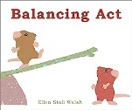  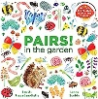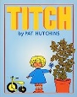  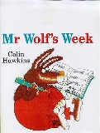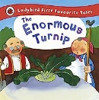 | Number bond song to tune of Row row row your boat  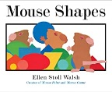  5 little monkeys  10 green bottles  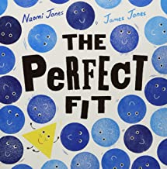 |  | Ten green bottles  10 fat sausages | 10 fat sausages  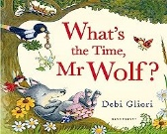  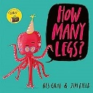
Number and Numerical Patterns | Pupils will build on previous experiences of number from their home and nursery environments, and further develop their subitising and counting skills. They will explore the composition of numbers within 5. They will begin to compare sets of objects and use the language of comparison.  -identify when a set can be subitised and when counting is needed  -subitise different arrangements, both unstructured and structured, including using the Hungarian number frame  - make different arrangements of numbers within 5 and talk about what they can see, to develop their conceptual subitising skills  spot smaller numbers ‘hiding’ inside larger numbers |  |  | Pupils will continue to develop their subitising and counting skills and explore the composition of numbers within and beyond 5. They will begin to identify when two sets are equal or unequal and connect two equal groups to doubles. They will begin to connect quantities to numerals.  -continue to develop their subitising skills for numbers within and beyond 5, and increasingly connect quantities to numerals  -begin to identify missing parts for numbers within 5  explore the structure of the numbers 6 and 7 as ‘5 and a bit’ and connect this to finger patterns and the Hungarian number frame  -focus on equal and unequal groups when comparing numbers  -understand that two equal groups can be called a ‘double’ and connect this to finger patterns  -sort odd and even numbers according to their ‘shape’  -continue to develop their understanding of the counting sequence and link cardinality and ordinality through the ‘staircase’ pattern  -order numbers and play track games  -join in with verbal counts beyond 20, hearing the repeated pattern within the counting numbers |  | -continue to develop their counting skills, counting larger sets as well as counting actions and sounds  -explore a range of representations of numbers, including the 10-frame, and see how doubles can be arranged in a 10-frame  -compare quantities and numbers, including sets of objects which have different attributes  -continue to develop a sense of magnitude, e.g. knowing that 8 is quite a lot more than 2, but 4 is only a little bit more than 2  -begin to generalise about ‘one more than’ and ‘one less than’ numbers within 10  -continue to identify when sets can be subitised and when counting is necessary  -develop conceptual subitising skills including when using a rekenrek
  -connect quantities and numbers to finger patterns and explore different ways of representing numbers on their fingers
  -hear and join in with the counting sequence, and connect this to the ‘staircase’ pattern of the counting numbers, seeing that each number is made of one more than the previous number
  -develop counting skills and knowledge, including: that the last number in the count tells us ‘how many’ (cardinality); to be accurate in counting, each thing must be counted once and once only and in any order; the need for 1:1 correspondence; understanding that anything can be counted, including actions and sounds
  -compare sets of objects by matching
  -begin to develop the language of ‘whole’ when talking about objects which have parts
  Pupils will consolidate their counting skills, counting to larger numbers and developing a wider range of counting strategies. They will secure knowledge of number facts through varied practice.
Shape, Space and Measure | -select, rotate and manipulate shapes – circles and triangles  -continue, copy and create repeating patterns AB, ABB  -Spatial awareness  -Positional language  -Comparing amounts/size/mass/capacity  -Using balance scales | -make a direct comparison using tall and short  -understand and use the language next to, between, below, above, under, in front of, behind, close to, far away  -identify straight and curved sides on 2D shapes  -Shapes with 4 sides  -Combining shapes |  | -make my own ABBC pattern  -understand morning, afternoon, day, night  -order a simple sequence of events  -identify flat and curved sides on 3D shapes  -Compare mass  -use language and make direct comparisons of capacity  -Balancing numicon  -Length and height | -identify and name 3D shapes (cylinder, cube, cuboid, sphere) and talk about their properties  -Pattern  -Sorting and matching  -Comparing and ordering | -understand and use the language: forwards, backwards, sideways, through, above, below, opposite |  |  | -create a pattern that has a fixed number of spaces  -understand and use the language near, far, direction, left, right, towards, fast, slow, nearest, furthest  -use language and make direct comparisons of weight
Vocabulary | match, sort, compare, pair, same, size, shape, different, many, few, odd, altogether, count, more, less, fewer, least, most, total, number, groups, more, amounts, height, width, estimate, guess, big, small, larger, smaller, many, patterns, repeat, repeating, first, then, next, add, plus, equals, numerals, symbols, circle, curve, side, medium, triangle, straight, 1, 2, 3, | in, on, under, over, above, below, next to, out, behind, in front, up, down, beside, 4, 5, more than, square, 10 frame, take away, one less, triangle, corners, rectangle, today, tomorrow, weekend, days, Monday, Tuesday, Wednesday, Thursday, Friday, Saturday, Sunday, week, night, day, light, dark, time, flat, 2D shape, after, yesterday, evening, later, morning, afternoon |  | Numeral, count, oval shape, round, zero, letter O, before 1, empty, nothing, none, none left, how many more, What happens..?, why? Weight, heavier, lighter, heavy, light, medium, explain, balance, scales, heaviest, lightest, capacity, hold, size, empty, full, half, pour, fill, predict, too much, too little, enough, not enough, overflow, record, nearly empty, fill, fullest, emptiest, measure, total, share, score, number line, tens frame, arrangement, exact, mix up, random, part, whole, model | 8 o’clock, Midday, 3 o’clock, 7 o’clock, Time, hands, timer, clock biggest, smallest, shortest, longest, score, minutes, hours, o’clock, Clock, missing, number bonds, counting on, left, semi-circle, 3D solid, flat, face, round, straight, cube cuboid, cylinder, prism, cone, subitise, fair, forwards, backwards, wider, narrow | Before, next, after, start, end, enough, in between, digit, represent, explore, timer, choice, mistake, correct, rule, first, then, now, subtract, subtraction, minus, number track, middle, copy, double, doubling, half, having |  |  | Up, down, across, check, close, 100 square, odd, even, remaining, route, around, through, over, under, start, finish, map, location, change, position, direction, inside, outside, identify, continue
In addition to daily adult led maths sessions, children will be exposed to mathematical vocabulary and mathematical experiences and challenges in the indoor and outdoor classrooms. Through well-chosen resources, children will be able to play what they know in a purposeful way whilst learning. All vocabulary highlighted in red appear in the Year 1 vocabulary list.

End of Reception ELG for Number and Numerical Patterns and Cavendish expectations for SSM | Number - Have a deep understanding of number to 10, including the composition of each number. Subitise (recognise quantities without counting) up to 5. Automatically recall (without reference to rhymes, counting or other aids) number bonds up to 5 (including subtraction facts) and some number bonds to 10, including double facts.  Numerical Patterns - Verbally count beyond 20, recognising the pattern of the counting system. Compare quantities up to 10 in different contexts, recognising when one quantity is greater than, less than or the same as the other quantity. Explore and represent patterns within numbers up to 10, including evens and odds, double facts and how quantities can be distributed equally.  Spatial Awareness – Be able to give directions and describe what they see. Be able to turn and flip objects. Be able to make maps with imagination.  Shape – Be able to use informal shape language. Be able to make shapes from other shapes.  Pattern – Be able to spot pattern in the environment. Be able to choose loose parts to create repeating patterns.  Measures – Be able to carry out problem solving with measuring. Measure using time. Use measuring tools in play. Order and sequence events using everyday language.
The Reception Year provides the foundation for mathematical skills the children will build upon in Year one.  Where are they going?  Y1 Expectations: | Number and place value (within 20): use the language of: equal to, more than, less than (fewer), most, least Identify and represent numbers using objects and pictorial representations including the number line  Addition and subtraction (within 20)  (addition and subtraction Read, write and interpret mathematical statements involving addition (+), subtraction (-) and equals (=) sign  Read and write numbers from 1 to 20 in numerals and words  Number and place value (within 100): Begin to recognise the place value of each digit in a two-digit number (tens, ones)  Fractions: Recognise, find and name a half as one of two equal parts of an object, shape or quantity  Fractions: Recognise, find and name a quarter as one of four equal parts of an object, shape or quantity  Multiplication and Division: count in multiples of twos, fives and tens solve one-step problems involving multiplication and division, by calculating the answer using concrete objects, pictorial representations  Comparing & Estimating: compare, describe and solve practical problems for: lengths and heights , mass/weight, time  Number Bonds: Represent and use number bonds and related subtraction facts within 20  Shape: Recognise and name common 2-D and 3-D shapes,  Positional Language: Describe position, direction and movement, including half, quarter and three quarter turns  Money: Recognise and know the value of different denominations of coins and notes  Time: Tell the time to the hour and half past the hour Recognise and use language relating to dates, including days of the week, weeks, months and years

Reception Curriculum Overview for Understanding the World - Past and Present
Educational Programme for Understanding the World | Understanding the world involves guiding children to make sense of their physical world and their community. The frequency and range of children’s personal experiences increases their knowledge and sense of the world around them – from visiting parks, libraries and museums to meeting important members of society such as police officers, nurses and firefighters. In addition, listening to a broad selection of stories, non-fiction, rhymes and poems will foster their understanding of our culturally, socially, technologically and ecologically diverse world. As well as building important knowledge, this extends their familiarity with words that support understanding across domains. Enriching and widening children’s vocabulary will support later reading comprehension.
In EYFS the teaching of historical concepts is not limited to taught sessions, but are taught through high quality teaching and learning experiences throughout the provision. | 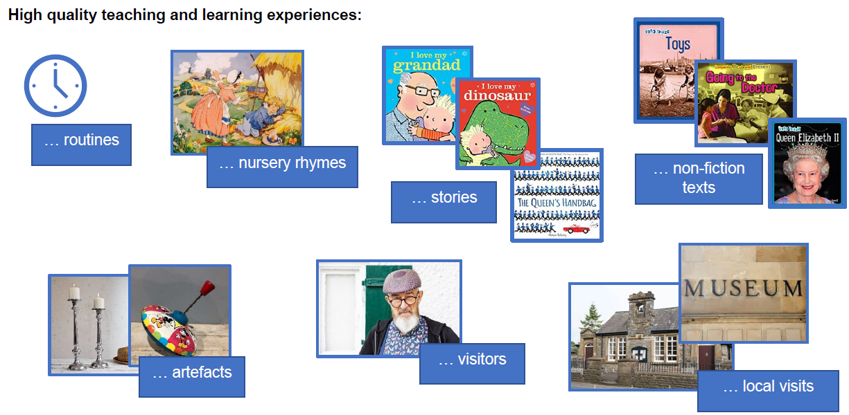
Key Theme: Chronology

Progression in Learning | The Big Picture of Events Across Time: - Understand, follow and talk about the daily routine using a visual timetable - Begin to understand that their birthday and some key festivals are annual and take place at different times of the year - Know that across the year there are four seasons - Understand and interact with a timeline that represents the school year e.g. showing birthdays, festivals, trips and other significant events - Begin to develop an understanding of past and present  Sequence: - Predict what might happen next within the daily routine with some accuracy and understanding - Develop an understanding of the repeating sequence of seasons - Understand, predict and talk about key events to complete an activity e.g. how to complete an independent Weekly Challenge - Identify and talk about the beginning, middle and end of stories - Sequence key events within a story and give reasons / begin to innovate familiar stories (i.e with an alternative sequence of events) - Use sequencing vocabulary e.g. before / next / after / finally - Recite numbers beyond 10 within the context of nursery rhymes and counting up to 10 objects - Recognise, sequence, correct and create a repeating pattern  Duration: - Understand the difference between a day and a week, and the structure of their week (5 days in school and 2 days at home during the weekend) - Begin to understand the length of a school holiday e.g. short / long holiday; one week / two weeks - Begin to use comparative language to measure time, and use tools to measure time e.g. sand timer / timers / stopwatch - Recite the days of the week and begin to recite the months of the year - Begin to talk about the amount of time until an event e.g. 6 more sleeps before my birthday  Sense of period: - Understand that their parents and grandparents were once babies and children (Own life story and family history) - Begin to recognise the change, similarities and differences within specific periods of time e.g. toys used by themselves / parents / grandparents (Own life-story and family history) - Develop a sense of ‘a long time ago’ and talk about similarities and differences between the past and present e.g. dinosaurs - Recognise that things happened before they were born e.g. rocket going to the moon - Begin to develop an understanding of past and present (The Big Picture of Events Across Time)
Key Learning Experiences across Reception | ▪ The Big Picture & Events Across Time: * Daily Routines – □ Use a visual timetable – encourage children to use this to predict what they will be doing next □ Consolidate words such as later / after /next □ Role play daily school and home routines - with increased attention to the sequence of events * Independent Challenges – □ Talk about and explain the order of what they need to do in their independent challenges □ * Seasons – □ Name and sequence the seasons □ Talk about what happens in the natural world in each season □ Seasonal clothes in the role play area  ▪ Sequencing – through Stories and Maths: * Stories – □ Identify and talk about the beginning, middle and end of the story. □ Sequence a series of pictures or props from a familiar story □ Retell stories using: actions; a simple story map/mountain (with beginning, middle and end); words such as before, next, after, finally □ Innovate stories – talking about the consequence of changing one event /character / setting on the rest of the story * Extend repertoire of number rhymes □ represent numbers with fingers □ act the rhymes out □ use props and pictures * Explore patterns –- using e.g. natural resources, objects/toys, beads / cubes, paint / collage etc □ recognise □ repeat □ correct errors □ create, □ talk about describe patterns / talk about the rule of the pattern – using words such as next, before, after, middle, between  ▪ Time / Duration: * Calendars – □ Begin to use a simple monthly calendar, showing each day and week (role play) * Months of the year – □ Sing songs to recite the months of the year □ Count how many months until their birthday or special festival * Measuring time e.g. for turn on a bike or completing an obstacle course etc, using □ counting □ sand /egg timer □ stop watch ▪ How I Have Changed Over Time & Things That Happened Before I Was Born: * How Have I changed Over Time - □ See also ‘Own Life Story and Family History’ □ Use words such as a long time ago / ancient  ▪ Sing Songs: Consolidate songs from previous years and continue to extend repertoire □ Ten Green Bottles □ Months of the year □ Time for Another Year (https://learnenglishkids.britishcouncil.org/songs/time-another-year)  Texts will be linked to The Natural World (Seasons)
Key Theme: Own Life-story and Family History (Autumn 1)

Progression in Learning
  ▪ Talk about their immediate family - Develop an awareness of who is in their extended family e.g. grandparents, aunts, uncles, cousins - Develop an awareness of different types of families - Share key family events / celebrations
  ▪ Name and describe people who are familiar to them - Understand that their parents were once babies and children (Chronology: Sense of Period)
  ▪ Know some similarities and differences between things in the past and now (linked to own family and experiences) - Begin to recognise the change, similarities and differences within specific periods of time e.g. toys used by themselves / parents / grandparents (Chronology: Sense of Period)
  ▪ Talk about the lives of the people around them and their roles in society (Linked to RE)- Develop an awareness of roles, present and past, in the local community / society e.g. jobs / voluntary
Key Learning Experiences across Reception | All about me: □ Share baby / toddler photographs. Match the baby / toddler (past) to now photographs (present) □ (ii) baby clothes to present clothes □ grandparent stay and play.  ▪ My family: * My extended family - □ Share family photographs including extended family members e.g. aunts / cousins □  ▪ Creating and sharing memories … let’s remember / my history * A special event - □ Talk about upcoming class / school events and share any linked previous experiences e.g. what happened in nursery on World Book Day last year. This could include revisiting nursery class. * My birthday - □ Birthday display □ Celebrate practitioner birthdays □ Practitioners share photographs / stories of own birthday celebrations when a child – what is the same / different? * Imaginative Play - □ Domestic role to re-enact: (i) everyday family events (ii) different seasons (iii) special events / celebrations (iiii) babies with accessories, clothes and toys  ▪ Sing songs: □ Finger Family □ Happy Birthday in different languages  Linked Texts: □ When's My Birthday? - Julie Fogliano and Christian Robinson □ The Great Big Book of Families – Mary Hoffman
Key Theme: Figures / Characters, Settings and Events from the Past (Spring 1)

Progression in Learning | ▪ Compare and contrast characters from stories, including figures from the past.  - Become familiar with fictional stories and rhymes set in the past  - Become familiar with simple non-fiction texts about some significant figures from the past  ▪ Understand the past through settings, characters and events encountered in books read in class and storytelling.  - Begin to talk about similarities and differences between the lives of character’s / figure’s and their own
Key Learning Experiences across Reception | ▪ Nursery rhymes / stories □ Sing rhymes and read stories with illustrations and actions □ Look carefully at linked illustrations □ Compare and contrast the past with now using illustrations / photographs: (i) own life with that of main character e.g. what the characters are wearing – Little Boy Blue; jobs the children are doing, Jack and Jill; fetching water from the well, Miss Polly had a Dolly; doctor coming to the house and needing paying □ Stories linked to: (i) dinosaurs – continued from nursery (ii) introduce stories linked to royalty – princes, princesses and knights □ Small world fossil hunt □ Small world play – castles  ▪ Non-fiction texts – figures □ Read-aloud of non-fiction texts e.g. the Queen, Anne Bonnie / Edward Teach – famous pirates □ Watch linked video clips □ Read-a-loud of non-fiction texts  ▪ Sing songs: □ Nursery rhymes; Jack and Jill, Little Boy Blue, Miss Polly had a Dolly, Portside Pirates  Linked Texts: □ The Princess and the Pea □ There’s a Triceratops in the house □
Key Theme: Familiar Situations from the Past (Similarities and Differences)

Progression in Learning
  - Develop an understanding of when events are taking place or have taken place i.e. past, present or future
  - Talk about past, present and future events and experiences using the correct tense
  - Understand and interact with a timeline that represents the school year e.g. showing birthdays, festivals, trips and other significant events (Chronology: The Big Picture of Events Across Time)
  - Talks about past and present events in their own life and in the lives of family members
  ▪ Comment on images of familiar situations in the past
  - Linked to personal experiences e.g. different birthdays / favourite toys
  - Identifying and talking about similarities and differences between past and present e.g. home / school / transport / local area
  ▪ Talk about the lives of the people around them and their roles in society
  - Begin to develop an awareness of how some familiar roles have changed over time
  ▪ Know some similarities and differences between things in the past and now, drawing on their experiences and what has been read in class
Key Learning Experiences across Reception
  ▪ Past, present and future events: * Timelines – □ See Chronology activities / experiences □ Regularly engage with the class timeline – encouraging children to talk about past, present and future events (model and scaffold the correct use of tenses) □ Ask children questions to help them to compare and past events, identifying similarities and differences between events □ Talk about what happened recently / yesterday and what happened long ago e.g. starting school
  ▪ Familiar situations in the past (similarities and differences): * Home –□ Use vocabulary such as ‘used to’ and ‘old fashioned’, ‘traditional’ □ Home learning Questionnaire (Ask a Grandparent) □ Ask children what their favourite toys are. Then ask their grandparents about their favourite toys when they were little. What was the same? What was different? □ Use the story of Major Glad, Major Dizzy to discuss how toys have changed over time
  ▪ Roles in society: * Present – □ Throughout the year, introduce the children to roles in the society, linked to their focus topics / texts * Past – □ Use stories and nursery rhymes to talk about how some roles have changed □ Learn the Nursery Rhymes such as ‘Muffin Man’ and ‘Cobbler, Cobbler’ and explain who the muffin man and cobbler were
  ▪ Sing songs: □ Muffin Man □ Cobbler, Cobbler
  Linked Texts: □ Major Glad, Major Dizzy
Learning through adult led sessions |  | Autumn 1  Own life story and family history | Autumn 2 | Spring 1  Figures / Characters, Settings and Events from the Past | Spring 2 | Summer 1  Familiar Situations from the past | Summer 2
Learning through adult led sessions | Text | -When's My Birthday? by Julie Fogliano  -The Great Big Book of Families by Mary Hoffman |  | -The Princess and the Pea  -Non-fiction texts/ videos about Queen Elizabeth II and a famous Pirate  - There’s a Triceratops in the House |  | -Major Glad, Major Dizzy
Learning through adult led sessions | Rhyme | -Finger family  -Happy birthday in different languages |  | -Miss Polly Had a Dolly  -Jack and Jill  -Little Boy Blue  -Portside Pirates | - | -Muffin Man  -Cobbler Cobbler
Learning through adult led sessions | Pictures | - Family photos  - Photos of parents as babies  -Photos of children and teachers as a baby, toddler and now.  -Pictures/ Videos of birthday celebrations |  | -Comparing traditional illustrations with modern day (Princess and the pea) |  | -Photos and artefacts of traditional toys/ modern toys  - First day of school photos
Learning through adult led sessions | Goals | -I know how I have changed since I was a baby  - I can order the events of my life (Baby, toddler, now)  - I can talk about who is in my family  -I know what is unique about my family  -I know that my parents used to be babies.  - I know how birthdays can be celebrated. |  | -I can use nursery rhymes to talk about the past  -I can use stories to talk about the past (The Princess and the Pea)  -I know that Queen Elizabeth II used to rule England  -I can talk about a pirate from the past  -I know that dinosaurs are from the past |  | -I can use a timeline to talk about my year in Reception  -I know an event that happened in my past  -I know some events that will happen in the future  -I can use nursery rhymes to talk about how some jobs have changed over time  -I know that toys have changed over time  -I know the difference between traditional and modern toys
The Reception Year provides the foundation for past and present/history skills children will build upon in Year one. |  | The History National Curriculum (2014) states that… Changes within living memory. Where appropriate, these should be used to reveal aspects of change in national life, events beyond living memory that are significant nationally or globally  the lives of significant individuals in the past who have contributed to national and international achievements. Some should be used to compare aspects of life in different periods. Significant historical events, people and places in their own locality.

Reception Curriculum Overview for People, Culture and Communities
Educational Programme for Understanding the World | Understanding the world involves guiding children to make sense of their physical world and their community. The frequency and range of children’s personal experiences increases their knowledge and sense of the world around them – from visiting parks, libraries and museums to meeting important members of society such as police officers, nurses and firefighters. In addition, listening to a broad selection of stories, non-fiction, rhymes and poems will foster their understanding of our culturally, socially, technologically and ecologically diverse world. As well as building important knowledge, this extends their familiarity with words that support understanding across domains. Enriching and widening children’s vocabulary will support later reading comprehension.

The Natural World and People, Culture and Communities (links to Geography) | Autumn 1 | Autumn 2 | Spring 1 | Spring 2 | Summer 1 | Summer 2
The Natural World and People, Culture and Communities  (Geography) objectives | Forest school -Seasonal weather and effects on environment, clothes, activities in Autumn  Draw pictures of their houses, school and places they know.  Talk about children’s journey to and from school and draw a map of the things they see on the way to school | Forest school  Through stories and pictures recognise some similarities and differences between life in this country and life and celebrations in India (Diwali) | Forest school Seasonal weather and effects on environment, clothes, activities in winter  Learn about and meet people who help us in the community through asking questions, first-hand experience and showing interest in different occupations. | Forest school Seasonal weather and effects on environment, clothes, activities in spring  Children to be aware of where the different areas of the school are.  Explore local area eg walks around locality including to church and mosque (links to RE) | Increase their knowledge of a range of animals to include animals from a pond/water habitat.  Visit a pond/water habitat and explore the features of the animals that live there and suggest possible reasons why. | Forest school Seasonal weather and effects on environment, clothes, activities in summer  Use a globe and ICT to identify the location of holiday destinations.  Understand how we get to different destinations  (transport)  Link to ICT curriculum – using ICT for a purpose
People, Culture and Communities ELG Describe their immediate environment using knowledge from observation, discussion, stories, non-fiction texts and maps; Know some similarities and differences between different religious and cultural communities in this country, drawing on their experiences and what has been read in class; Explain some similarities and differences between life in this country and life in other countries, drawing on knowledge from stories, non-fiction texts and – when appropriate – maps.
The Reception Year provides the foundation for the natural world and people, culture and community/geography skills children will build upon in Year one. | Pupils should develop knowledge about the world, the United Kingdom and their locality. They should understand basic subject-specific vocabulary relating to human and physical geography and begin to use geographical skills, including first-hand observation, to enhance their locational awareness.
People, culture and communities (linked to Geography) | Autumn 1 | Autumn 2 | Spring 1 | Spring 2 | Summer 1 | Summer 2
Text, pictures and rhyme | 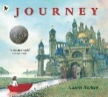 | 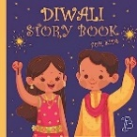 | 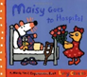  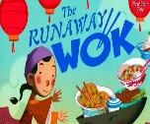 | 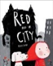  Maps of classroom and school  Local area photos and maps | 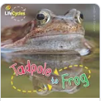 | 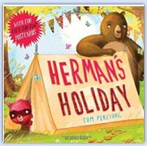  I do like to be beside the seaside
The Natural World ELG Explore the natural world around them, making observations and drawing pictures of animals and plants; Know some similarities and differences between the natural world around them and contrasting environments, drawing on their experiences and what has been read in class; Understand some important processes and changes in the natural world around them, including the seasons and changing states of matter.

People, Culture and Communities linked to R.E | Autumn 1 | Autumn 2 | Spring 1 | Spring 2 | Summer 1 | Summer 2
People, Culture and Communities  (R.E) objectives | Which people are special and why?  -to talk about how they themselves are special  -begin to know about the beliefs of a person from a religious community  -listen to stories from religious communities  -recognise that stories about Jesus are special to Christians | Which times are special and why?  -recall simple stories connected with Diwali and Christmas  -say why Diwali, Sukkot and Christmas are special times for believers  -hold conversations about special religious times using new vocabulary  -talk about the lives of other people using simple ideas about how celebrations are valued  -talk about information on the festivals of different religious communities of the UK | Which stories are special and why?  -know that some stories are special to people and the reasons why  -name and identify features of the Bible  -listen to a religious story  -know that religious stories have meaning  -know that there are similarities and differences between religious communities in this country  -name and identify features of the Qur’an | What is special about our world?  -to have a developing awareness of their feelings towards the natural world and creation and be sensitive to those of others  -know that many Christians and Muslims believe they should care for the earth | Which places are special and why?  -explore, observe and find out about places that matter in Christianity  -know that a mosque is a religious building where Muslims pray  -name a range of features of a mosque and a church  -look for and talk about similarities and differences between two places of worship | Where do we belong?  -recognise symbols or badges which show belonging, including religious symbols  -have a developing respect for the way that their family and other families welcome a baby  -explore, observe and find out about objects that matter in Hinduism
People, Culture and Communities ELG Describe their immediate environment using knowledge from observation, discussion, stories, non-fiction texts and maps; Know some similarities and differences between different religious and cultural communities in this country, drawing on their experiences and what has been read in class; Explain some similarities and differences between life in this country and life in other countries, drawing on knowledge from stories, non-fiction texts and – when appropriate – maps.
The Reception Year provides the foundation for the people, culture and community/R.E skills children will build upon in Year one. | In year 1 the children will continue the Manchester Sacre programme to become Cavendish Brilliant Citizens, gaining further knowledge and understanding of varying religious beliefs, and answering the questions: Who is a Christian and what do they believe? What makes some places  sacred? How and why do we celebrate special and sacred times? What does it mean to belong to a faith?

Reception Curriculum Overview for Understanding the World – The Natural World
Educational Programme for Understanding the World | Understanding the world involves guiding children to make sense of their physical world and their community. The frequency and range of children’s personal experiences increases their knowledge and sense of the world around them – from visiting parks, libraries and museums to meeting important members of society such as police officers, nurses and firefighters. In addition, listening to a broad selection of stories, non-fiction, rhymes and poems will foster their understanding of our culturally, socially, technologically and ecologically diverse world. As well as building important knowledge, this extends their familiarity with words that support understanding across domains. Enriching and widening children’s vocabulary will support later reading comprehension.

The Natural World ELG Explore the natural world around them, making observations and drawing pictures of animals and plants; Know some similarities and differences between the natural world around them and contrasting environments, drawing on their experiences and what has been read in class; Understand some important processes and changes in the natural world around them, including the seasons and changing states of matter.
The Natural World linked to Science | Autumn 1 | Autumn 2 | Spring 1 | Spring 2 | Summer 1 | Summer 2
Text, pictures and rhyme | 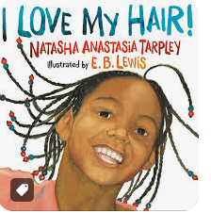  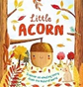  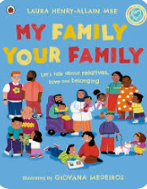  Heads, shoulders. Knees and toes | 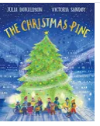  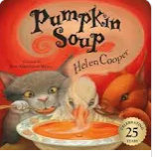  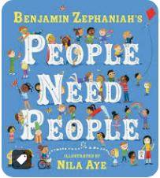 | 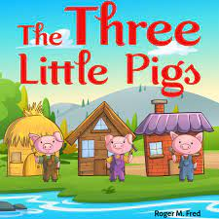  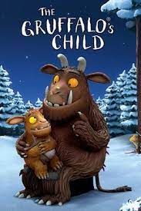  I’m going to build a house, This is the House that Jack built, London Bridge is falling Down  houses/different materials  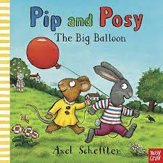 | 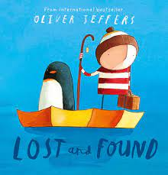  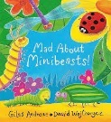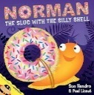  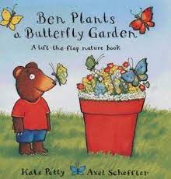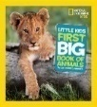  Walking in the Jungle, The animal fair, The Habitat Song-Youtube, Incey,Wincey Spider,  Ladybird, Ladybird Fly Away home  Maps, Habitats | Tiny Tim, Wind the Bobbin Up  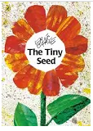  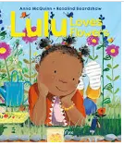 |   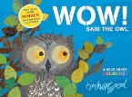  Twinkle, twinkle little star, Star light, star bright, This little light of mine  Chalk outlines/shadows
The Natural World (Science) objectives  Seasons-ongoing throughout the year | Humans  Talk about members of their immediate family and community.  Learn the names of and identify body parts- chin, cheeks, neck, shoulders, elbows, knees, ankles, knuckles | Humans  Name and describe people who are familiar to them.  Understand the body parts which are linked to the senses  Know the senses  Explore the senses | What are things made from?  Explore the natural world around them.  Describe what they see, hear and feel whilst outside.  Group/sort found materials according to children’s own criteria  Understand what waterproof means  Test materials to check if they are waterproof | Animals/Living Things and Habitats  Recognise some environments that are different to the one in which they live.  Understand key features of lifecycle of frog  Name animals and their young | Plants  Plant sunflowers, potatoes, tomatoes  Understand the key features of the life cycle of a plant | Light  Recognise that they need light in order to see things.  To identify shadows and how they are formed.  Learn earth and space vocab – sun, moon, stars, night, day
The Natural World ELG Explore the natural world around them, making observations and drawing pictures of animals and plants; Know some similarities and differences between the natural world around them and contrasting environments, drawing on their experiences and what has been read in class; Understand some important processes and changes in the natural world around them, including the seasons and changing states of matter.

The Reception Year provides the foundation for the natural world/science skills children will build upon in Year one. Where are they going? | Working scientifically: Asking simple questions and recognising that they can be answered in different ways. Observing closely, using simple equipment. Performing simple tests Identifying and classifying. Using their observations and ideas to suggest answers to questions. Gathering and recording data to help in answering questions.  Plants: identify and name a variety of common wild and garden plants, including deciduous and evergreen trees ♣ identify and describe the basic structure of a variety of common flowering plants, including trees.  Animals, including humans: Identify and name a variety of common animals including fish, amphibians, reptiles, birds and mammals. Identify and name a variety of common animals that are carnivores, herbivores and omnivores  Everyday materials: Distinguish between an object and the material from which it is made. Identify and name a variety of everyday materials, including wood, plastic, glass, metal, water, and rock. Describe the simple physical properties of a variety of everyday materials. Compare and group together a variety of everyday materials on the basis of their simple physical properties.  Seasonal changes: Observe changes across the four seasons. Observe and describe weather associated with the seasons and how day length varies.

Reception Curriculum Overview for Computing

Educational Programme for Computing in EYFS | Computing and technology are vitally important subjects to deliver to EYFS children. Not only will teaching a well-planned Computing curriculum ensure that children enter Key Stage 1 with a strong foundation of knowledge, but Computing lessons in the EYFS also ensure that children develop listening skills, problem-solving abilities and thoughtful questioning — as well as improving subject skills across the seven areas of learning. We live in a technological world and there is no escape from the reality that technology is integrated into the lives of young children. Just as we ensure the children in our care are ready for the adult world by teaching them maths and literacy, we also make sure that they are fluent in computer literacy and all-important e-safety. Our computing lessons for EYFS are centred around play-based, unplugged activities that focus on building children’s listening skills, curiosity and creativity and problem solving. While there is no longer a specific technology strand, the skills learned in computing lessons will ensure progression across all other subjects.
 | Autumn 1 | Autumn 2 | Spring 1 | Spring 2 | Summer 1 | Summer 2
 | Computing/technology through provision:  Technology in the Early Years can mean: taking a photograph with a camera or tablet, searching for information on the internet, playing games on the interactive whiteboard, exploring an old typewriter or other mechanical toys, using a Beebot, watching a video clip, listening to music. Allowing children the opportunity to explore technology in this carefree and often child-led way, means that not only will they develop a familiarity with equipment and vocabulary but they will have a strong start in key stage 1 Computing and all that it demands. | Computing systems  and networks:  Using a computer  -learn what a keyboard is and how to locate relevant keys.  -learn to log in and out.  -learn what a mouse is and developing control when using a mouse.  -develop basic mouse skills, including moving and clicking and using an online paint tool.  -develop basic mouse skills, including moving and clicking and using an online paint tool. | Computing/technology through provision:  Technology in the Early Years can mean: taking a photograph with a camera or tablet, searching for information on the internet, playing games on the interactive whiteboard, exploring an old typewriter or other mechanical toys, using a Beebot, watching a video clip, listening to music. Allowing children the opportunity to explore technology in this carefree and often child-led way, means that not only will they develop a familiarity with equipment and vocabulary but they will have a strong start in key stage 1 Computing and all that it demands. | Hardware:  -explore and tinker with different hardware and are introduced to the relevant vocabulary.  -explore and tinker with hardware and identify where technology is used in places that they are familiar with, such as homes and  school.  -learn to operate a basic camera to take photographs of their independent play.  -further develop their photography skills, taking photographs of their discoveries on a walk around the school grounds.  -work with an adult to take selfie photographs to create a class gallery. | Computing/technology through provision:  Technology in the Early Years can mean: taking a photograph with a camera or tablet, searching for information on the internet, playing games on the interactive whiteboard, exploring an old typewriter or other mechanical toys, using a Beebot, watching a video clip, listening to music. Allowing children the opportunity to explore technology in this carefree and often child-led way, means that not only will they develop a familiarity with equipment and vocabulary but they will have a strong start in key stage 1 Computing and all that it demands. |  | Programming:  Bee-bots  -learn the meaning of directional arrows and follow a simple sequence of instructions.  -experiment with programming a Bee-Bot/Blue-Bot and tinker with hardware to develop familiarity and introduce relevant  vocabulary.  -experiment with programming a Bee-bot/Blue-bot and to learn how to give simple commands.  -follow an algorithm as part of an unplugged game and learn to debug instructions when things go wrong.  -experiment with programming a Bee-Bot/Blue-Bot and learn how to give simple commands.  -understand how to debug  instructions, with the help of an adult, when things go wrong.

Reception Curriculum Overview for Expressive Arts and Design (Art, DT, Music, Roleplay)

Educational Programme for Expressive Arts and Design | The development of children’s artistic and cultural awareness supports their imagination and creativity. It is important that children have regular opportunities to engage with the arts, enabling them to explore and play with a wide range of media and materials. The quality and variety of what children see, hear and participate in is crucial for developing their understanding, self-expression, vocabulary and ability to communicate through the arts. The frequency, repetition and depth of their experiences are fundamental to their progress in interpreting and appreciating what they hear, respond to and observe.
Term | Autumn 1 | Autumn 2 |  | Spring 1 | Spring 2 | Summer 1 | Summer 2
Creating with Materials  Art | To explore the marks and patterns made by different textures.  To explore making marks with felt tips.  To explore making marks with chalk.  To explore mark making using pencils.  To create a simple observational drawing. | - explore colour mixing – primary and secondary colours (link to Bonfire night and Diwali celebrations) |  | To explore paint through finger painting  To create natural paintbrushes using found objects  To create collages using mixed media  To respond to music through the medium of painting  To create landscape collages inspired by the work of Megan Coyle  To create a large piece of group artwork |  | To explore the properties of clay  To generate inspiration and conversation about sculpture art and artists  To create a 3d clay animal sculpture  -explore the sculptural qualities of malleable materials and natural objects.  -develop the use of tools (modelling tools, rolling pins, pattern rollers, cutters, small child-safe knives, scissors, tweezers) and joining techniques;
Vocabulary | Observe, copy, look, notice, shape, colour, lines, represent | lighter, darker, mix, primary colour, secondary colours, light, dark, shades |  | Paint, painting, colour, choice, splatter, flick, brushes, thick, thin, difference, loose parts, moveable Transient art, collage |  | modelling tools, rolling pins, pattern rollers, cutters, small child-safe knives, scissors, tweezers, sculpture, malleable, roll, squash, splat
DT | -Use a variety of joining techniques (tape, slit pins, clip, tie, slot, flange)  -construct with a purpose in mind, using a variety of resources | -design a fruit and vegetable recipe  -use a knife safely  -use tools safely to prepare ingredients  -design food packaging |  |  | -investigate how the shape and structure of boats and ships affects the way it moves  -design a boat  -create and test a boat design |  | -apply weaving skills to paper  -apply threading skills with binka and wool  -design and create a textiles bookmark  -reflect on how design aims have been achieved
Vocabulary | tape, slit pins, clip, tie, slot, flange | Tools, cutting, care, safety, equipment, purpose, independence. |  |  | Structure, test, evaluate |  | Materials, textures, weaving, instructions, in and out, natural, manmade, pattern
Being Imaginative and Expressive | Focus: Beat |  | Focus: Rhythm |  |  | Focus: Pitch
Music | -sing in a group or on my own, matching the pitch and following the melody  -request a favourite song or rhyme  -create beats with percussion instruments | -know and join in with nursery rhymes and favourite songs  -make up own songs  -listen to music and identify and play along with the beat  -listen and respond to music from different cultures and historical periods |  | -change a song/rhyme to create a desired effect  -sing along to favourite songs  - move body and use percussion to show rhythm in rhymes and songs | -move body in a variety of ways in response to the rhythm of music  -talk about my favourite music/song and explain why I like it | -perform familiar songs or rhymes in small groups  -sing the melodic shape of familiar songs (moving melody such as up and down, down and up/pitch), with support | -engage in music and follow a story map creating a musical accompaniment  -perform in a performance  Dance in a sequence of learnt moves  -sing the melodic shape of familiar songs (moving melody such as up and down, down and up/pitch), with increasing independence
Repertoire of songs | 5 (or 10) Babies in the Bed  Baby in a High Chair – Jack Prelutsky  One finger one thumb, Two Little Dickie Birds  Number fun bus  Sing a song of sixpence  Dancing in the sun  Opposites  The water in the cup  All 3 pattern parrot songs  Song of the senses  Number party (3)  Can you draw (1-5)  The 2d shape song  Little Soldiers  Rabbit Ears  Teddy Dance  Mud  Together As One  Tommy Thumb, Grandma, Grandma | Party Time – Michael Rosen  Grand Old Duke of York, Hokey Cokey,  5 little men in a flying saucer  1, 2, 3, 4, 5 once I caught a fish alive  Number party 4  In a row  Number party 5  Recognise  On the bus (to 5)  The 2d shape song  In a week  Good morning  The story of my day  There’s a Place  Finger family  Family members Song |  | Cobbler, Cobbler  5 little monkeys  5 currant buns  In the biscuit tin  Wobbly tooth  Wiggly Worms  Number party 4  Number party 5  5 little monkeys  5 currant buns  Opposites  The water in the cup  3 bowls 3 bears  I am the captain  Number party 6  Number party 7  Number party 8  Wellies  Knickers  On the bus  Bananas  For Me  Miss Polly Had a Dolly  Do You Know the Muffin Man?  I’m going to build a house  This is the House that Jack built  London Bridge is falling Down | This is the way we exercise …  Heads, Shoulders, Knees & Toes  Number bond song to tune of Row row row your boat  Opposites  In a week  The story of my day  Good morning  Number party 9  Number party 10  Farmer Pete  Number Bond  The 3d shape song  Make A Good Decision  Walking in the Jungle The animal fair  The Habitat Song  Incey, Wincey Spider  Ladybird, Ladybird Fly Away home | How much is that doggy in the window?  Ten Little Doggies  5 little monkeys  10 green bottles  Relationships  Tiny Tim  Wind the Bobbin Up | Ten green bottles  10 fat sausages  A New Day  I do like to be beside the seaside  Twinkle, twinkle little star  Star light, star bright  This little light of mine
Picture books and rhymes used to enrich role play experience |  | 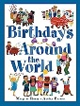 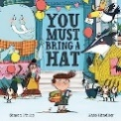 Hinduism – Info Buzz; Judaism – Info Buzz; Christianity – Info Buzz  Party Time – Michael Rosen |  | 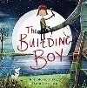 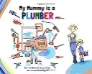 Cobbler, Cobbler | 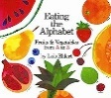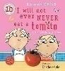  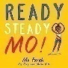  This is the way we exercise …; Heads, Shoulders, Knees & Toes | 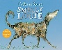 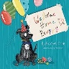 How much is that doggy in the window? Ten Little Doggies | 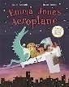Info Buzz series such as, ‘Info Buzz India’; 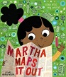
  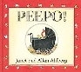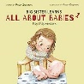
  5 (or 10) Babies in the Bed; Baby in a High Chair – Jack Prelutsky
Role Play | -develop story lines in my pretend play  -develop storylines through small world or role play with my peers  -new baby theme to link with overarching theme | -take part in simple, pretend play often based on experiences  -play cooperatively as part of a group to develop and act out a narrative  - celebrations theme to link with overarching theme |  | -use enhancements to extend my imaginative play  -use fabric, tubes, boxes and joining materials to make props  - fix it theme to link with overarching theme | -use different materials to add to costumes and make own  -healthy living theme to link with overarching theme | -create more complex narratives in pretend play, building on contributions of peers  -new puppy theme links with taking care of living things | -retell parts of familiar stories through enhancements  -holiday time theme to link with overarching theme
 |  | correct names of objects, actions (past, present, future), celebration (birthday, festival e.g. harvest, Diwali, Hannukah, Christmas), candle, diva lamp, menorah, decorate, prepare, invite |  | correct names of occupations/ objects, action words (past, present, future), tools, job, fix, occupation, measure, emergency, broken repair, time, invoice/ payment, part, order, lunch/ break, problem | correct names of objects, food, exercises, action words (past, present, future), healthy, unhealthy cook, fresh, vitamin, planner, fast, faster, slow, slower, fit, physical, rest, sleep, heart, beat, breath, pulse, bones, joints, muscles, gym, membership | correct names of objects, action words (past, present, future), dog, puppy, vet, veterinary nurse, appointment, injection, treatment, medication, breed e.g. springer, spaniel, poodle, dalmatian, rescue, train, command, trick, reward, treat | correct names of objects, action words (past, present, future), holiday, travel, journey, sunscreen, country, city, town, village, countryside, beach, coast, mountains, lakes, river, land, ocean, near, far, airport, station, taxi, museum, art gallery, money, wallet, credit card
  correct names of objects, body parts, actions (past, present future) settle, burp, wind emotions (happy, sad, hungry, thirsty, tired, baby clinic, weigh (heavy, heavier, light, lighter measure (long, longer, short, shorter), change, dirty, clean, wipe, wet, dry, full, empty
End of Reception ELG EAD | Creating with Materials ELG Safely use and explore a variety of materials, tools and techniques, experimenting with colour, design, texture, form, and function; Share their creations, explaining the process they have used; Make use of props and materials when role playing characters in narratives and stories.  Being Imaginative and Expressive ELG Invent, adapt and recount narratives and stories with peers and their teacher; Sing a range of well-known nursery rhymes and songs; Perform songs, rhymes, poems and stories with others, and – when appropriate try to move in time with music.
Year 1 expectations in EAD | Music: A summary of the composition work developed in Y1. The children will: Experiment with, creating, selecting and combining sounds. Improvising and composing music for a range of purposes. Using and understanding staff and other musical notations.  A summary of the performance work developed in Y1. The children will: Use their voices expressively and creatively by singing songs and speaking chants and rhymes. Listening with attention to detail and recall sounds with increasing aural memory. Playing and performing in solo and ensemble contexts.  A summary of the appraisal work developed in Y1. The children will: Listening with concentration and understanding to a range of high-quality live and recorded music.
Year 1 expectations in EAD | Art: A summary of the techniques developed in Y1. The children will: Mark-making using different drawing tools. Colouring neatly. Showing different tones with pencils. Combining materials. Beginning techniques such as rolling, cutting, moulding, carving and marking using simple tools. Making simple joins when creating clay sculptures. Developing work in a sketchbook.  A summary of the influence work developed in Y1. The children will: Observing and describing patterns and beginning to replicate them. Talking to a peer or teacher about the artwork made. Taking inspiration from artwork to influence their own pieces. Expressing and sharing opinions about artwork.  A summary of the convey skills developed in Y1. The children will: Build knowledge of all the primary and secondary colours. Identify colours in pictures and on objects. Decide which tool/s would be appropriate when creating thick and thin lines. Exploring the use of observational drawing, to record what is seen.
Year 1 expectations in EAD | DT: A summary of the inspiration work developed in Y1. The children will: Develop knowledge that food comes from plants or animals, that food has to be farmed, grown or caught. Describing the differences between some food groups (i.e., sweet, vegetable etc.) They will learn of at least one British inventor, designer, engineer, chef or manufacturer. They will be beginning to design products that have a clear purpose and an intended user.  A summary of the invention work developed in Y1. The children will: Demonstrating a range of cutting and shaping techniques (such as tearing, cutting, folding and curling). They will cut, peel or grate ingredients safely and hygienically. Design a product that uses a mechanism.  A summary of the improvement work developed in Y1. The children will: Build knowledge of all the primary and secondary colours. Identifying colours in pictures and on objects. Decide which tool would be appropriate when creating thick and thin lines. Exploring the use of observational drawing, to record what is seen.

