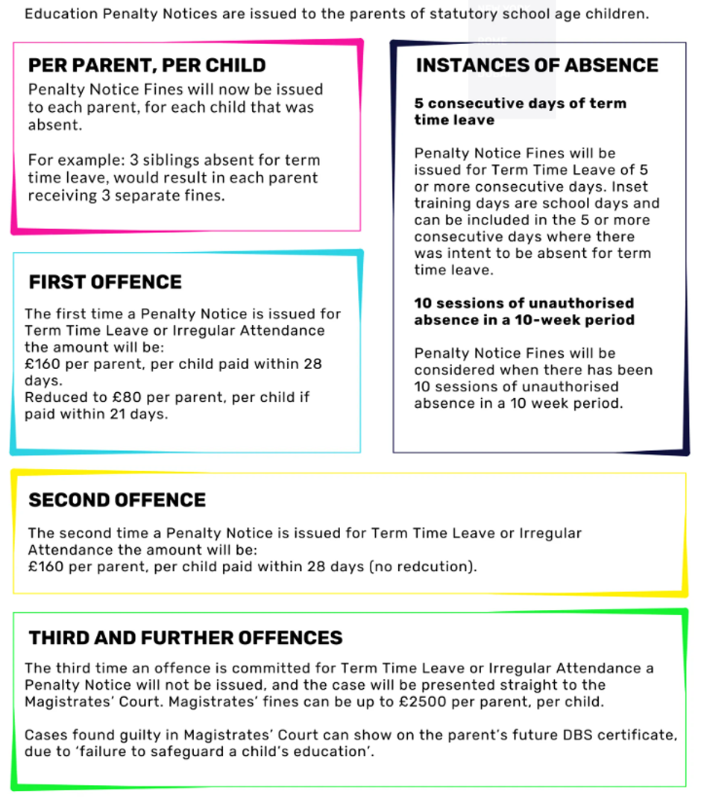
Penalty Notice Fines for School Attendance

