English
 | ELM | ASH | CHESTNUT | SYCAMORE | BEECH | OAK
AUT | Stories by the same author  Non-chronological reports  Poems on a theme | Stories with familiar settings  Non-chronological reports  Poems on a theme | Folk Tales  Recount: biographies | Stories with fantasy settings  Explanations  Film and playscripts | Legends  Persuasion | Novel as a theme  Biography
AUT 2 | Repetitive patterned stories  Poems on a theme  Range of non-fiction texts | Traditional tales with a twist  Instructions | Fables  Poems with a structure  Persuasion: letters | Fairy tales  Classic poetry  Recount: newspapers | Stories with historical settings  Film and play scripts  Classic narrative poetry | Classic fiction  Poetry – Songs and Lyrics  Persuasion: A Formal Review
SPR 1 | Classic stories or stories on a  theme  Instructions  Traditional rhymes | Stories by the same author  Non-chronological reports | Story as a theme  Poems on a theme  Discussion | Stories with issues and  dilemmas  Persuasion | Science fiction stories  Information booklets  Poems with a structure | Older literature  Information text hybrid  Poems with imagery
SPR 2 | Traditional tales  Recounts | Stories with familiar settings  Persuasion  Riddles | Novel as a theme  Recount: diaries | Novel as a theme  Non-chronological reports | Novel as a theme  Magazine: information text  hybrid | Detective / crime fiction  Explanations
SUM 1 | Stories with familiar settings  Non-fiction texts: booklets  Traditional rhymes | Animal adventure stories  Recount: letters  Classic poems | Playscripts  Non-chronological reports | Stories with a theme  Poems with a structure  Information booklets | Stories from other cultures  Debate | Short stories with flashbacks  Discussion and debate  Classic narrative poetry
SUM 2 | Stories with fantasy settings  Poems to learn by heart  Recounts | Story as a theme  Explanations  Poems on a theme | Classic poetry  Mystery / Adventure /  Fantasy stories  Explanations | Folk tales  Debate  Poems on a theme | Myths  Reports  Poems with figurative  language | Novel as a theme  Recount: autobiography  Poems on a theme

Maths
 | Autumn 1 | Autumn 2 | Spring 1 | Spring 2 | Summer 1 | Summer 2
SAPLING | Match, Sort and Compare  Talk About Measure and Patterns  It’s Me 1, 2, 3 | Circles and Triangles  1, 2, 3, 4, 5  Shapes with 4 Sides | Alive in 5  Mass and Capacity  Growing 6, 7, 8 | Length, Height and Time  Building 9 and 10  Explore 3-D Shapes | To 20 and Beyond  How Many Now?  Manipulate, Compose and Decompose | Sharing and Grouping  Visualise, Build and Map  Make Connections
ELM | Place Value (within 20)  Addition and Subtraction | Addition and Subtraction cont.  Shape | Place Value (within 20)  Addition and Subtraction | Place Value (within 50)  Length and Height  Measurement | Multiplication and Division  Fractions  Position and Direction | Place Value (within 100)  Money  Time
ASH | Place Value  Addition and Subtraction | Addition and Subtraction cont.  Shape | Money  Multiplication and Division | Length and Height  Mass, Capacity and Temperature | Fractions  Time | Statistics  Position and Direction
CHESTNUT | Place Value  Addition and Subtraction | Addition and subtraction cont.  Multiplication and Division A | Multiplication and Division B  Length and Perimeter | Fractions A  Mass and Capacity | Fractions B  Money  Time | Time cont.  Shape  Statistics
SYCAMORE | Place Value  Addition and Subtraction | Area  Multiplication and Division A | Multiplication and Division B  Length and Perimeter | Fractions  Decimals A | Decimals B  Money  Time | Shape  Statistics  Position and Direction
BEECH | Place Value  Addition and Subtraction | Multiplication and Division A  Fractions A | Multiplication and Division B  Fractions B | Decimals and Percentages  Perimeter and Area  Statistics | Shape  Position and Direction  Decimals | Negative Numbers  Converting Units  Volume
OAK | Place value  Addition, Subtraction, Multiplication and Division | Fractions A  Fractions B  Converting Units | Ratio  Algebra  Decimals | Area, Perimeter and Volume  Statistics | Shape  Position and Direction | Themed Projects, Consolidation and Problem Solving

Religious Education
 | Autumn 1 | Autumn 2 | Spring 1 | Spring 2 | Summer 1 | Summer 2
SAPLING | I am Special  Why are we all different and special? | Christmas  How do Christians celebrate Jesus’ birthday? | Special Places  What makes a place holy? | Easter  Why do Christians believe that Easter is all about love? | Prayer  What is prayer? | Special People  Why do Christians believe Jesus is special?
ELM | 1.1: How and Why Do People of Faith Celebrate and Give Thanks For The Harvest?.  How can we help those who do not have a good harvest? | 1.3: Why Do Many People Give and Receive Gifts at Christmas?  Why do we give and receive gifts? | 1.8 – Joseph.  Why is Joseph a Bible hero? | 1.5: Why Do Christians Believe Easter is a New Beginning?  Celebrating new life and new beginnings | 1.7: How Do People of World Faiths Welcome New Babies?  Why is baptism special? | 1.2: What Do People of Faith Believe About God as Creator?  What are your favourite things in creation?
ASH | 2.1: Why Are Sacred Texts/Holy Books So Important To People of Faith?  Why is it such a special book? | 2.2 - Why Do Christians Believe The Birth of Jesus Was Such Good News?  Why was the birth of Jesus such good news? | 2.3 - Why Did Jesus Welcome Everyone?  Why did Jesus welcome everyone? | 2.4 - How Do Symbols Help People To Understand The Easter Story?  How do Symbols help us understand the story? | 2.6 - What Do Christians Believe Happened at Ascension and Pentecost?  What happened at the Ascension and Pentecost? | 2.5 – Why Are Holy Buildings and Places Important To People of Faith?  Why is the church a special place for Christians?
CHESTNUT | 3.6 – Harvest  How do people of faith say thank you to God for the harvest? | 3.2 – Why Do Christians Believe Jesus Was ‘God With Us’?  How does the presence of Jesus impact on people’s lives? | 3.3 - Jesus  How did/does Jesus change lives? | 3.4 Easter  Is the cross a symbol of sadness or joy? | 3.1: What Is The Role of a Faith Leader Who Has Been Called By God?  What does it mean to be called by God? | Unit 3.5: Is The ‘Golden Rule’ Agreed by Everyone?  Which rules should we follow?
SYCAMORE | 4.1 - Considered To Be Important by People of Faith?  What values do you consider to be important? | Unit 4.2: Why Is Light An Important Symbol In World Faiths?  Why is Jesus described as the light of the world? | 4.3 - Jesus  Why do Christians believe Jesus is the Son of God? | 4.4 - Easter  A story of betrayal or trust? | 4.5: Why Are Holy Buildings and Places Important to People of Faith?  Are all Churches the same? | 4.6 – Prayer  What is prayer?
BEECH | 5.1 - Why Are Sacred Texts/Holy Books So Important to People of Faith?  How and why do Christians read the Bible? | 5.2 - How Does The Birth of Jesus Fit Into God’s Big Story?  How do our celebrations reflect the true meaning of Christmas? | 5.6 - Loss Death and Christian hope  Is death an ending or a beginning? | 5.4 – Easter  Why do Christians believe that Easter is a celebration of victory? | 5.9 - St Paul  How did the news of Jesus resurrection spread around the world? | 5.5 - Old Testament Women  Did she make the right choice?
OAK | 6.1 - Life as a journey  Is every person’s journey the same? | 6.2 – Advent  How do Christians prepare for Christmas? | 6.3: The Eucharist  Why do Christians celebrate the Eucharist? | 6.3A – The Exodus  Why is the Exodus such a significant event in Jewish and Christian history? | 6.4 - Easter.  Who was Jesus? who is Jesus | 6.6 – God  What is the nature and character of God?

Science
 | Autumn 1 | Autumn 2 | Spring 1 | Spring 2 | Summer 1 | Summer 2
ELM | Forces, Earth and space –  Seasonal changes. | Materials –  Everyday materials. | Animals, including humans –  Sensitive bodies. | Animals, including humans –  Comparing animals. | Plants –  Introduction to plants. | Making connections –  Investigating science through stories.
ASH | Living things and their habitats –  Habitats | Living things and their habitats –  Microhabitats. | Materials –  Uses of everyday materials. | Animals, including humans –  Life cycles and health. | Plants –  Plant growth. | Making connections –  Plant based materials.
CHESTNUT | Animals, including humans –  Movement and nutrition. | Forces, Earth and space –  Forces and magnets. | Materials –  Rocks and soil | Energy –  Light and shadows. | Plants –  Plant reproduction. | Making connections –  Does hand span affect grip strength?
SYCAMORE | Animals, including humans –  Digestion and food. | Energy –  Electricity and circuits. | Materials –  States of matter. | Energy –  Sound and vibrations. | Living things and their habitats –  Classification and changing habitats. | Making connections –  Hoe does the flow of liquid compare?
BEECH | Materials –  Mixtures and separation. | Materials –  Properties and changes. | Forces, Earth and space –  Earth and space. | Living things and their habitats –  Life cycle and reproduction. | Forces, Earth and space –  Unbalanced forces. | Animals, including humans –  Human timeline.
Making connections –
Does the size of an asteroid affect the size of its impact crater?
OAK | Living things and their habitats –  Classifying big and small. | Energy –  Light and reflection. | Living things and their habitats –  Evolution and inheritance. | Energy –  Circuits, batteries and switches. | Animals, including humans –  Circulation and health. | Making connections –  Are some sunglasses safer than others?

Topic – History/Geography
 | Autumn 1 | Autumn 2 | Spring 1 | Spring 2 | Summer 1 | Summer 2
ELM | How am I making history?  Looking at personal chronology and finding out about the past within living memory | What is it like here?  Locating where they live on an aerial photograph and recognising features within a local context. | How have toys changed?  Sequencing toys into a physical timeline, children investigate artefacts from the past and begin to pose questions. | What is the weather like in the UK?  Looking at the countries and cities that make up the UK, keeping a daily weather record and finding out more about hot and cold places in the UK | How have explorers changed the world?  Finding out about events and people beyond living memory, | What is it like to live in Shanghai?  Using a world map to start recognising continents, oceans and countries outside the UK with a focus on China.
ASH | How was school different in the past?  Understanding that although schools have been in the local area for a long time, they have not always been the same. | Would you prefer to live in a hot or cold place?  Introducing children to the basic concept of climate zones and mapping out hot and cold places globally. | How did we learn to fly?  Developing their knowledge of events beyond living memory and reinforcing their chronological understanding by looking at significant events in the history of flight on a timeline. | Why is our world wonderful?  Learning about the world’s wonders, the names and locations of the world’s oceans and considering what is unique about the local area | What is a monarch?  Finding out the role of a monarch, children compare the monarchy today with the monarchy in the past. | What is it like to live by the coast?  Naming and locating continents and oceans of the world while revisiting countries and cities of the UK and surrounding seas.
CHESTNUT | British history 1: Would you prefer to live in the Stone Age, Bronze Age or Iron Age?  Looking at the chronology of mankind, children are introduced to Britain’s story. | Why do people live near volcanoes?  Children learn that the Earth is constructed in layers, and the crust is divided into tectonic plates. | British history 2: Why did the Romans invade and settle in Britain?  Investigating why the Romans invaded Britain and the reaction of the Celts and learning how the Romans changed life in Britain. | Who lives in Antarctica?  Learning about how latitude and longitude link to climate and the physical and human features of polar regions with links to the explorer, Shackleton. | What was important to ancient Egyptians?  How historians learn about the past using mummies, the  Book of the Dead and pyramids.  Learn about the importance of religion in the ancient Egyptians’  lives and how this is evident in pyramids, worship and mummification. | Are all settlements the same?  Exploring different types of settlements, land use, and the difference between urban and rural.
SYCAMORE | How have children's lives changed?  Investigating the changes in children’s lives through time, children learn how children’s spare time, health and work have changed. | Why are rainforests important to us?  Developing an understanding of biomes, ecosystems and tropics; mapping features of the Amazon rainforest and learning about its layers. | British history 3: How hard was it to invade and settle in Britain?  Developing an understanding of why people invaded and settled, learning about Anglo-Saxon beliefs and the spread of Christianity and assessing the contribution of the Anglo-Saxons to modern Britain. | Where does our food come from?  Looking at the distribution of the world’s biomes and mapping food imports from around the world. | How did the achievements of the Maya civilisation influence their society and beyond?  Investigating historical and archaeological evidence. Explore the  achievements of ancient peoples like the Maya. | What are rivers and how are they used?  Learning about rivers; their place in the water cycle, the name and location of major rivers and how they are used.
BEECH | British history 4: Were the Vikings raiders, traders or something else?  Investigating what the Vikings were really like. | What is life like in the Alps?  Considering the climate of mountain ranges and why people choose to visit the Alps. | What was the impact of World War 2 on the people of Britain?  Investigating the causes of WW2. | Why do oceans matter?  Exploring the importance of our oceans and how they have changed over time. | What did the Greeks ever do for us?  Investigating the city-states of Athens and Sparta to identify similarities and differences between them. | Would you like to live in the desert?  Exploring hot desert biomes and learning about the physical features of a desert.
OAK | What does the census tell us about our local area?  Investigating local history during the Victorian period. | Why does population change?  Investigating why certain parts of the world are more populated than others. | British history 5: What was life like in Tudor England?  Comparing Henry VIII and Elizabeth I, children learn about the changing nature of monarchy. | Where does our energy come from?  Learning about renewable and non-renewable energy sources. | Unheard histories: Who should go on the £10 banknote?  Investigating why historical figures are on banknotes. | Can I carry out an independent fieldwork enquiry?  Observing, measuring, recording and presenting their own fieldwork study of the local area.

PE
 | Autumn 1 | Autumn 2 | Spring 1 | Spring 2 | Summer 1 | Summer 2
SAPLING | Fundamental Movement Skills | FMS  Transport | FMS  Rosies Walk | FMS  Jack and the Beanstalk | FMS  Mini Beasts | FMS  Rumble in the Jungle  A visit to the Zoo
ELM | Baseline Unit  Lost and Found | FMS -  Rolling a Ball  Catching and Bouncing Ball | Dance  Cheer Dance | Gymnastics  Core Tasks1 and 2 | Athletics | Underarm and Overarm Throw
ASH | Net and Wall Games | Core Task  Piggy in the Middle  Bounce Ball | Dance  Cheer Dance  FMS - Kicking | Gymnastics  FMS - Kicking | Swimming  Striking and Fielding Games | Athletics  End of KS assessment
CHESTNUT | Invasion Games  Netball | Dance  Disco | Gymnastics  Core Tasks 1 and 2 | Net Wall – Core Task 1  Swimming | Athletics | Net and wall  Core Task 2
SYCAMORE | Invasion Games  Netball | Gymnastics  Core Task 1 and 2 | Dance  Hip Hop  Swimming | Net and Wall  Core Task 1 and 2 | Striking and Fielding  Cricket | OAA  Trust and Trails
BEECH | Invasion Games  Netball  Swimming | Gymnastics  Core Task  Swimming | Dance  Urban Freestyle | Net and Wall  Tennis | Striking and Fielding  Cricket | Athletics  OAA  Problem Solving
OAK | Invasion Games  Football | Dance  Freestyle | Gymnastics  Core Task 1 and 2 | Striking and Fielding  Cricket  OAA  Problem Solving | Athletics | Swimming  Netball  Tennis

Art/DT
 | Autumn 1 | Autumn 2 | Spring 1 | Spring 2 | Summer 1 | Summer 2
ELM | DT  Structures – Stable structures | Art  Drawing –  Make your mark. | DT  Textiles –  Puppets. | Art  Sculpture and 3D –  Paper play. | DT  Smoothies. | Art  Painting and mixed media –  Colour splash.
ASH | Art  Craft and design –  Map it out. | DT  Structures –  Baby bear’s chair. | Art  Painting and mixed media –  Life in colour. | DT  Mechanisms –  Fairground wheel. | Art  Sculpture and 3D –  Clay houses. | DT  Mechanisms –  Making a moving monster.
CHESTNUT | DT  Cooking and nutrition –  Eating seasonally. | Art  Drawing –  Growing artists. | DT  Digital world –  Wearable technology | Art  Craft and design –  Ancient Egyptian. | DT  Structures –  Constructing a castle. | Art  Sculpture and 3D –  Abstract shape and space.
SYCAMORE | Art  Drawing –  Power prints. | DT  Structure –  Pavilions. | Art  Painting and mixed media –  Light and dark. | DT  Mechanical systems –  Mechanical cars | Art  Craft and design –  Fabric of nature. | DT  Electrical systems –  Torches.
BEECH | DT  Electrical systems –  Doodlers | Art  Sculpture and 3D –  Interactive installation. | DT  Mechanical systems –  Gears and pulleys | Art  Drawing –  I need space. | DT  Cooking and nutrition -  Developing a recipe | Art  Painting and mixed media –  Portraits.
OAK | Art  Craft and design –  Photo opportunity. | DT  Textiles –  Bags. | Art  Drawing –  Expressing Ideas. | DT  Structure –  Playgrounds. | Art  Sculpture and 3D –  Making memories. | DT  Digital world –  Navigating the world.

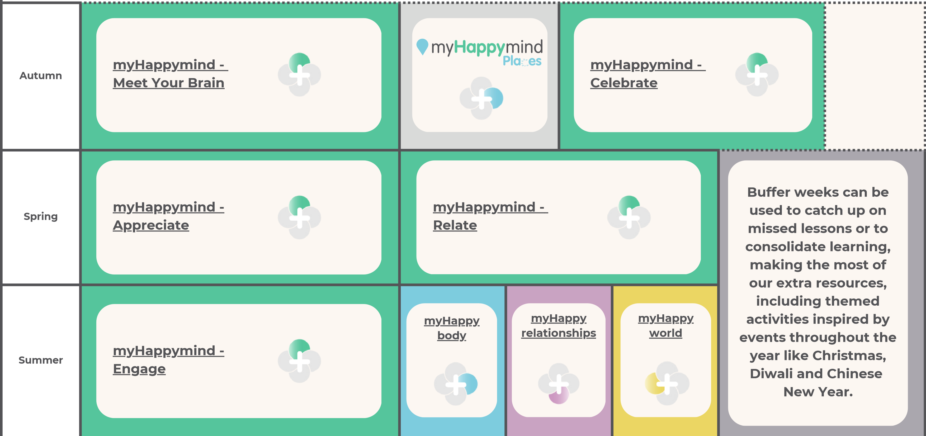
PSHE - SAPLING CLASS - EYFS


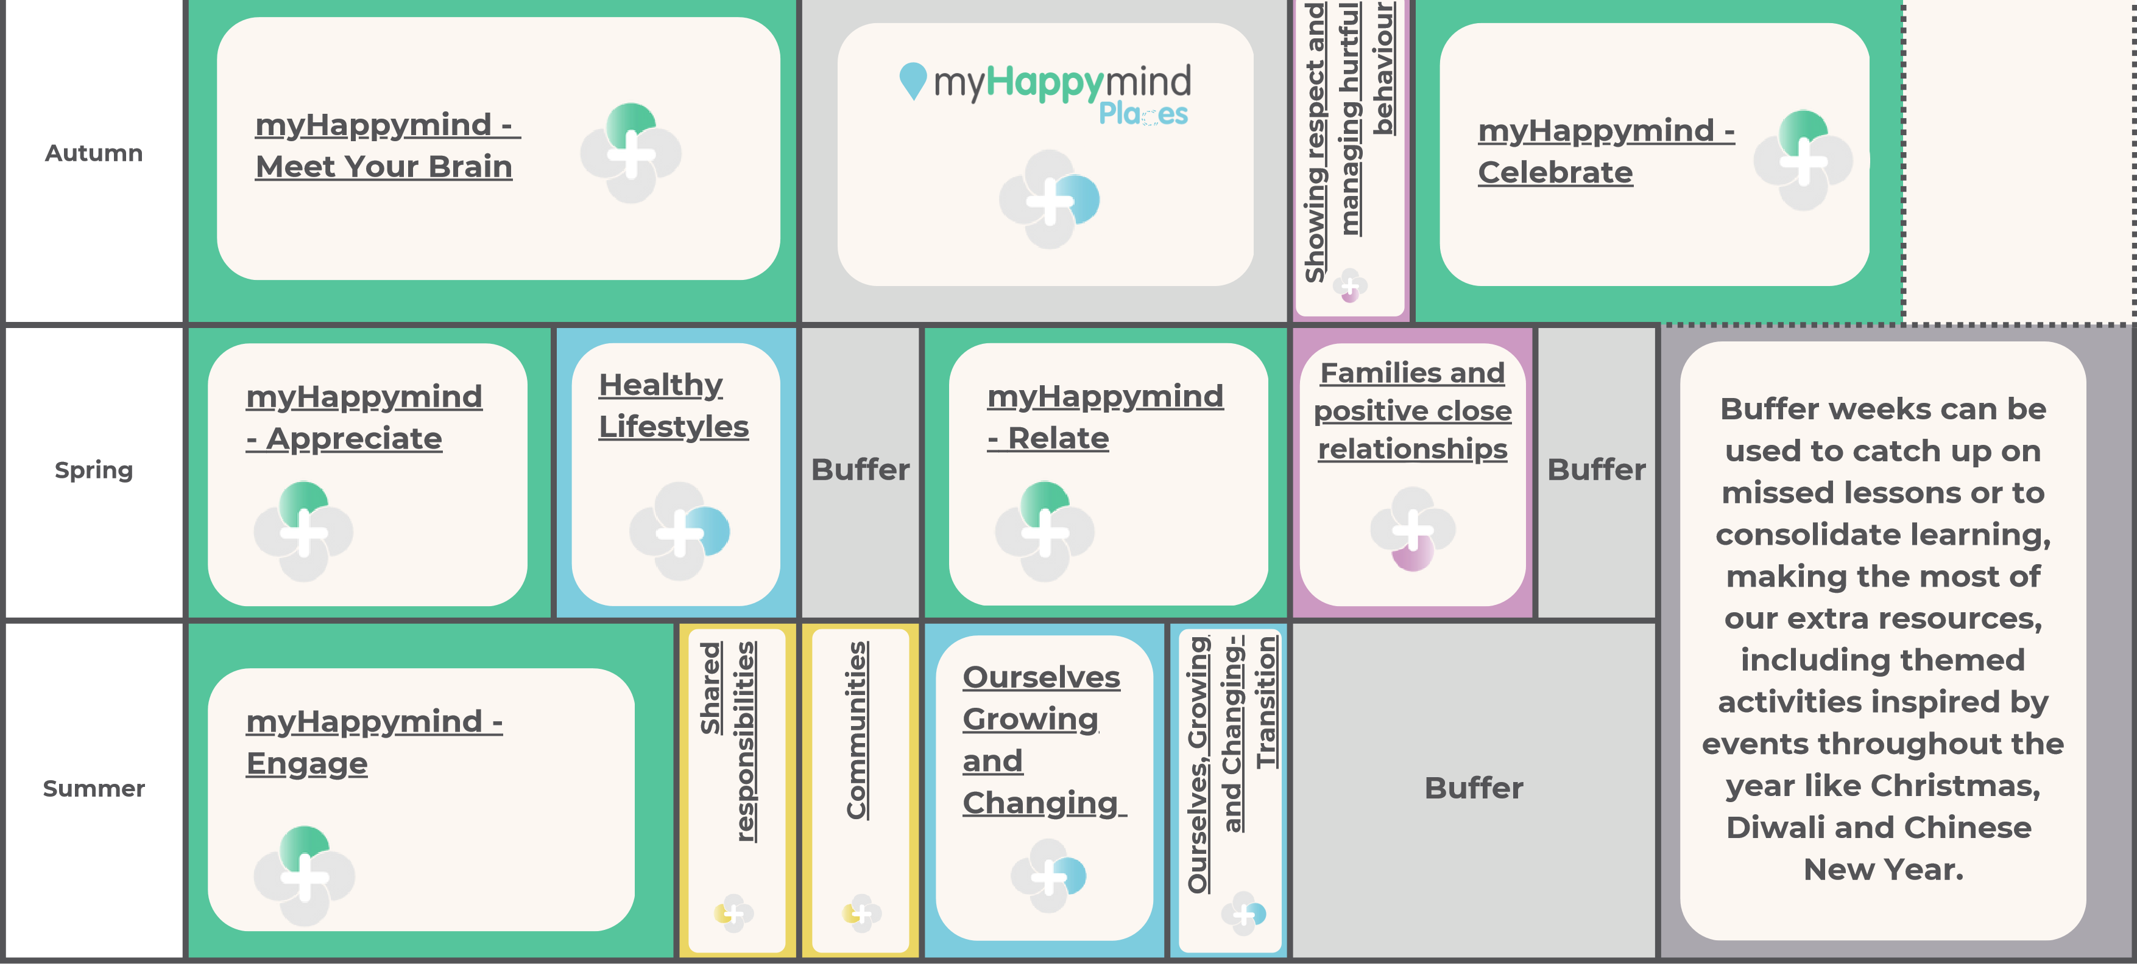
PSHE - ELM CLASS– YEAR 1

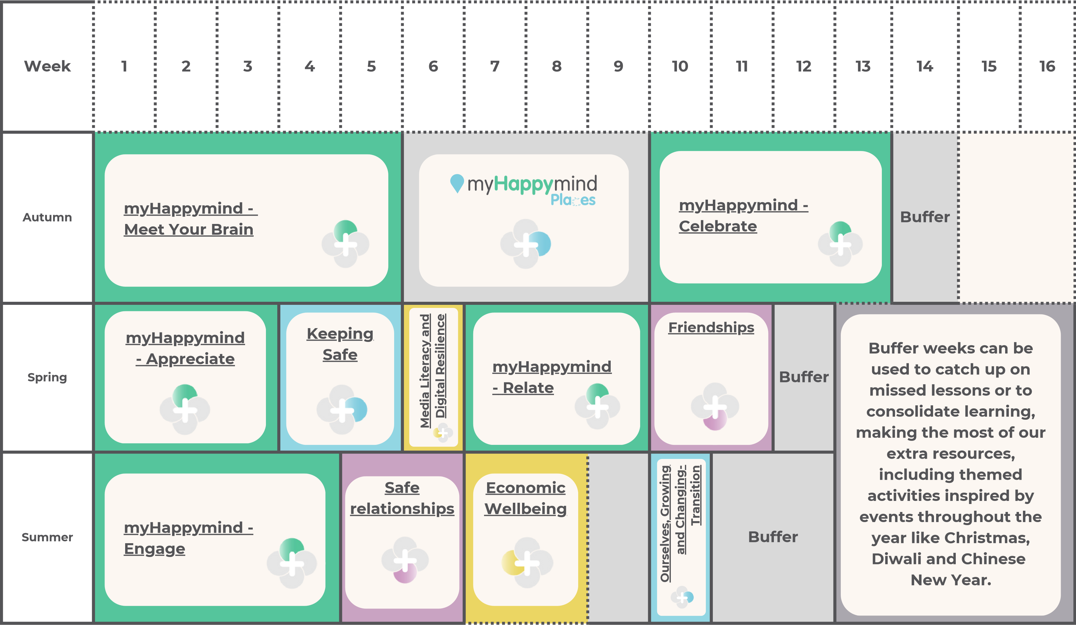
PSHE - ASH CLASS – YEAR 2
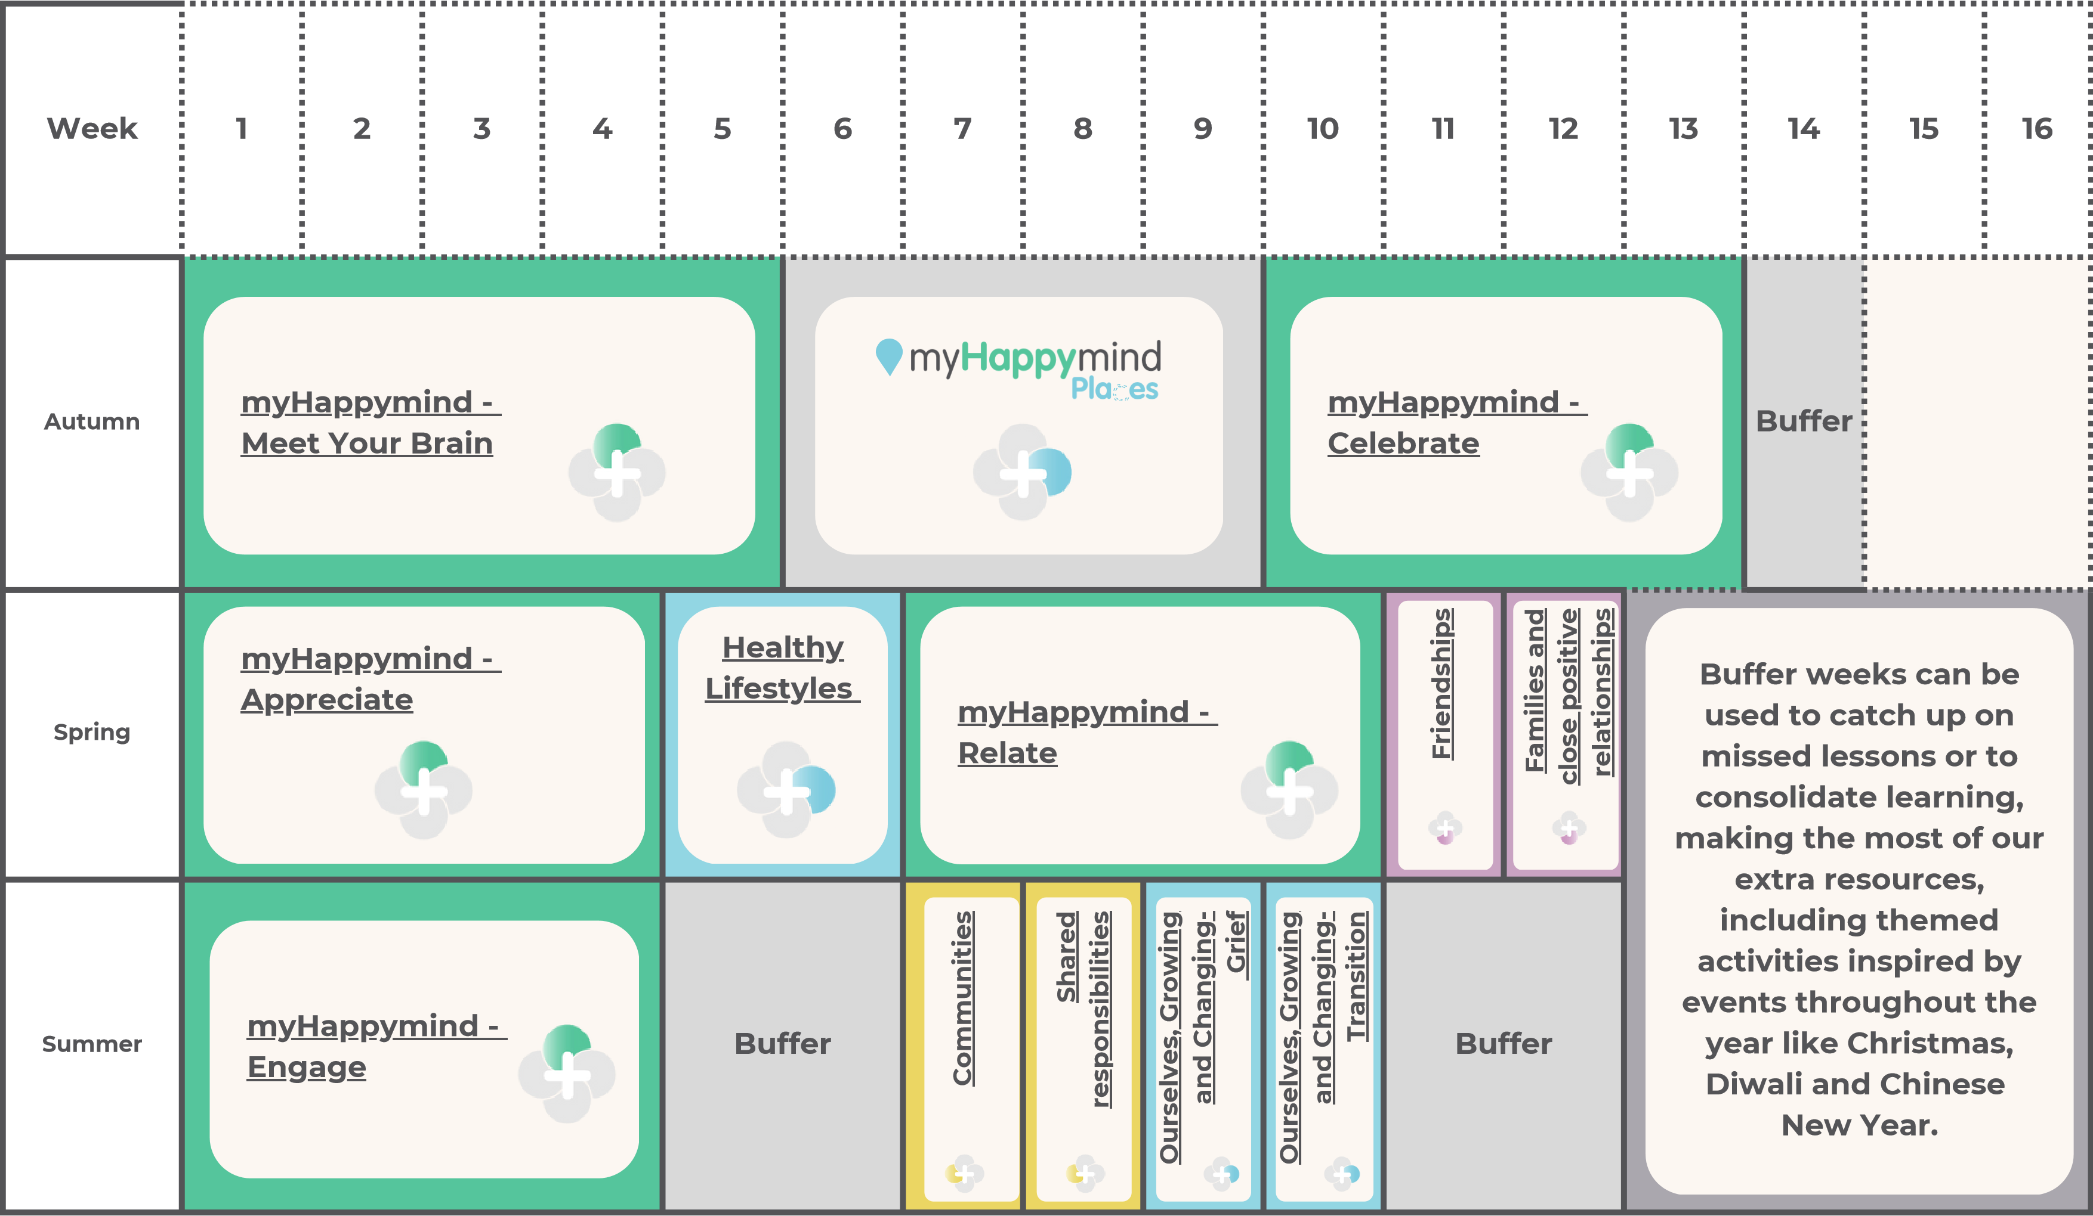
PSHE - CHESNUT CLASS – YEAR 3
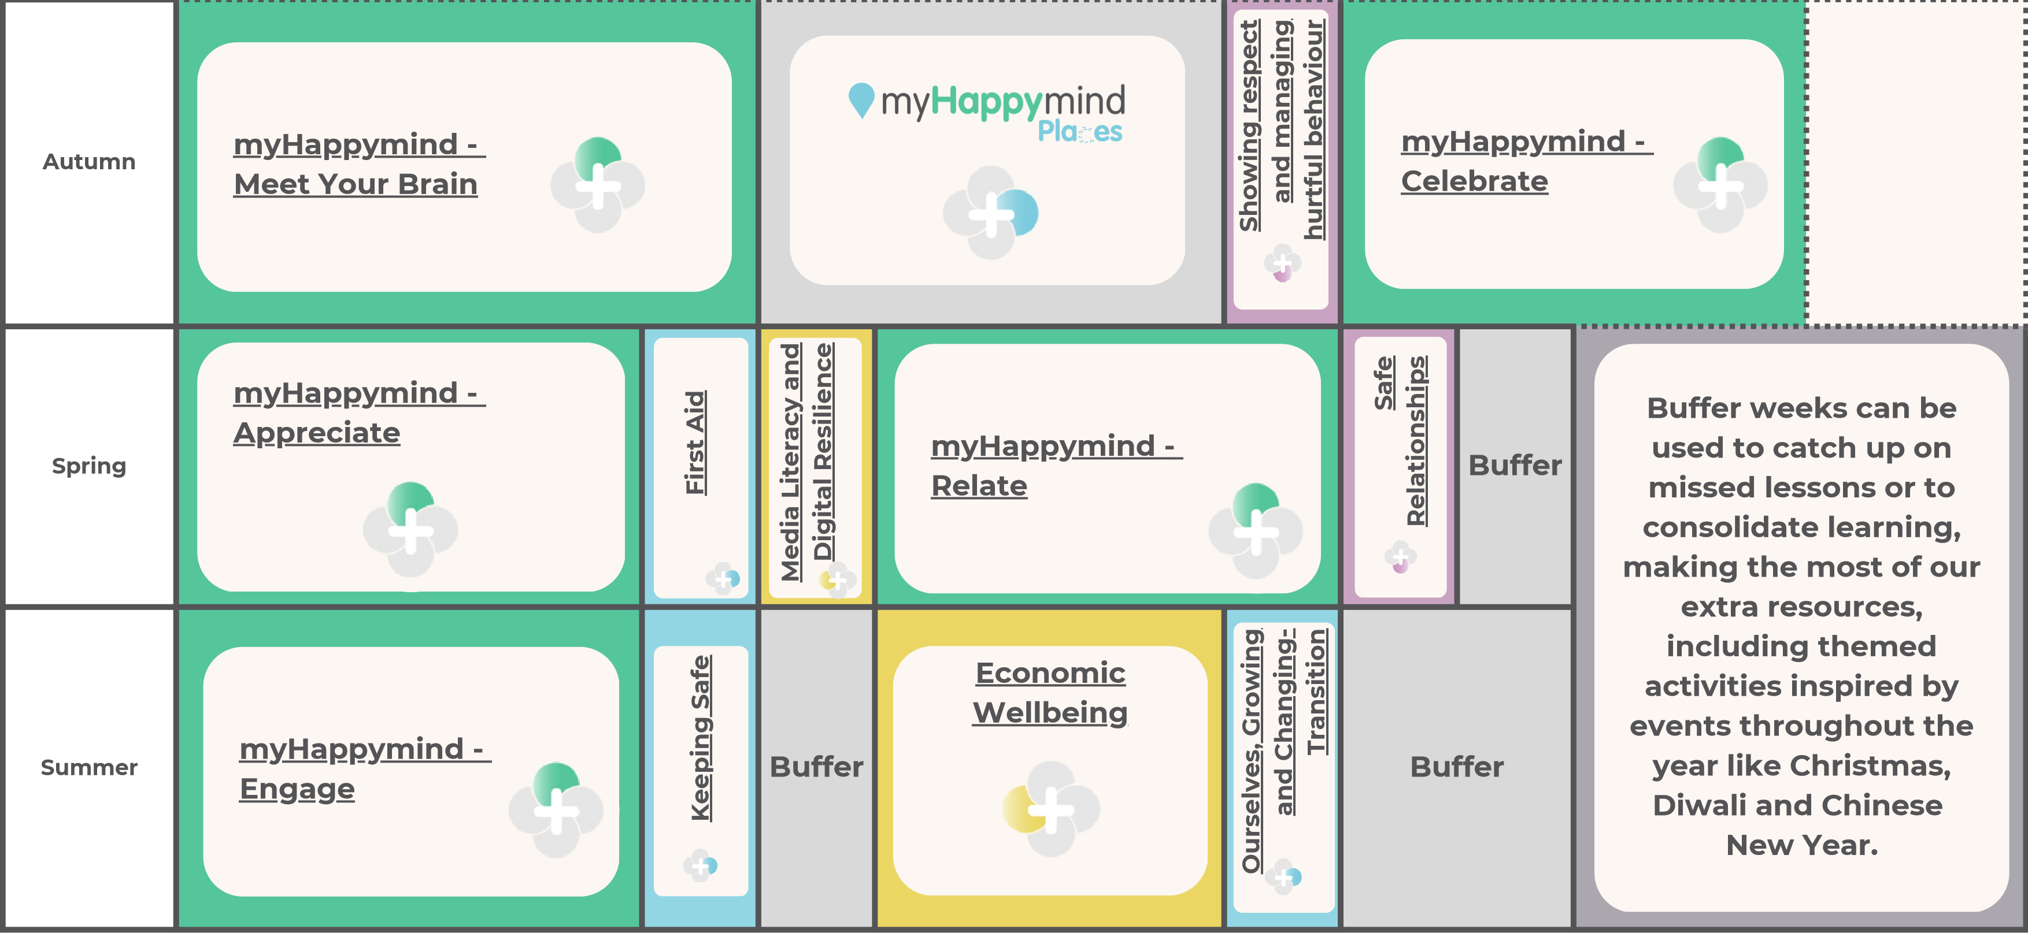
PSHE - SYCAMORE CLASS – YEAR 4
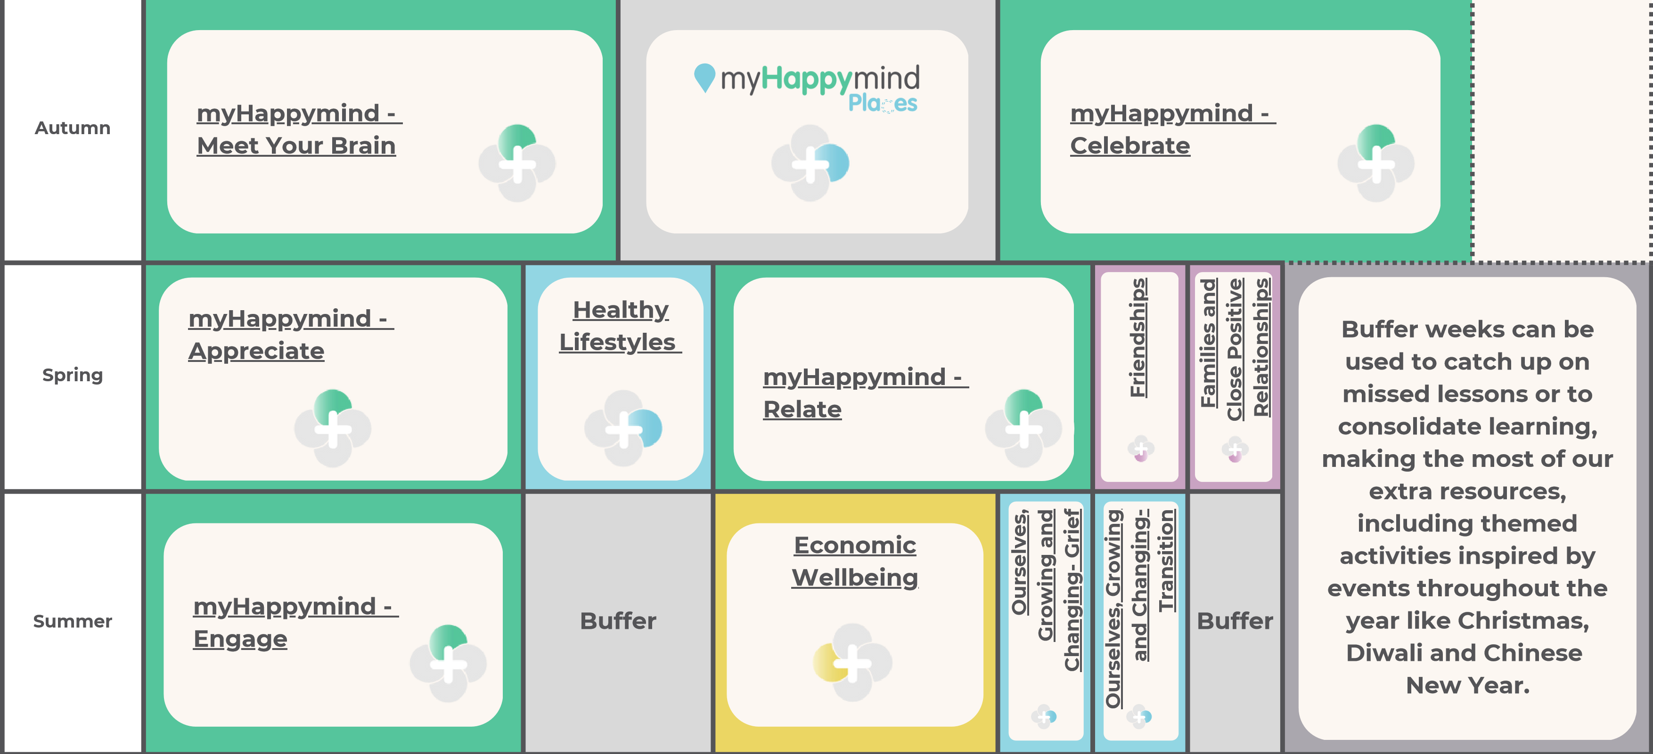
PSHE - BEECH CLASS – YEAR 5
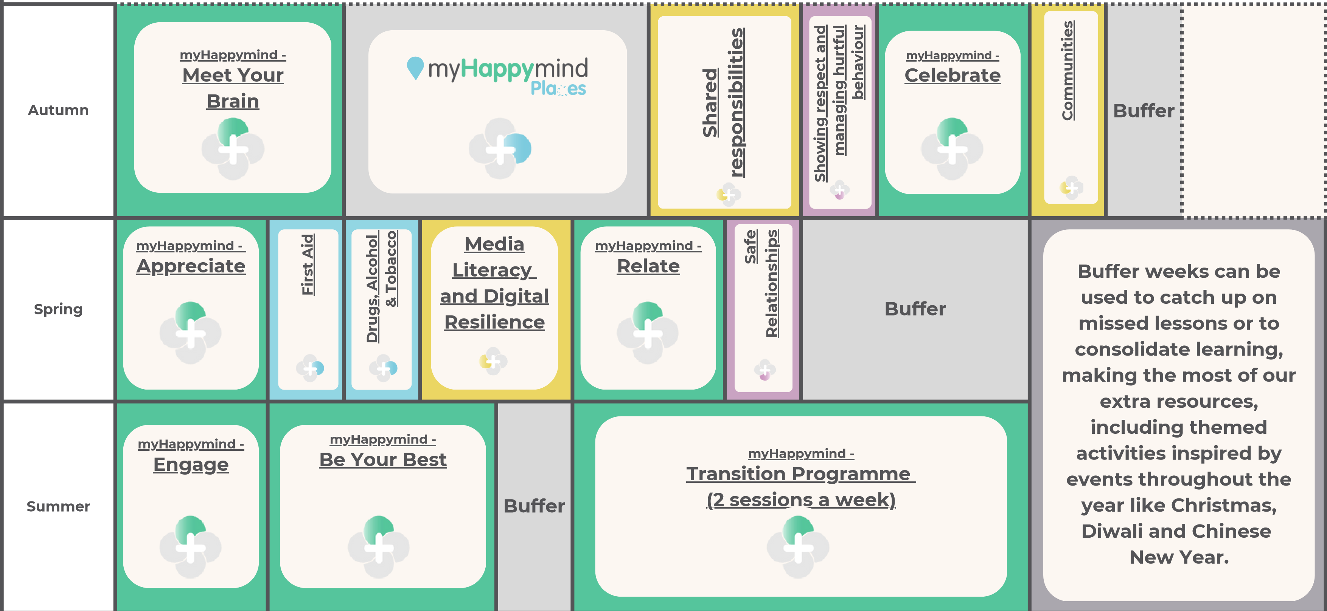
PSHE - OAK CLASS – YEAR 6
Computer Science
 | Autumn 1 | Autumn 2 |  |  | Spring 1 |  | Spring 2 |  | Summer 1 |  | Summer 2
SAPLING | Computing systems and networks 1: Using a computer |  | Programming 1:  instructions | Computing systems and networks 2: Exploring hardware |  | Programming 2: Programming Codapillars |  | Data handling:  Introduction to data
ELM | Computing systems and networks: Improving mouse skills |  | Programming 1: Algorithms | Skills showcase: Rocket to the moon  Developing keyboard and mouse skills. |  | Programming 2: Codapillars  Developing early programming skills |  | Creating media: Digital imagery |  | Data handling: Introduction to data  Learning what data
ELM | Online safety: Year 1  Learning about online safety, including using useful tips to stay safe when online; how to manage feelings and emotions when someone or something has upset us online; learning about the responsibility we have as online users; exploring the idea of a ‘digital footprint’.
ASH | Computing systems and networks 1:  What is a computer? | Programming 1: Algorithms and debugging |  |  | Computing systems and networks 2:  Word processing |  | Programming 2: MakeCode |  | Creating media: Stop motion |  | Data handling: International Space Station
ASH | Online safety: Year 2  Learning about online safety, including: what happens to information posted online; how to keep things private online; who we should ask before sharing online; describing different ways to ask for, give, or deny permission online.
CHESTNUT | Computing systems and networks 1: Networks | Programming: Scratch |  |  | Computing systems and networks 3:  Journey inside a computer |  | Creating media: Video trailers |  | Data handling: Comparison cards databases |  | Computing systems and networks 2: Emailing
CHESTNUT | Online safety: Year 3  Learning about online safety: ‘fake news’, privacy settings, ways to deal with upsetting online content, protecting our personal information on social media.
SYCAMORE | Computing systems and networks: Collaborative learning | Programming 1: Further coding with Scratch |  |  | Creating media: Website design |  | Skills showcase: HTML |  | Programming 2: Computational thinking |  | Data handling: Investigating weather
SYCAMORE | Online safety: Year 4  Learning how to navigate the internet in an informed, safe and respectful way.
BEECH | Computing systems and networks:  Search engines | Programming 1: Music |  |  | Data handling: Mars Rover 1 |  | Programming 2: Micro:bit |  | Creating media: Stop motion animation |  | Skills showcase: Mars Rover 2
BEECH | Online safety: Year 5  Learning about potential online dangers and safety.
OAK | Computing systems and networks: Bletchley Park and the history of computers | Programming:  Intro to Python |  |  | Data handling 1:  Big Data 1 |  | Computing systems and networks: Exploring AI |  | Data handling 2:  Big Data 2 |  | Skills showcase: Inventing a product
OAK | Online safety: Year 6  Learning how to navigate the internet in an informed, safe and respectful way.

SPANISH
 | Autumn | Spring | Summer
CHESTNUT | Y3 - Spanish greetings with puppets (Lessons 1, 2 and 4)  Using puppets to practise a variety of greetings, children learn how to introduce themselves and perform a finger rhyme based on a Spanish puppet festival tradition.  Y3 - Spanish numbers and ages (Lessons 2, 3 and 4)  Through playing traditional Spanish counting games, children learn the numbers from one to twelve. They discover how to say their age in Spanish and ask others how old they are. | Y3 - Shapes and colours in Spanish  Describing different shapes using colour adjectives in Spanish. | Y3 - Classroom objects in Spanish  Following classroom instructions, naming classroom objects and exploring grammar rules such as masculine and feminine nouns, plurals, and forming a negative construction.
SYCAMORE | Y3 - Journey around Latin America.  Exploring Spanish-speaking Latin American countries and learning the days of the week and modes of transport in Spanish. | Y4 - Dates in Spanish.  Mastering numbers to 31 and months of the year, children learn to say the date and find out about some Mexican birthday traditions. | Y4 - Pets in Spanish  Listening to a song about pets, children learn the names of different animals. Developing their knowledge of adjectives, children describe the characteristics of different animals when writing a fun story about a visit to a pet shop.
BEECH | Y4 - In a Spanish café.  . Reading and creating menus in Spanish to role-play conversations in a Spanish café. | Y4 - Spanish celebrations  Learning about how some festivals are celebrated in Spain; expressing likes and dislikes about different celebrations | Y5 - Describing family and friends in Spanish  Looking at a family tree, children find out the vocabulary for family members and use different verbs to write a description of them.
OAK | Y5 - Spanish portraits  Deducing the vocabulary for describing facial features; applying their knowledge of noun-adjective agreement to plural nouns; creating portraits in the cubist style and describing the faces in their portraits. | Y5 - Spanish food and drink  Expressing likes and dislikes about food; developing questioning skills to find out about food preferences. | Y5 - A trip across Spain  Finding out about different Spanish cities; discussing future travel plans to key tourist attractions.

Music
 | Autumn 1 | Autumn 2 | Spring 1 | Spring 2 | Summer 1 | Summer 2
ELM | Hey You!  Style: Old-School Hip Hop | Rhythm In The Way We Walk and Banana Rap  Style: Reggae and Hip Hop style | In The Groove  Style: Blues, Latin, Folk, Funk, Baroque, Bhangra | Round And Round  Style: Latin Bossa Nova, Film music, Big Band Jazz, Mash-up, Latin fusion | Your Imagination  Style: Pop | Reflect, Rewind and Replay  Style: Western Classical Music and your choice from Year 1
ASH | Hands, Feet, Heart  Style: South African styles | Ho Ho Ho  Style: Christmas, Big Band, Motown, Elvis, Freedom Son | I Wanna Play In A Band  Style: Rock | Zootime  Style: Reggae | Friendship Song  Style: Coming soon! | Reﬂect, Rewind and Replay  Style: Western Classical Music and your choice from Year 2
CHESTNUT | Glockenspiel Stage 1  Style: Learning basic instrumental skills by playing tunes in varying styles |  | Three Little Birds  Style: Reggae |  | Bringing Us Together  Style: Disco
SYCAMORE | Glockenspiel Stage 2  Style: Learning basic instrumental skills by playing tunes in varying styles |  | Mamma Mia  Style: ABBA |  | Lean On Me  Style: Gospel
BEECH | Livin' On A Prayer  Style: Rock |  | Fresh Prince Of Bel-Air  Style: Hip Hop |  | Dancing In The Street  Style: Motown
OAK | Happy  Style: Pop/Motown |  | You've Got A Friend  Style: The Music of Carole King |  | Music and Me  Style: Contemporary, music and identity

