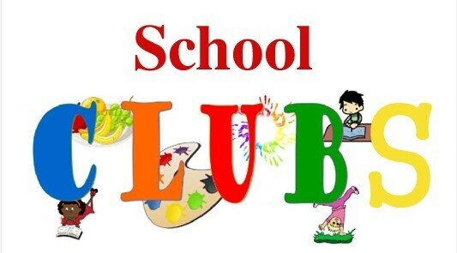
 | MONDAY | TUESDAY | WEDNESDAY | THURSDAY | FRIDAY
BREAKFAST CLUB |  |  |  |  |   8.00– 8.45AM  REFLECTION GANG  8.00– 8.45AM  ALTERNATE WEEKS  MRS BIRD
AFTER SCHOOL | 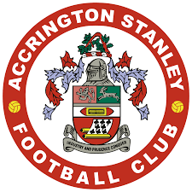ACCRINGTON STANLEY FOOTBALL CLUB | KEYSTAGE 2  CHOIR    MRS MORGAN |   MAD SCIENCE CLUB |   MRS PARTINGTON AND  MRS BIRD | CHAPLAINS  MRS BIRD
AFTER SCHOOL | LEGO ROBOTICS    MR MCNAB |  |  |  | SPORTS CLUB    MISS GREENWOOD

