Ash Class – Autumn 1 Homework Grid

English  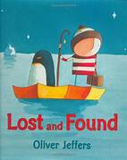  Ask your child to draw a scene from their favourite book. Ask them to write some sentences including 'and' and 'but' to extend their simple sentences.  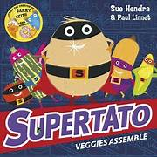 | Maths  Practice counting In 2s, 3s, 5s, and 10s. Look online for some fun songs and chants to get your children excited to learn!  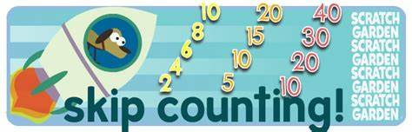 | Science  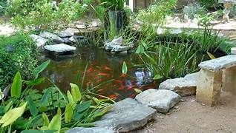  Go for a walk with your adult. How many different habitats can you find? What animals live in the habitats? What do they need to survive? Draw a picture of what you find and label it.
RE  In Re we will be widening the children’s understanding of the Bible, its contents, presentation and importance to Christians. Share some bible stories with your children and ask them to draw a picture of their favourite story.  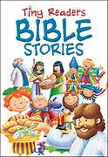 | History  Pack an explorer's bag – draw and label what they might have taken.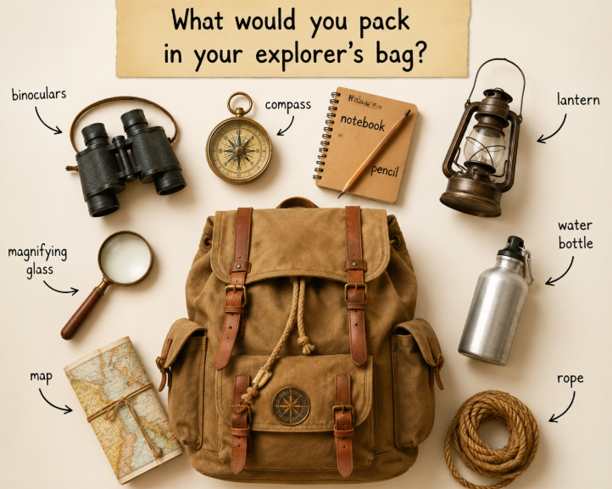 | Art  Ask someone at home to make a funny or dramatic expression and draw their portrait!  