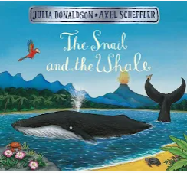
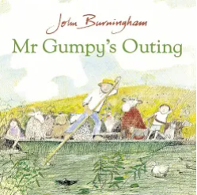
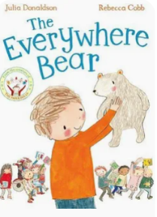
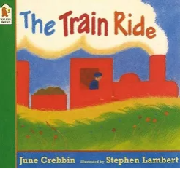
Key books this term…
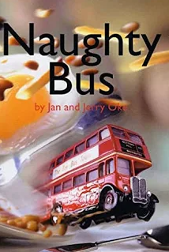

Mr Grumpy’s Outing- Children will explore friendship, cooperation and journeys through role play and storytelling. They will discuss how characters feel and work together to solve problems.
The Snail and the Whale- Children will explore the wider world, oceans and habitats through this text. They will learn about different places around the world and how animals survive in different environments.
The Train Ride – Using this story, children will explore journeys and compare different places they might travel through. They will sequence events, discuss what they can see and compare environments.

The Naughty Bus - Using this story as a stimulus we will be introducing our topic. We will look at where the bus travels and how it gets into trouble. We will sequence the story and write about our own ideas.

The Everywhere Bear – Children will follow the adventures of the Everywhere Bear and explore how journeys can take us to different places. They will create maps, retell events and write simple sentences.

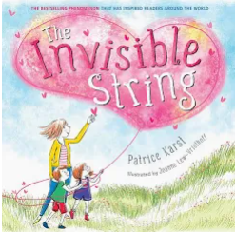
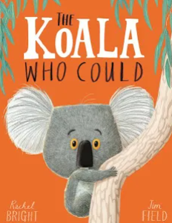

Key Vocabulary
Journey, travel, route, map, globe, country, world, community, same, different, habitat, survive, environment, ocean, woodland, pond, future, past, present, memory, change, grow, artist, collage, sculpture, design, improve and evaluate.
The Kola who could- Using this story, children will explore resilience, confidence and embracing new experiences. They will discuss how characters overcome worries and learn that trying new things can help us grow. This text will support transition to Year 1 and developing a positive attitude towards challenges.
The Invisible String - Using this story, children will explore relationships, belonging and transition. They will learn that special connections with family and friends remain even when people are apart. This text will support discussions about moving to Year 1 and managing change positively.
PSED/Happy Minds
Children will reflect on their Reception journey and celebrate their achievements. They will develop resilience, confidence and independence as they prepare for Year 1. They will discuss friendships, emotions and managing challenges positively.
Understanding of the World
Where can my journey take me next?
Children will reflect on how they have changed throughout Reception and discuss what might happen next. They will explore different places around the world, use maps and globes and compare communities. They will investigate habitats and learn why animals and plants live in different places.
Skills
History- Recall memories, sequence events, use past, present and future language
Geography- Compare places, use maps and globes, identify similarities and differences
Science- Identify habitats, match animals to habitats, explain food, water and shelter needs, observe and compare environments.
Communication and Language
Is at the heart of our provision and in everything we do!
Physical Development: Fine and Gross Motor
Fine motor – working on clear letter formation and using our cutting skills for a purpose, focusing on manipulating tools correctly.
Gross Motor- Children will continue to develop strength, balance, coordination and control through outdoor games, obstacle courses, team challenges and sports activities. They will refine throwing, catching, kicking and travelling skills whilst preparing for Year 1.

Skills

✓ Balance

✓ Coordination

✓ Agility

✓ Throwing

✓ Catching

✓ Kicking

✓ Teamwork

✓ Spatial awareness

✓ Movement control

Religious Education
This half term we will be learning about How do you celebrate special times?
Children will be learning about birthdays and special times throughout the religious calendar.

Expressive Arts and Design
How can I create, improve and perform my own ideas?
Children will create artwork inspired by journeys, habitats and stories. They will explore drawing, painting, printing, collage, sculpture, textiles and photography. Children will compose music, adapt songs, create stories, perform and evaluate their creations.
Skills
Art Drawing from imagination, painting within mixed media, printing, Collage, Sculpture, Textiles and Digital photography.
DT- Design, make, evaluate and improve
Music & Performance- Singing, Composition, Performance, Movement and Storytelling.
Maths
We will be learning:
Sharing and grouping
Odds and evens
Number bonds
Partitioning
Counting
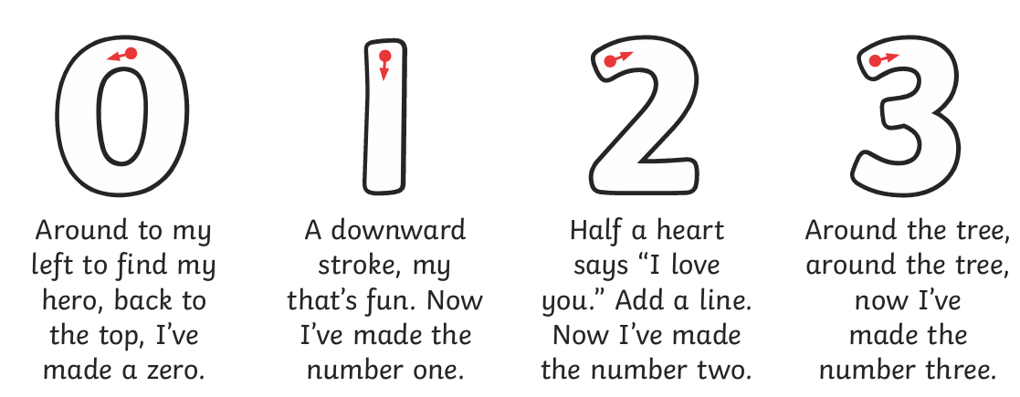
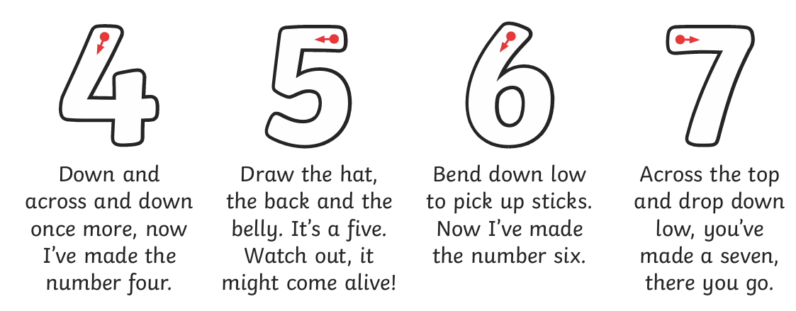
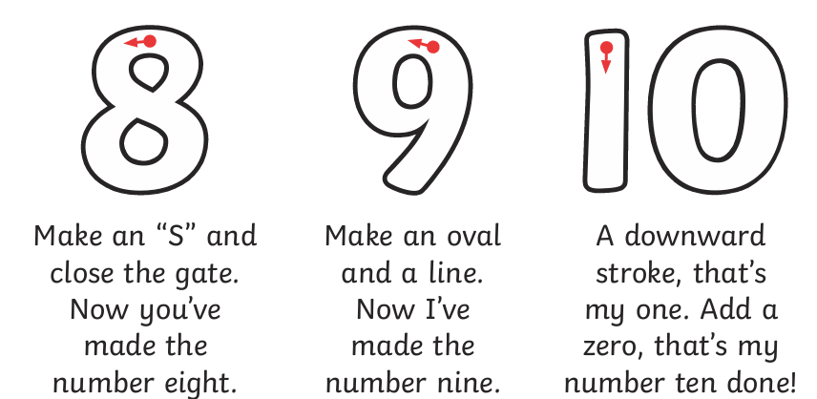

Please suppport your child in helping them form these number correctly.
Literacy

Reading
This half term we will be exploring a range of high-quality texts linked to journeys, adventures, friendships, resilience and transition. Children will develop their comprehension skills by listening to longer stories, discussing characters, events and settings, answering questions and making predictions. They will retell familiar stories in their own words, sequence events and compare experiences across different texts. Children will continue to build fluency and confidence in reading by applying their phonic knowledge and recognising familiar tricky words. We will also explore a range of non-fiction texts to develop understanding of the wider world, habitats and different places.

Writing
This half term we will be using our key texts as inspiration for meaningful writing opportunities. Children will write labels, captions, messages, lists, postcards, maps and simple sentences linked to journeys and experiences. They will begin to create their own stories, drawing on familiar story structures and characters. Children will continue to apply their phonic knowledge to spell words phonetically, represent sounds in sequence and spell an increasing number of tricky words correctly. We will focus on forming lower-case letters accurately, using finger spaces between words and re-reading our writing to check it makes sense.
Phonics and Early reading
We follow and teach our phonics using Read Write Inc Phonics. This half term we will be focusing and learning these letter sounds below along with all the other letter sounds and tricky words we have taught.

We will be focusing on reading these tricky words by sight.
I, the, said, you, your, was, no, be, he, she, me, want, some, all and her.

Handwriting
This half term we will be focusing on RWI handwriting letters and how they are formed.

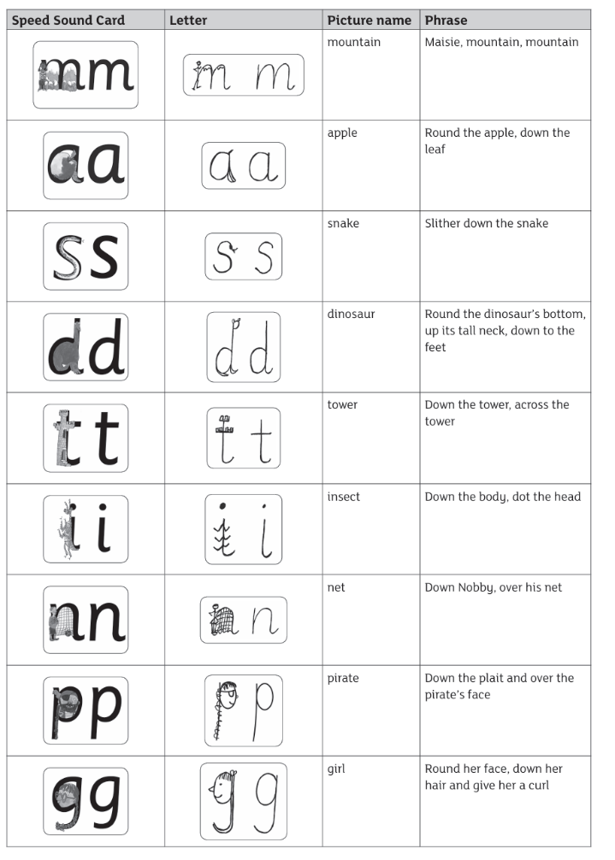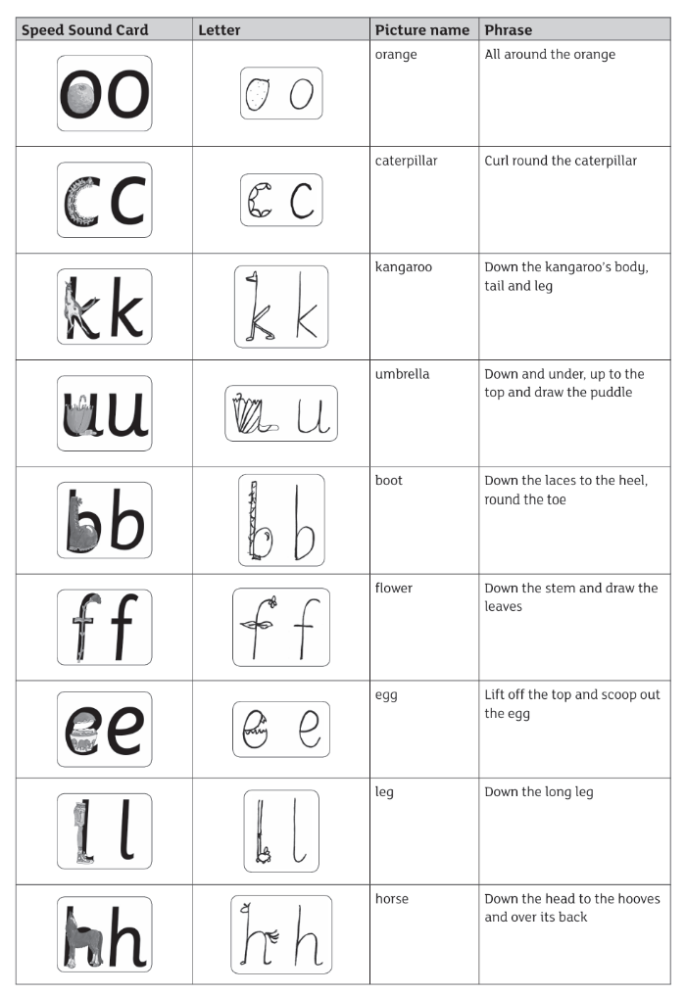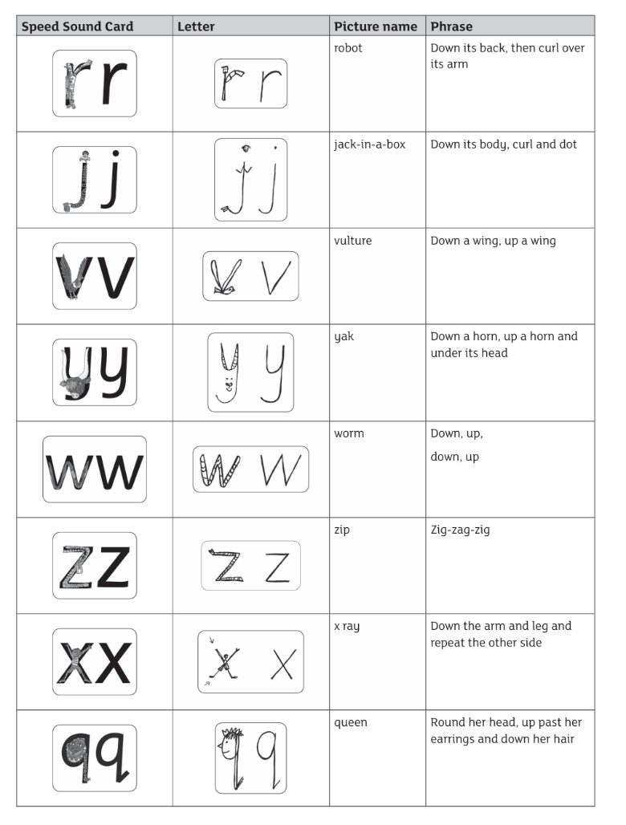

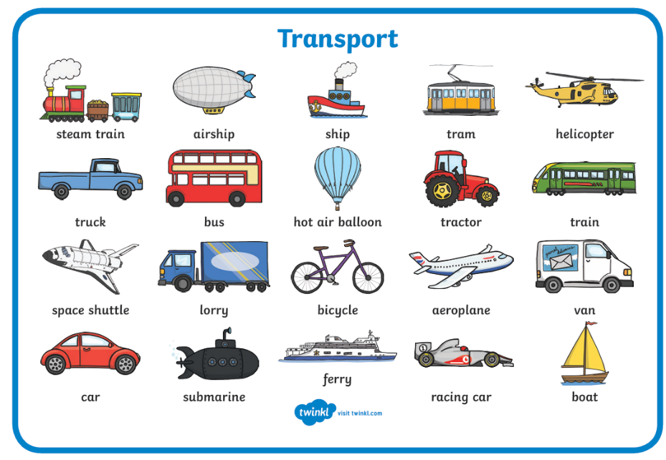
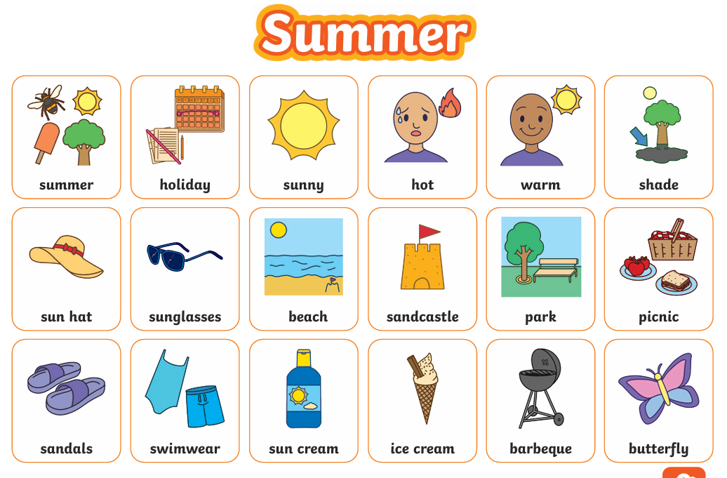
How to help at home?
Can you listen to the stories together and encourage your child to retell what happens?
Can you practise writing tricky words?
Can you practise number formation?
Can you talk about journeys?

