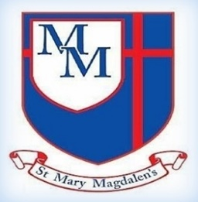
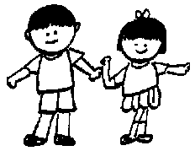
PSHE
My Happy Mind
In PSHE, the children will explore wellbeing, safety, economic awareness and personal growth, including activities to support their transition and emotional development through my Happy mind.
Science
In Science, Year 4 will learn about deforestation and its impact on habitats, as well as exploring teeth, digestion and food chains. The children will investigate different types of teeth, learn about the digestive system and carry out a tooth decay experiment while developing their understanding of how living things depend on one another in ecosystems.
Hello,
We hope you’ve all had a lovely break and that you and the children have made the most of the hot weather. Miss Milner and I are really looking forward to welcoming the children back for their final half term in Year 4 and working together to achieve some fantastic learning and help everyone reach their full potential together in Christ.
✨ Key Information ✨
PE is still on a Friday. Please make sure your child has their full PE kit on this day.
Spellings: Please make sure your child practises their spellings. These can be found on the Year 3/4 spelling list on the class page.
Times Tables: We are nearly at the children’s Multiplication Check, so please continue to encourage regular practise at home right up until the test. As always, if you have any questions or concerns, please do not hesitate to speak to a member of the team.
Kind regards,
Mrs Yates and Miss Milner
Sycamore Class – Summer 2
Mrs Yates and Miss Milner

Tel: 01254 232329

English
This half term, we will be exploring A Year Full of Stories by Angela McAllister, using folk tales and legends from around the world to inspire their writing. The children will develop their narrative skills through descriptive writing, dialogue and characterisation, as well as taking part in poetry and debate activities to build confidence in performance and discussion.

5
Art
In Art, we will explore imagined environments through painting, using colour to create atmosphere and developing their painting techniques. The children will also use sketchbooks to develop ideas and learn about influential artists and designers.
Maths
This half term, the children will develop their understanding of time, including reading analogue and digital clocks, using am and pm, and solving problems involving durations and units of time. The children will also explore Roman numerals and apply their knowledge through a range of practical problem-solving activities.
Geography
In Geography, we will explore rainforests and environmental impact, learning about climate zones and biomes while comparing geographical similarities and differences. The children will also investigate why Lancashire cannot support a rainforest climate.
Music
In Music, the children will explore the gospel song Lean On Me, developing their singing, listening and performance skills while learning about rhythm, pitch and musical style. They will also create and perform their own musical compositions inspired by the song.
Spanish
n Spanish, the children will learn the names of pets and use adjectives to describe different animals. They will develop their speaking, listening and writing skills through songs and by creating a fun story about a visit to a pet shop.
RE
In RE, the children will explore the meaning and importance of prayer, learning about how, when, where and why people pray in different faiths and communities. They will also reflect on the role prayer can play in people’s lives.
Computing
In Computing, the children will explore repetition in games by using a block-based programming language to create programs with count-controlled and infinite loops. They will learn how repetition can make programs more efficient while designing and improving their own interactive games.
PE
The children will develop their attacking and defending skills through invasion games, learning how to use tactics to outwit opponents, work effectively as a team and evaluate their performance in competitive games.
Spelling Rules
This term we will continue to look at spelling rules, and how we can use them in our writing.

