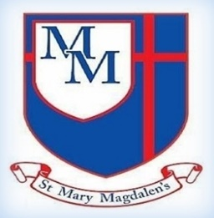
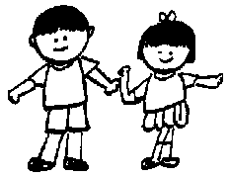
Ash Class – Autumn 2
Mrs Maddox, Mrs Hall, Miss Jackson

Tel: 01254 232329

Welcome to Year 2!
Welcome back after half-term. I hope you have had a great break and are ready for the next term together in Ash Class! This is going to be a fun filled, busy and exciting half term with lots of new learning taking place. We have lots of time to learn, grow, and reach our full potential together in Christ.

✨ Key Information ✨

PE will be on Tuesdays. Please ensure your child bring their PE kit to change into at school.

Please ensure you read you’re your child. Spelling, number bonds, and times tables. Ideally these should be practised regularly to support their learning in class.

Please do not hesitate to speak to one of the team if you have any concerns.

Science
Growing up
Growing and cooking
Seasonal changes
English
Aladdin
To support end of Key Stage 1 expectations in reading and writing.
PSHE/ Happy minds
Ourselves, Growing and Changing TRANSISTION

Art
Sculpture: Clay
Computing
Programming B - Programming quizzes

Online safety: Year 2 Learning about online safety, including: what happens to information posted online; how to keep things private online; who we should ask before sharing online; describing different ways to ask for, give, or deny permission online.
R.E
2.5 – Why Are Holy Buildings and Places Important To People of Faith?
Why is the church a special place for Christians?

Music – Charanga
Reﬂect, Rewind and Replay

Style: Western Classical Music and your choice from Year 2

﻿﻿﻿﻿﻿﻿

PE
FMS END OF KS1ASSESSMENT ﻿﻿﻿﻿﻿﻿

Spelling and Tables
We will continue to look at spelling rules, and how we can use them in our writing. Our tables in Ash are 2s,5s, 10s, and 3’s.
Please remind your child to practise as often as they can.

P
Geography
Weather Study (Accrington Focus)
Maths
Fractions
Time
Statistics
Position and Direction

