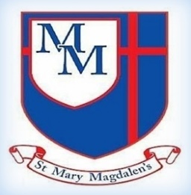
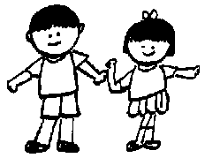
Chestnut Class – Summer 1
Mrs Ruggieri, Miss Bradshaw and Mrs Ormerod
Design Technology
In DT, we will be learning how they can make a healthy savoury dish. children will explore what makes a savoury dish healthy, which ingredients could be used, what food preparation skills we need and concepts of nutrition using the Eatwell Guide.

Welcome to Year 3!
Well come back! We hope you all had a lovely break, and the children are ready to get back to it As always, we are looking forward to welcoming the children back and working hard together to achieve this terms learning.

✨ Key Information ✨

PE will be on Tuesdays. Please ensure your child has their full PE kit in school

Please make sure your child practises their spellings and times tables at home. Spellings: Check the Year 3/4 spelling list on the class page.
Times tables: Children should practise the 3, 4, and 8 times tables.

Please do not hesitate to speak to one of the team if you have any concerns.

Kind regards,
Mrs Ruggieri, Miss Bradshaw and Mrs Ormerod
Tel: 01254 232329

Science – Plants
The children will learn to identify the different parts of a plant, be able to describe the functions of each part and what a plant needs to grow. Before we dissect a plant then grow our own plants from seeds.
English
In English, we will be looking at playscripts and non-chronological reports through our class text ‘Romans on the Rampage’ by Jeremy Strong. There will be opportunities for children to discuss, predict, infer, and use evidence from the text.

5
PSHE/RSE
My Happy Mind
Focussing on Engage, healthy lifestyles and relate and how these can improve the children’s mental health.
Friendships
children will explore what makes a positive, healthy friendship, why friendships are important for their wellbeing, and how to handle changes or challenges in friendships
Families and close positive relationships.
The children will explore different types of families and relationships, learn what makes a healthy and happy family, and understand how to seek help if something doesn’t feel right.

Spelling and Tables
This term we will continue to look at spelling rules, and how we can use them in our writing. Our tables this year are 3s,4s and 8s. Please remind your child to practise as often as they can, and if possible, on a computer using the right-hand number pad.

P
Music
Choir Church.
Charanga –
Bring us together Song Style: A little bit funky and music from around the world.
Computing
In Computing, children will create video trailers, learn about online safety — including fake news and protecting personal information — and develop basic HTML skills.
﻿﻿﻿﻿﻿﻿

PE
﻿﻿﻿﻿﻿﻿In PE, children will be doing gymnastics.

Spanish
The children will learn classroom instructions. They will practise speaking, reading, writing and following the instructions.

R.E
Children will learn ‘What is the role of a Faith Leader that has been called by God?’
We will look at what it means to be called by God, how God speaks to people and what sort of tasks God calls people to do.
History
In History, the children will be learning about Why was Ancient Egypt one of the most important early civilisations?
During this half term we will look at the River Nile, settlements, farming, mummification and the beliefs of the ancient Egyptians
Maths
Children will learn to add and subtract fractions and find fractions of an amount. They will also develop their understanding of money, converting pounds and pence and adding and subtracting money. In addition, they will work on telling the time, converting between units of time and solving problems with time.

