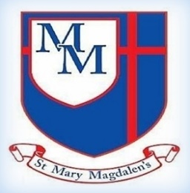
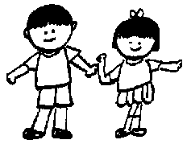
Hello,
The team and I hope you've all had a lovely break and that the children are ready for the new half-term. As always, we are really looking forward to welcoming the children back and working to achieve some fantastic learning and reaching our potential together in Christ.
✨ Key Information ✨
PE will be on Friday. Please make sure your child has their full PE kit on this day.
Spellings: Please make sure your child practises their spellings. These can be found on the Year 3/4 spelling list on the class page.

Times Tables: We would be grateful if you would encourage you children to practise all their tables in preparation for the multiplication check later this year. As always, if you have any questions or concerns, please do not hesitate to speak to a member of the team.

Kind regards,
Mrs Yates and Miss Milner
English
This half term, Year 4 will explore The Mousehole Cat, developing descriptive writing using expanded noun phrases, rich vocabulary and key grammar. Children will build from sentences to paragraphs, leading to writing their own narrative.
Painting: Imagined Environments
How can colour create atmosphere in paintings?
Children will learn how colour can create mood and atmosphere in paintings. They will explore how artists design imagined environments, using colour, layering and composition.
By the end of the unit, pupils will create their own atmospheric landscape painting.

Science – Data collection, habitats and deforestation
This half term, pupils will learn to collect, analyse and interpret data, and draw conclusions. They will study living things and their habitats, use classification keys for animals and plants, and explore human impacts on habitats, including deforestation.
Sycamore Class – Summer 1
Mrs Yates and Miss Milner

Tel: 01254 232329

5
PE
﻿﻿﻿﻿﻿﻿In PE, children will develop
dodging, throwing, rolling, and aiming skills through creative tag and target games, applying these in team activities with a focus on accuracy and control. They build cooperation by sharing ideas, working together, and evaluating games.
Spanish
This term, children will build their Spanish skills by taking part in simple conversations, expanding their vocabulary, understanding familiar texts, and speaking clearly in sentences with improving pronunciation.
History
Pupils explore how Accrington changed from rural to industrial, why industry grew, and how jobs and daily life were affected. They learn to explain these changes and why they are important to local history.
Maths
This half term, the children will be learning about decimals, moving from tenths (fractions to decimals, place value and number lines) and dividing by 10, to hundredths (fractions linked to money and time, then decimals and place value) and dividing by 100.
PSHE/RSE
My Happy Mind

Focussing on Happy Minds modules to explore
What healthy habits and positive relationships improve mental health, helping children feel happier, more resilient, and more connected.
Keeping Safe:
Recognise dangers at home and outside and learn how to manage risks safely.
Growing & Changing:
Understand how change and loss affect feelings and explore ways to manage emotions.
RE
In RE, the children will learn to understand Christianity as a multi-cultural worldwide faith, explore denominations and symbolism, and develop knowledge of sacred places of worship across world faiths.ge and understanding of sacred places of worship across world faiths.
Computing
Programming 2: Computational thinking
This half term, children will use logical thinking to explore software, learn key database terms, and understand how to sort and filter data. They will also compare digital and paper databases and use charts and graphs to interpret information.
﻿﻿﻿﻿﻿﻿

Music
Choir Church.
Churanga - Our music topic this term is Blackbird by The Beatles. They will develop musical skills through listening, singing, playing instruments, improvising, composing, and performing.

Spelling Rules
This term we will continue to look at spelling rules, and how we can use them in our writing.

