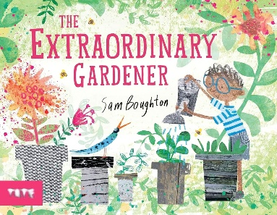
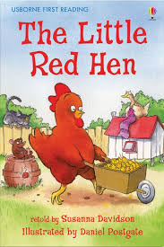
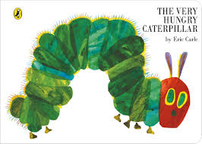
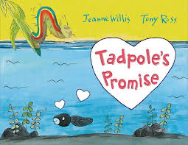
Key books this term…
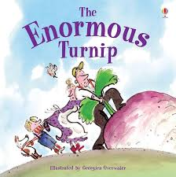

The Hungry Caterpillar – We will sequence the story and then observe our own caterpillar changing into a butterfly, creating artwork with our own predictions of what we think will appear out of the cocoons.

The Extraordinary Gardener- children will sequence, and begin to map out and label their own garden using our school garden as a template.
The Little Red Hen- children will be roleplay the story creating a character chart and writing their own descriptions.
Tadpoles Promise – Using this story as a stimulus, we will learn more about tadpoles and changes in life cycles, learning about birth and metamorphosis linking to our story on ‘The hungry caterpillar’.

The Enormous Turnip How does a seed grow? We will be sequencing the story and writing simple sentences. We will be growing our own vegetables and watching them over time to see how big they grow, caring for them in the process.

Key Vocabulary
Growth
Planting
Leaves
Stem
Seed
Cocoon
Metamorphism
Prayer
New life
Goals
Perseverance
Chrysalis

Possible Experiences linked to living things – We will be observing our own caterpillars metamorphosise into butterflies.

Possible Experiences – baking our own bread writing instructions and sending a letter to local farm allowing children to ask questions in comparison to the story.
Possible Experiences linked to life. Visit a local allotment. Create our own garden planting different vegetables and plants. The chn will be looking after them and observing them as time goes on.

Songs/Rhymes – Rhymes: Mary, Mary Quite Contrary. Ring a ring o roses. Poem: Spritz, Sprinkle and Spray.

We will be reading other stories about different kinds of life too. We will also be completing a range of activities connected to these stories.

Understanding of the World –
Geography – Use non-fiction texts, maps and videos to explore our immediate natural world. Do plants grow the same around the world? Create a map of our own garden and label.
Science – Exploring our natural world through plants and animals. Making observations and predictions through scientific enquiry.
History – Use the language of time when talking about past/present events in their own lives such as planting and recalling past events when observing the metamorphosis of a caterpillar.

Communication and Language
Is at the heart of our provision and in everything we do!
PSED/Happy Minds
Engage topic – looking at perseverance and goal setting for ourselves.

Expressive Arts and Design
Painting and drawing focus: Goldsworthy’s art focuses on the transformation of materials and the "life" of the landscape, aiming to understand nature by becoming part of it. Children will take his concepts to create art with nature taking inspiration from his work.
Music – We will be listening and appraising Funk music to sing Big Bear Funk and revisiting other nursery rhymes and action songs. Playing instruments within the songs and improvisation using voices and instruments. We will then perform the learning that has taken place
Design – We will design and create our mini greenhouse using different resources such as plastic and acrylic.

Physical Development: Fine and Gross Motor
Physical Development: Fine motor – working on clear letter formation and using our cutting skills for a purpose, focusing on manipulating tools correctly.
Physical Development: Ball games.: we will continue to be developing a range of ball skills including: throwing and catching with more accuracy. Travel: The children will also be moving in different ways, balancing, climbing and rolling in a variety of ways.

Religious Education
This half term we will be learning about ‘Prayer’ and its meaning in Christianity as well as exploring different religions and cultures, such as Judaism and Buddhism.

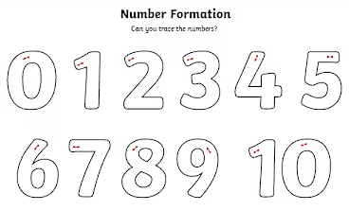
Literacy
Reading – exploring stories and retelling familiar stories using T4W. Enjoy listening to longer stories and can remember much of what happens. Show understanding of what has been read to them by answering questions and talking about key events. Retell familiar stories in their own words. Anticipate key events or phrases in stories. Use and understand new vocabulary from stories, non-fiction and conversations. Writing - Write labels, captions and short sentences. Write for different purposes (lists, messages, stories, instructions, role-play writing).Use some taught letter–sound correspondences in their writing. Begin to use phonetic spelling, representing most sounds in sequence. Spell some tricky/common exception words. Form most lower-case letters correctly. Use spaces between words. Re-read what they have written to check it makes sense.

Maths
We will be learning:
- To explore 3D shapes.
- To 20 and beyond.
- Manipulate, compose and decompose.

Please suppport your child in helping them form these number correctly.

Phonics and Early reading
We follow and teach our phonics using Read Write Inc Phonics. This half term we will be focusing and learning these letter sounds below.

Handwriting
This half term we will be focusing on RWI handwriting letters and how they are formed.

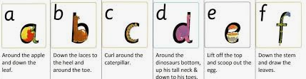
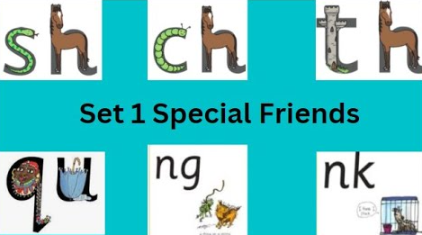

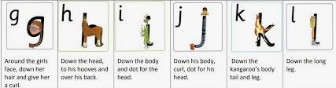

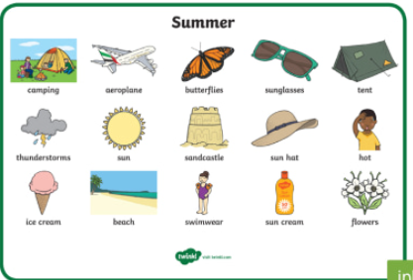
How to help at home?
Can you listen to the stories together and encourage your child to retell what happens?
Can you practise writing tricky words? The, to, I, no and go
Can you practise addition and subtraction to ten using everyday objects like pasta?
Can you create Natural artwork like Andy Goldsworthy
Can you name different parts of the plants you see?

