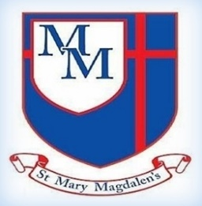
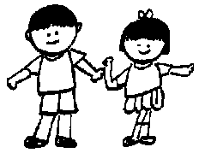
Beech Class – Spring 2
Mrs Shackleton & Mrs McKee

Tel: 01254 232329

ART
Painting and mixed media – Portraits
We will be learning about artists who created self-portraits. We will be creating our own self-portraits using a range of different materials.
Science
Living things and their habitats – Life cycle and reproduction
We will be learning about different life cycles such as plants, mammals, birds, amphibians and insects.

Welcome to Year 5!
We are looking forward to welcoming the children back and continuing to help every child reach their full potential in Christ. Please take a look at what we will be learning this half-term.

✨ Key Information ✨

PE
P.E will be on Tuesdays. Please can all children come to school in their PE kit rather than changing at school.

Homework
Spellings will be sent home Fridays with a spelling test the following Friday. Timetables still need to be learnt. Reading is vitally important. The children need to be reading as often as possible. They will need to bring their reading book and bag into school daily, so that staff can also read with the children.

Kind regards,
Mrs Shackleton
English
In English we will be reading invention stories. We will then write our own chapter for an invention to share with another year group. We will be creating our magazine information text hybrid.

Spanish

We will be learning about Spanish festivals and celebrations. We will be learning how to express our likes and dislikes for different celebrations.
Geography
Why do oceans matter? Exploring the importance of our oceans and how they have changed over time
We will be learning about the importance of our oceans and the great barrier reef. We will be looking at how we keep our oceans healthy and look at what types of litter pollutes our marine environment.
Computing
Micro:bit
We will be learning to program an animation, program a pedometer and be able to use a temperature sensor. We will also be looking a debug and evaluating.

﻿﻿﻿﻿﻿﻿

PE
Net and Wall – Tennis
We will be learning forehand and backhand shots. We will also be learning to reasonable hit a target and play some short simple games.

﻿﻿﻿﻿﻿﻿

R.E
5.4 – Easter Why do Christians believe that Easter is a celebration of victory?
We will be exploring the reason as to why Christians believe that Easter is a celebration. We will be learning about how Christians believe the death and resurrection is seen as a rescue plan to restore the relationship between God and his people.

PSHE/RSE
Appreciate / Relate
We will be learning all about appreciation and how to live a happy and healthy lifestyle.

Music
We will be continuing with our Choir Church along with looking at spooky music to create effect. We will be composing our own piece of spooky music and then evaluating it.

Maths
Fractions, division, multiplication, decimals, percentages, perimeter and area statistics

We will be continuing working on division and multiplication. Alongside this we will be learning about decimals and percentages. This half term we will also be learning about perimeter and area. Daily mental arithmetic skills will be taught and we will be continuing to work on our time tables and division facts.
myHappymind
We will be continuing with myHappymind and learning all about the brain!

