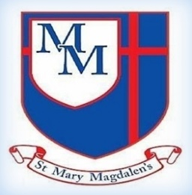
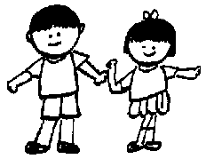
Chestnut Class – Spring 2
Mrs Yates, Mrs Ormerod and Miss Jackson
Art
Craft and design –
Ancient Egyptian.
In Art, children will explore colour, pattern, texture, line, shape, form, and space, use sketchbooks to develop ideas, learn about famous artists and designers, and create artwork using a range of materials.

Welcome to Year 3!
Well come back! We hope you all had a lovely break, and the children are ready to get back to it As always, Mrs Ormerod, Miss Jackson and I are looking forward to welcoming the children back and working hard together to achieve this terms learning.

✨ Key Information ✨

PE will be back on Tuesdays. Please ensure your child has their full PE kit in school

Please make sure your child practises their spellings and times tables at home. Spellings: Check the Year 3/4 spelling list on the class page.
Times tables: Children should practise the 3, 4, and 8 times tables.

Please do not hesitate to speak to one of the team if you have any concerns.

Kind regards,
Mrs Yates, Mrs Ormerod and Miss Jackson
Tel: 01254 232329

Science – Energy - Light and Shadows
The children will learn that we need light to see and darkness is when there is no light. They will explore how light reflects from surfaces, how to stay safe in the sun, and how shadows are made and change size.

English
In English, we will be looking at recounts through our class text The Iron Man by Ted Hughes, alongside diary recounts, where children will practise discussion, prediction, inference, and using evidence from the text.

5
PSHE/RSE
My Happy Mind
Focussing on appreciation, healthy lifestyles and relate and how these can improve the children’s mental health.
Friendships
children will explore what makes a positive, healthy friendship, why friendships are important for their wellbeing, and how to handle changes or challenges in friendships
Families and close positive relationships.
The children will explore different types of families and relationships, learn what makes a healthy and happy family, and understand how to seek help if something doesn’t feel right.

Spelling and Tables
This term we will continue to look at spelling rules, and how we can use them in our writing. Our tables this year are 3s,4s and 8s. Please remind your child to practise as often as they can, and If possible, on a computer using the right-hand number pad.

P
Music
Choir Church.
Churanga - The Dragon Song Style: A little bit funky and music from around the world.
Computing
In Computing, children will create video trailers, learn about online safety — including fake news and protecting personal information — and develop basic HTML skills.
﻿﻿﻿﻿﻿﻿

PE
﻿﻿﻿﻿﻿﻿In PE, children will take part in a Net and Wall unit, developing their running, jumping, throwing, and catching skills, playing simple competitive games, and improving strength, balance, control, and teamwork, while working towards their personal best.

Spanish
The children will learn to name colours and describe shapes using colour adjectives. They will practise speaking, reading, and writing descriptive phrases, create a design brief using shape and colour vocabulary, and present their ideas in Spanish.

R.E
Children will learn about the Easter story, explore feelings during Holy Week, understand how church services reflect sadness and joy, and deepen their understanding of salvation.
Geography
In Geography, the children will learn about Antarctica and the polar regions, including who lives there and how people explore these environments. They will learn how latitude and longitude link to climate and study the physical and human features of polar regions, with links to the explorer Ernest Shackleton.

Maths
Children will learn to measure, compare, add, and subtract length, mass, and capacity using different units, as well as use scales and find equivalent measures. They will also develop their understanding of fractions by comparing, ordering, placing them on number lines, and finding equivalent fractions.

