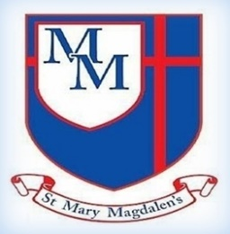
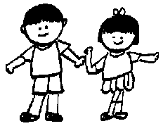
Oak Class – Spring 2
Mr Wilson, Mrs Naughton, Miss Mitchell

Energy –
Circuits, batteries and switches.
In science, pupils will construct and refine series circuits using bulbs, buzzers, switches and batteries. They investigate how voltage affects components and represent circuits accurately using scientific symbols.
English
In English we will finish exploring Macbeth using it as inspiration to create different texts.
We will also be looking at crime fiction and creating our own detective style story.

Welcome to Year 6!
The Year 6 team are really looking forward to working with the children to help them grow, flourish, and reach their full potential in Christ. It is going to be an amazing year full of exciting learning opportunities for all the children.

✨ Key Information ✨

PE
P.E will be on Fridays. Please can all children come in their school PE kit (white polo/t-shirt, black shorts/pants, school jumper/hoody rather than changing at school.

Homework
Homework will be sent each Friday, with specific focus on units we have been learning or areas which need to be reinforced. Spellings will be sent home Fridays with a spelling test the following Friday. Timetables need to be learnt – please use Topmarks, Timestables.co.uk and TTRockstars. Reading is vitally important. The children need to be reading as often as possible.

Kind regards,
Mr Wilson, Mrs Naughton and Miss Mitchell
DT
Structure – Playgrounds.
We will be exploring how artists express ideas and how they use scale to do so.

PE
Striking and Fielding
Cricket
Pupils will learn to develop their batting, bowling and fielding techniques, applying accuracy, control and tactical awareness in game situations. They work collaboratively in teams, refining strategies and demonstrating sportsmanship and effective communication during competitive play.

﻿﻿﻿﻿﻿﻿

Geography
Where does our energy come from?
Pupils explore renewable and non-renewable energy sources and examine where energy resources are found globally. They analyse the environmental impact of energy use and consider how energy choices affect sustainability.
Music
You've Got A Friend
Style: The Music of Carole King

Spanish
Spanish food and drink
We will be learning to express likes and dislikes about food.
PSHE/RSE
Appreciate,
First Aid,
Drugs, Alcohol and Tobacco,
Media Literacy and Digital Resilience.

6.3: The Eucharist
Why do Christians celebrate the Eucharist?
Area, Perimeter and Volume, Statistics
Shapes – same area, Area and perimeter, Area of a triangle – counting squares, Area of a right-angled triangle, Area of any triangle, Area of a parallelogram, Volume – counting cubes, Volume of a cuboid
Converting Units – Metric measures – converting and calculating, miles and kilometres, imperial measures.
Computing systems and networks: Exploring AI
We will explore how large data sets are collected, analysed and used in the real world. They interpret and present data to identify patterns and evaluate how data can inform decisions.
﻿﻿﻿﻿﻿﻿

myHappymind
We will be continuing with myHappymind and learning all about the brain!

