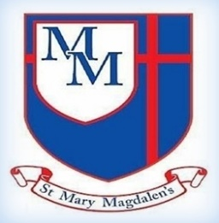
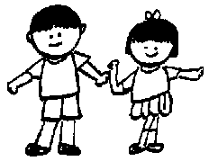
Beech Class – Spring 1
Mrs Shackleton, Mrs McKee & Miss Ruggieri

Tel: 01254 232329

DT
Mechanical systems- Gears and Pulleys
We will be learning alla bout gears and their functions. We will also be exploring pulleys and creating our own Eco-Gadget bike using a design criteria.

Science
Forces Earth and Space
In science, we will be learning all about our Solar System along with the moon. We will be exploring night and day. We will also be devising our own sundial to tell the time.
Welcome to Year 5!
Happy New Year to you all. We are looking forward to welcoming the children back and continuing to help every child reach their full potential in Christ. Please take a look at what we will be learning this half-term.

✨ Key Information ✨

PE
P.E will be on Tuesdays. Please can all children come to school in their PE kit rather than changing at school.

Homework
Spellings will be sent home Fridays with a spelling test the following Friday. Timetables need to be learnt – please see Timetable chart sent home Friday 9th January. Reading is vitally important. The children need to be reading as often as possible. They will need to bring their reading book and bag into school daily, so that staff can also read with the children.

Kind regards,
Mrs Shackleton
English
In English we will be reading science fiction stories. We will then write our own science fiction story to share with another year group. We will be creating our own Space information booklets and creating our own poems with a structure.

PSHE/RSE
Appreciate
We will be learning all about appreciation and how to live a happy and healthy lifestyle.

Music
We will be continuing with our Choir Church along with looking at Fresh Prince Of Bel-Air focusing on the style of Hip- Hop.

Spanish

We will be learning about Spanish festivals and celebrations. We will be learning how to express our likes and dislikes for different celebrations.
PE
Dance
We will be learning all about Urban Freestyle dance. We will create group routines and enjoy performing them to our peers.

﻿﻿﻿﻿﻿﻿

History
What was the impact of Word War 2 on Britain?
We will be learning all about World War Two. We will look at the causes and the impact. We will explore the Blitz and what it was like to be an evacuee.

Computing
Data Handling- Mars Rover
We will be learning how to program a Micro-bit and look at block coding. We will learn specific techniques to create a program for a specific purpose.

﻿﻿﻿﻿﻿﻿

R.E
Unit 5.6 Loss, Death and Christian Hope
We will be learning all about death. We will be exploring if death is the beginning or the end. We will be exploring where we go when we die and what heaven is like.
Maths
Fractions, Division, Multiplication, Decimals and Percentages
We will be continuing with fractions. We will be learning how to multiply 4-digit numbers by a 1-digit number. We will be learning about division and division with remainders. We will also be learning about decimals and percentages.

myHappymind
We will be continuing with myHappymind and learning all about the brain!

