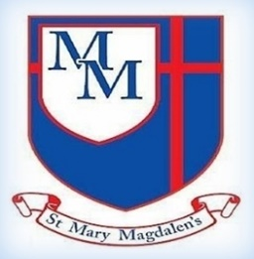
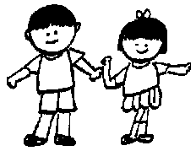
DT
Digital World – wearable technology
The children will learn about designing digital wearable technology and developing a program and housing for a Micro: bit.
.
Chestnut Class – Spring 1
Mrs Yates and Mrs Ormerod

Science - Materials: Rocks and soil
The children will explore rocks and soils by identifying rock properties, learning how rocks change and form fossils. They will learn to understand what Palaeontologists do and how important their work is and compare soil types, investigate the role of earth works and study sediment layers.

Welcome to Year 3!
Well come back! We hope you all had a lovely break, and the children are ready to get back to it As always, Mrs Ormerod and I are looking forward to welcoming the children back and working hard together to achieve this terms learning.

✨ Key Information ✨

Swimming will replace PE on Tuesdays. Please ensure your children have the appropriate swim wear including costume/trunks, towel, hat and goggles (if required) Swimming hats can also be obtained to buy via school or at the swimming pool

Spellings and times tables ideally these should be practised regularly, ready for their tests on
Fridays.
Please do not hesitate to speak to one of the team if you have any concerns.

Kind regards,
Mrs Yates and Mrs Ormerod
Tel: 01254 232329

English
In English we will be looking at ‘Storis and Poems as themes. The children will listen to, read aloud, discuss and learn to perform. They will also develop the understanding by asking questions, making inferences and learning new vocabulary.
Discussion

5
Music
Choir Church.
Churanga
Three Little Birds
Style: Reggae

PE
Swimming
On Tuesdays the children will be going up to Accrington Academy for swimming lessons.
﻿﻿﻿﻿﻿﻿

Maths
Multiplication and division
Lots of learning in Maths this term. The children will learn about; equal groups, using arrays, multiples of 2, 5 and 10s, sharing and grouping, multiply and dividing by 3, 4, 8. Learning 2s, 3s, 4s & 8 times-tables

PSHE/RSE
My Happy Mind
Focussing on appreciation, healthy lifestyles and relate and how these can improve the children’s mental health.
Friendships
children will explore what makes a positive, healthy friendship, why friendships are important for their wellbeing, and how to handle changes or challenges in friendships
Families and close positive relationships.
The children will explore different types of families and relationships, learn what makes a healthy and happy family, and understand how to seek help if something doesn’t feel right.

Computing
Systems and networks 3:
Journey inside a computer
The children will learn about ‘inputs & outputs’, identifying components inside a computer, building a paper laptop, following instructions, computer memory and how to dismantle a tablet.

﻿﻿﻿﻿﻿﻿

Spanish
The children will be learning about Spanish shapes and colours. How to describe the different shapes and use colour adjectives.
History
British history 2: Why did the Romans invade and settle in Britain?
The children will Investigate why the Romans invaded Britain. The reaction of the Celts and how the Romans changed life in Britain.
R.E
Unit 3.3
How did/does Jesus change lives?
This half term we will be learning how Jesus did/does changes our lives. We will deepen the children’s understanding on the impact of Jesus. Look, discuss and reflect what change means? how it can impact, what it can look like and why it happens.
Spelling and Tables
We will continue to look at spelling rules, and how we can use them in our writing. Our tables in Chestnut are 3s,4s and 8s. Please remind your child to practise as often as they can. If possible, on a computer using the right-hand number pad.

P

