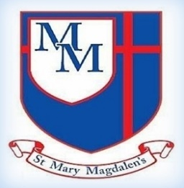
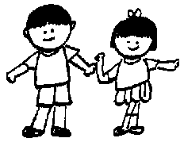
Ash Class – Autumn 2
Miss Greenwood, Mrs Mckee, Mrs Hall

Tel: 01254 232329

Welcome to Year 2!
Welcome back after half-term. I hope you have had a great break and are ready for the next term together in Ash Class! This is going to be a fun filled, busy and exciting half term with lots of new learning taking place. We have lots of time to learn, grow, and reach our full potential together in Christ.

✨ Key Information ✨

PE will still be on Tuesdays.

Please ensure you read you’re your child. Spelling, number bonds, and times tables ideally these should be practised regularly to support their learning in class.

Please do not hesitate to speak to one of the team if you have any concerns.

English
In English we will be looking Traditional tales with a twist, and instructions.

Science - Living things and their habitats – Microhabitats.
Children will learn that a microhabitat is a very small habitat, minibeasts are small creatures without a backbone, and scientists use questioning and research.

DT
Structures – A chair for bear.
Children will explore different structures and decide what materials are suitable for their chair.
Computing
Programme 1: Algorithms and debugging.
Online safety.
Learning about online safety, including what happens to information posted online; how to keep things private online; who we should ask before sharing online; describing different ways to ask for, give, or deny permission online.
Music – Charanga
HO HO HO
Style – Christmas, Big Band, Motown, Elvis, Freedom Son.

﻿﻿﻿﻿﻿﻿

R.E
Unit 2.2 – Why do Christians believe that the birth of Jesus was such good news?
The aim of this unit is to explore the story of Christmas from the perspective that it was good news then and now.
PE
Core Task Piggy in the Middle, and Bounce Ball

﻿﻿﻿﻿﻿﻿

Geography
Would you prefer to live in a hot or cold place?

Introducing to children the basic concept of climate zones and mapping out hot and cold places globally.

PSHE/ Happy minds
We will be looking at our character strengths and some strengths in action. The children will learn to recognise their own character strengths and realise they are what make them unique.
Maths
Addition and Subtraction, and shape
The children will be learning to add and subtract two-digit numbers, crossing a 10.
In our shape unit we will be focusing on 3d shapes.
Phonics
Our children will be placed in a small group where the work is tailored to their individual needs, ensuring they make as much progress as quickly as possible.
Spelling and Tables
We will continue to look at spelling rules, and how we can use them in our writing. Our tables in Chestnut are 2s,5s,
10s, and 3’s. Please remind your child to practise as often as they can.

P

