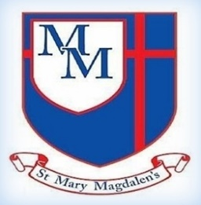
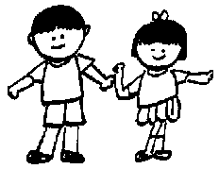
Science - Forces and magnets.
Looking at ‘Pushes and Pulls’ exploring contact and non-contact forces. ‘Friction’ investigating how and why things move differently on different surfaces. ‘Magnets’, how they work, their strength and why we use them

English
In English we will be looking folktales, focussing on ‘The Tin Forest’, but also looking at ‘Red Riding Hood’ and ‘The Lancashire Giant’. They will learn features and how to retell using ‘Talk for Write’

Welcome to Year 3!
Well come back after half-term. Hope you and the children have had a lovely break and they are ready to get back to it As always, myself, Mrs Ruggeri and Mrs Ormerod are looking forward to seeing them and working hard together to achieve this terms learning.

✨ Key Information ✨

PE will still be on Tuesdays. Please can the children come to school in their PE uniform rather than changing at school.

Homework will be sent home on Thursdays to reinforce the children’s learning, rather than as extra work. Please be reassured it should not cause any distress, should anyone have any difficulties please speak to either myself or Mrs Ormerod.

Spellings and times tables ideally these should be practised regularly, ready for their tests on
Fridays.
Please do not hesitate to speak to one of the team if you have any concerns.

Kind regards,
Mrs Yates, Mrs Ruggieri and Mrs Ormerod
Chestnut Class – Autumn 2
Mrs Yates, Miss Ruggieri, Mrs Ormerod

Tel: 01254 232329

Art
Drawing: Developing drawing skills
Developing shading skills and drawing techniques to create botanical-inspired digital drawings.
.

PSHE/RSE
Health and Wellbeing
Health Prevention
The children will understand ways to prevent tooth decay.
Physical Health and Wellbeing
How positive impact relaxation can have on the body, know the different food groups and how much of each of them we should have to have a balanced diet.
Mental Well Being
They will learn to understand the importance of belonging, what being lonely means and that it is not the same as being alone. They will also learn how to understand what a problem or barrier is and that these can be overcome.

Geography
The children will learn about how the Earth is made up of different layers and be able to name and say a fact about them. They will discover that the Earth’s crust is split into sections called tectonic plates and explore how these plates move and interact to shape our planet.Geogr
Spanish
Spanish numbers and ages
Through playing traditional Spanish counting games, children learn the numbers from one to twelve. They discover how to say their age in Spanish and ask others how old they are.
PE
Gymnastics
The children will learn about core skills, how to move with control, learn how to balance whilst staying still, basic rolls, jumping and landing safely and learn and demonstrate a sequence of six actions.

﻿﻿﻿﻿﻿﻿

R.E
Unit 3.2
Why Do Christians Believe Jesus Was ‘God with Us’?
How does the presence of Jesus impact on people’s lives? The children will learn and reflect about how Christmas is a celebration of God’s presence with us 2000 years ago, and now. We will also deepen their understanding of the concept of Incarnation.

Maths
Place value, Addition and Subtraction
Lots of learning in Maths this term. The children will learn about place value, placing and portioning numbers up to 1000, adding and subtracting 1s, 10s, and 100s without exchange, flexible partitioning, estimating and inverse operations and what methods to be used.
Spelling and Tables
We will continue to look at spelling rules, and how we can use them in our writing. Our tables in Chestnut are 3s,4s and 8s. Please remind your child to practise as often as they can. If possible, on a computer using the right-hand number pad.

P

