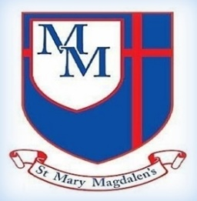

Tel: 01254 232329

**R.E**

Can you interview a Christian to find out how they use the Bible to influence their life or the decisions they make?

**English**

Can you continue to practice handwriting- remembering to try hard for a pen licence. Reading needs to be a priority – try to read as much as possible. Continue to learn weekly spellings. Write as often as possible- write about all the amazing things you do and share them with the class.

**Science**

Can you combine your own mixture and then see if you can return it back to its original state?

**Maths**

Do you know your Roman numerals?

Can you round to the nearest 10, 100 & 1000?

Can you partition numbers correctly?

Do you know you times tables of by heart?

**PSHE/RSE**

Can you create a list or write a short poem about what makes a good friend?

Can you live out our Christian Values and share with your family, friends or teachers how you are demonstrating this value?

Can you create a family tree?

**History**

In History we are learning about the Vikings.

Can you create a model of a Viking boat?

