Ash Class – Autumn 1 Homework Grid

English  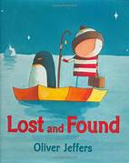  Ask your child to draw a scene from their favourite book. Ask them to write some sentences including 'and' and 'but' to extend their simple sentences.  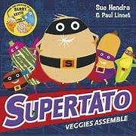 | Maths  Practice counting In 2s, 3s, 5s, and 10s. Look online for some fun songs and chants to get your children excited to learn!  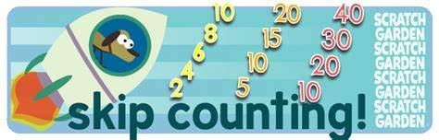 | Science  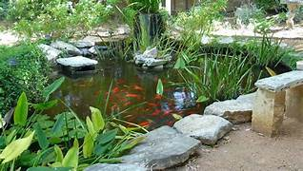  Go for a walk with your adult. How many different habitats can you find? What animals live in the habitats? What do they need to survive? Draw a picture of what you find and label it.
RE  In Re we will be widening the children’s understanding of the Bible, its contents, presentation and importance to Christians. Share some bible stories with your children and ask them to draw a picture of their favourite story.  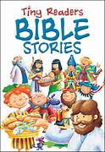 | History  In History we are learning about how school was different in the past. Ask your parents, grandparents or any other adults about their life at school. Can you find out any interesting facts about schools in the past? It would be amazing if you could share any photographs or objects.  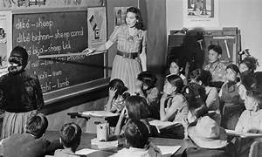 | Art  Use materials from around the house such as pasta and rice. Create some artwork of your choice.  