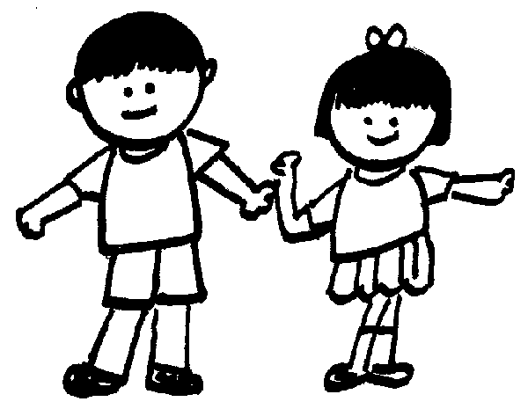++

**P.E.**

Net and wall games

**English**

RWI

**Music**

Hands, Feet, Heart Style: South African styles

**Maths**

Place value

Addition and subtraction

Shape

**Art**

Map it out.

**In English we will be focusing on:**

We are continuing with our new English/ reading scheme that will ensure all children read with accuracy and understanding through finely levelled modules and age-appropriate collections of work. Our children will be placed in a small group where the work is tailored to their individual needs, ensuring they make as much progress as quickly as possible. Home reads will be sent home every third or fifth day depending on their reading group. They will receive a book that they have mastered in class and another that follows alongside.

Welcome back, I hope you and the children have had a lovely break. I am very excited to join the children on their journey in year 2.

* PE is on Tuesdays, so please send your child with their full school PE kit; School jumper/hoody, school/white t-shirt and black shorts/tracksuit bottoms or leggings.
* Please encourage your child to read at home and as much as possible. Home reads will be sent home every third or fifth day depending on their reading group. They will receive a book that they have mastered in class and another that follows alongside.

If you have any questions, please ask.

**History**

How was school different in the past? Understanding that although schools have been in the local area for a long time, they have not always been the same.

**Science**

Living things and their habitats

**PSHE**

FAMILIES AND RELATIONSHIPS – Family, friendships, respectful relationships, change and loss.

**ICT**

Computing systems and networks 1: What is a computer?

Online safety

**RE**

The Bible. Why is it such a special book?

**Maths Targets block 3:**

* *Recognise 2-D and 3-D shapes*
* *Count sides on 2-D shapes*
* *Count vertices on 2-D shapes*
* *Draw 2-D shapes*
* *Lines of symmetry on shapes*
* *Use lines of symmetry to complete shapes*
* *Sort 2-D shapes*
* *Count faces on 3-D shapes*
* *Count edges on 3-D shapes*
* *Count vertices on 3-D shapes*
* *Sort 3-D shapes*
* *Make patterns with 2-D and 3-D shapes*

**Maths Targets block 2:**

* *Bonds to 10*
* *Fact families - addition and subtraction bonds within 20*
* *Related facts*
* *Bonds to 100 (tens)*
* *Add and subtract 1s*
* *Add by making 10*
* *Add three 1-digit numbers*
* *Add to the next 10*
* *Add across a 10*
* *Subtract across 10*
* *Subtract from a 10*
* *Subtract a 1-digit number from a 2-digit number (across a 10)*
* *10 more, 10 less*
* *Add and subtract 10s*
* *Add two 2-digit numbers (not across a 10)*
* *Add two 2-digit numbers (across a 10)*
* *Subtract two 2-digit numbers (not across a 10)*
* *Subtract two 2-digit numbers (across a 10)*
* *Mixed addition and subtraction*
* *Compare number sentences*
* *Missing number problems*

**Maths Targets block 1:**

* *Numbers to 20*
* *Count objects to 100 by making 10s*
* *Recognise tens and ones*
* *Use a place value chart*
* *Partition numbers to 100*
* *Write numbers to 100 in words*
* *Flexibly partition numbers to 100*
* *Write numbers to 100 in expanded form*
* *10s on the number line to 100*
* *10s and 1s on the number line to 100*
* *Estimate numbers on a number line*
* *Compare objects*
* *Compare numbers*
* *Order objects and numbers*
* *Count in 2s, 5s and 10s*
* *Count in 3s*

Year 2 Miss Greenwood, Mrs McKee, and Mrs Hall