Chestnut Class – Autumn1 Homework Grid

Science  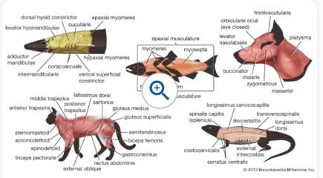  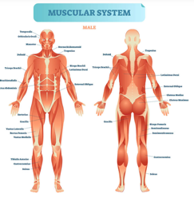  In science, we will be studying animals including humans – movement and nutrition. We will study the human skeleton. Can you find an animal with bones and an animal that doesn’t? |   Do you know your 2x, 5x and 10x tables? Can you count 10s forward and backwards, from any given number? If you know them, well done! If not, you may need a little more practise. Don’t worry, we are here to help.  Our tables this year are 3x, 4x, and 8x tables, and our topic this term is multiplication and division. We will be looking at multiples of 10, reasoning, problem solving, multiplying and dividing a 2-digit number by a 1-digit number with no exchange/with exchange, flexible partitioning and remainders. | History  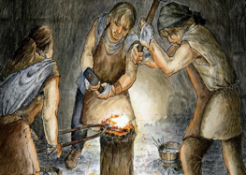  In history we are looking at Iron, Bronze and Stone age. Can you design or create your own tool from one of these ages. Think carefully about which materials you will need to use and how they might be cut and shaped.  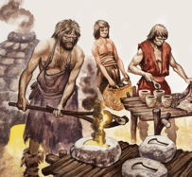  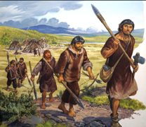
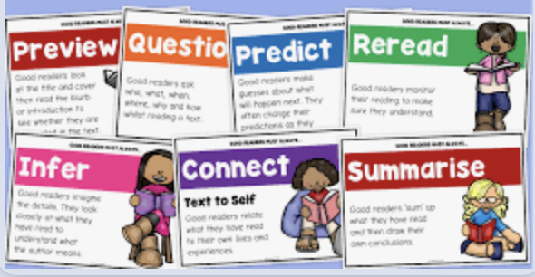  It is important to read as much as you can. It will help you learn new words, write better stories, and understand what you read. It also helps you to use your imagination and step into the adventures you are reading. The more you read, the more you will learn! | English  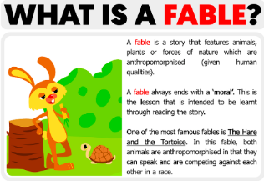  In English we will be learning all about recounts of fables, myths and legends. A recount is when you retell a story describing the characters and settings in the order that it has happened and has a message.  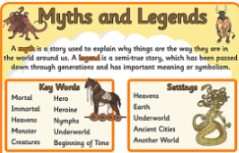 | R.E  3.6 – Harvest  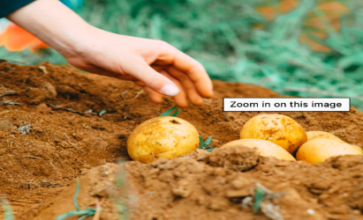  In R.E we will be learning about Harvest. We will discuss how people of faiths say thank you to God for the harvest and how Harvest is celebrated around the world by people with, and without faith. Can you write/draw about how Harvest is celebrated around the world.

