Children’s Mental Health Week
Wellbeing bingo – can you try and cross all these out by the end of the week? If you don’t have a pet, you could give someone in your family bubble a big hug
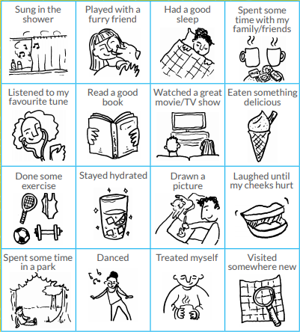
Called family or a friend for a chat.
Been for a walk without moaning.
outdoors

