Lesson 5
LO: To evaluate and consider how to improve your product
(WAGOLL)
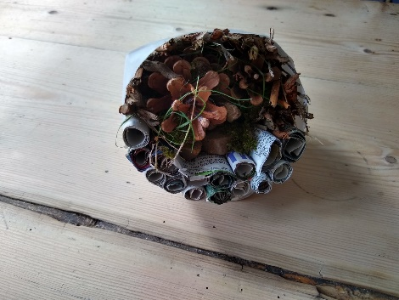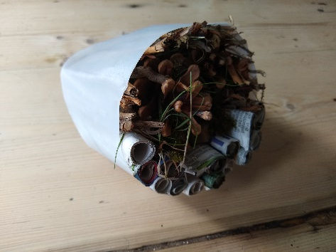
I am pleased with the outcome of my product.
From my design criteria, it has achieved:

- A Bug Hotel for minibeasts to live in for my garden

- Made from recycled and natural materials
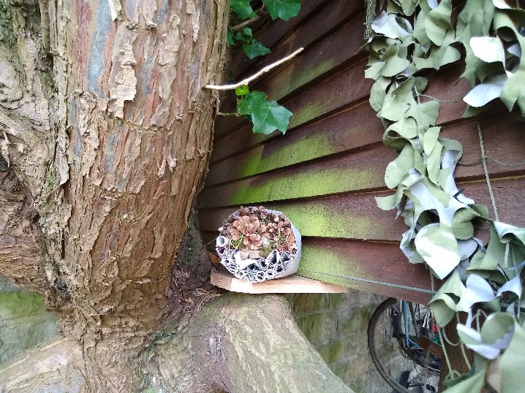
- An attractive design.
- Well- made (not fall apart).
- Inviting for insects and bugs.
- Can observe the bugs inside.
- Well- made (not fall apart).

What I have learnt from making this product…
- I learnt that you had to layer the different materials inside
- I learnt that I had to fit everything in tightly so it didn’t fall out
- I learnt that I needed a variety of different natural materials for different bugs to be attracted to.

Next time, I would…
Use a bigger container that was more transparent, I would like to be able to encourage bigger creatures into my hotel and I would like to be able to see them more clearly.

