Year 5 – Home Learning
Wednesday 13th May
Lesson and Learning Objective | Task
Maths  Wednesday  To measure with a protractor  Thursday  To measure with a protractor - continued | I really liked the Maths Shed PowerPoint that I sent last week, unfortunately I’d have to buy them to access more so we’ll use these instead. We’ll try these this week but if you find them confusing or tricky let me know and we’ll use something else.  This might be the first time you’ve used a protractor (angle measurer). Frist you’ll be measuring angles that are less than (<) 90˚, these angles are known as acute angles. You’ll be using your knowledge of what a right angle looks like to be able to estimate the size of acute angles eg “It’s close to a right angle, so about 80˚.” Make sure you’re looking at the right numbers. You’ll notice the numbers go from left to right and right to left so check you’re reading the right scale.  Open the PowerPoint document called Wednesday-Measuring-with-a-Protractor-1.pptx. As you read through the file jot down a piece of paper what you think the answer might be, before you go onto the next page. Half way through complete a fluency task and then at the end there are some problem solving and reasoning questions to complete.  Today you’ll be focusing on obtuse angles (> or more than 90˚). You might say “It’s just over a right angle, so about 100˚.” Keep checking that you’re reading the right scale on your protractor to make sure you’re getting more and more accurate.  Open the PowerPoint document called Thursday-Measuring-With-a-Protractor-2 and just like yesterday work your way through the file. Half way through complete a fluency task and then once you’ve finished the PowerPoint complete a problem solving and reasoning task.
English  LO: To familiarise myself with and retell a visual text  LO: To create a relationship web to explore characters in depth | We know you have all been working really hard on your English work at home and we want to make sure you stay super sharp with your SPaG skills. As you would always do in school, you should all still be ensuring that you apply your SPaG knowledge to your English work for each activity – there are always opportunities to use a variety of punctuation, cohesive devices and sentence structures so keep this up! If you would like further SPaG practise for the Year 5 objectives, we are going to add an extra SPaG based activity for each blog post to consolidate the SPaG skills you have already been taught this year.  Today’s task – Modal verbs. Open the attached document and choose your level. Select the most appropriate modal verb to indicate possibility.  Support – 1 star  Challenge – 3 stars  Wednesday 13th May – English  There are two tasks to complete so you may wish to do them all at once or split them over Wednesday and Thursday,  LO: To familiarise myself with and retell a visual text  We are moving on to looking at narratives with flashbacks embedded. To do this we are going to use a ‘visual text’ as a stimulus. First thing is to watch ‘The Piano’ by Aidan Gibbons (attached to the blog). It would be good to discuss your responses to the text with someone at home. What happens? How does it make you feel?  Watch it again and jot down the key events in the narrative. Think about the woman – who is she? Is she real? What is her relationship to the man? Who are the soldiers? When did this happen? Who are the boys?  Complete this diagram using what you know from the video.  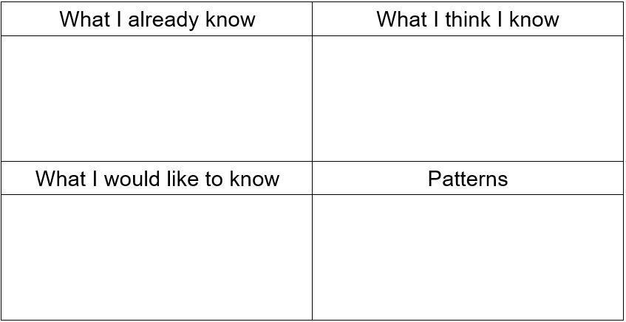  Task: List the main points of the story on post-its (or similar). Use these to retell the story to someone in your household – could you do this over dinner or later on to see what you can recall?  Support – There are stills from the video which you can order and use to prompt your retelling.  Challenge – Can you remove any events and still retell the story accurately? Can you retell it in any other order? Does this affect the retelling?  LO: To create a relationship web to explore characters in depth  Rewatch the clip. What characters appear? What relationships do they have to each other? What questions would you like to ask the characters?  You now need to create a relationships web between the man, the woman and the child. See this example layout.  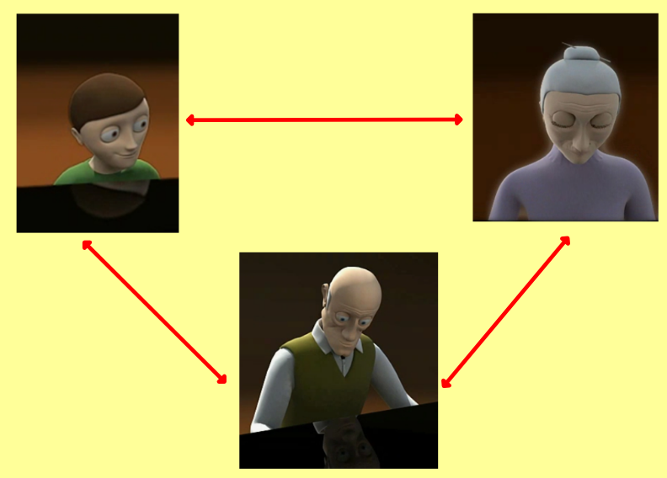  Connect the pictures with a line and include (with reasons or evidence where appropriate!) for each relationship:  - What is the relationship?  - What history do they have?  - Do they trust each other?  Challenge – Add any additional information or inferences from the video.
Reading | Wonder – read chapters ‘After School’ and ‘The Padawan Bites the Dust’.  - Find and copy out / show a grown up the sentence that provides an example of ‘show not tell’ about how Via’s Mum is feeling.  - Explain why you think Via wants Daisy with her.  Support: Which sentence below is an example of ‘show not tell’  - ‘After school I ducked into the bathroom.’  - ‘Okay she said slowly like she was letting out her breath.’  - ‘It was all lie on my part.’  Challenge: What do you think the Padawan represents?  I have also included a copy of first news for you to read should you like, it includes all the news from last week and might be a good talking point over dinner.
Wider Curriculum  PSHE  LO: Feeling embarrassed. | Read through the scenarios attached and colour in / discuss the embarrassment level. Tell a grown-up which you think is the most embarrassing and why.  Create your own storyboard of an embarrassing event, it could be real or fictional.
Science  LO: To compare life cycles | Have a discussion at home about the life cycles we have already looked at and what you know about birds and amphibians. Are there any similarities? Differences?  Look at the attached information sheets about amphibians and birds, and their life cycles. Could you set a quiz up for someone at home, writing a fact about one of the life cycles (and the answer on the back) and they have to tell you which cycle it relates to?  You are going to create a Venn Diagram to show the similarities and differences between the life cycles of birds and amphibians. Use the scaffold attached to create it. Remember if it doesn’t apply to either, the information goes on the outside! And if it applies to both groups, it goes in the middle.  Support – Sort the facts into amphibian or bird life cycles, placing them in the Venn diagram accurately before adding a couple of your own.  Here are the support facts:  Challenge – Place your own facts into the Venn and (either using your own research or the information sheets attached) create a three-way Venn to include a plant, insect or mammal.
  The cycle starts with an egg. | The cycle has three main stages.
  The young are not independent and need feeding by their mothers. | The mother and father care for the young until it can fend for itself.
  The young change to develop lungs. | The female lays eggs to reproduce.

