All From an Egg
What comes first, a bird or an egg? While it is impossible to answer this conundrum, it’s certain that all birds begin their lives carefully enclosed in eggs. The size and color of eggs and the amount of time a bird remains inside the egg varies by species, but eventually, all birds emerge from the egg. Some birds possess a specialized, temporary bony growth on their beaks called an egg tooth that helps them crack open the shell. During the time immediately following a juvenile bird’s exit from the egg, it is known as a hatchling.

Inside the Nest
Juvenile birds are covered in soft down instead of feathers and cannot fly. This makes them vulnerable to predators and incapable of feeding themselves. At this stage, baby birds are called nestlings because they spend all their time snug in the nest, relying on their parents for protection and food.

Learning to Fly
Eventually, nestlings lose their down and sprout feathers, which they need for flight. Juvenile birds who are growing flight feathers and learning to fly are called fledglings. These young birds work hard to practice the skills required for flying and strengthen their muscles. Once their flight feathers have grown in, fledglings take their first flight, which is called a fledge.

Starting the Cycle Over
Birds that are fully feathered and fly from the nest are now mature birds. These birds are ready to find mates and build nests of their own so they can lay eggs and become parents themselves, thus starting the bird life cycle all over.
There is no right answer to the question of whether the bird or the egg comes first since the life cycle of a bird is a circle with no beginning or end. None of that matters to the impressive number of birds on the planet who spend their lives naturally moving through their life cycle.

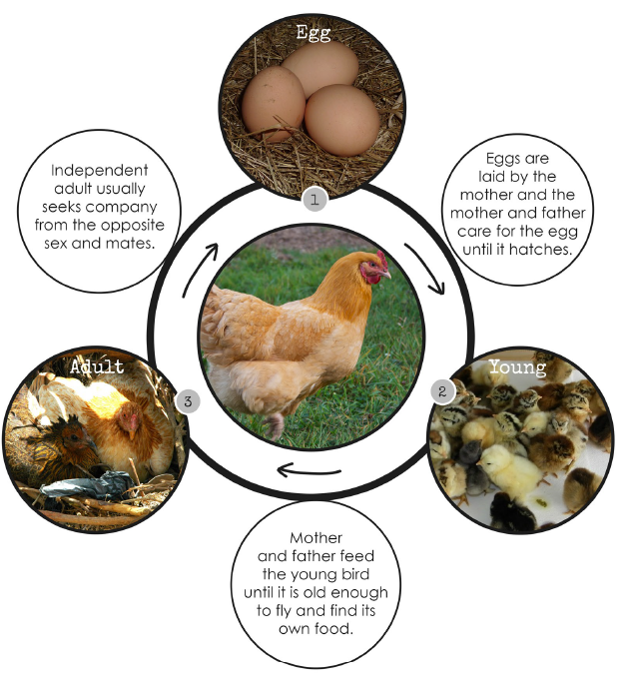

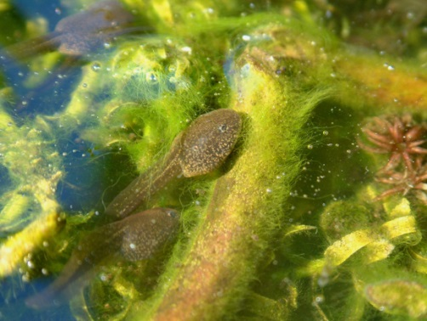
As the new year gets fully underway, native amphibians are at their most visible. Breeding season is upon them, and they’re clustering around ponds everywhere in the hope of finding a mate.
The winter months saw our frogs, toads and newts hibernating in compost heaps, piles of dead wood or at the bottom of ponds. But temperatures are slowly rising, causing them to wake up and re-emerge into the big wide world.
It’s around this time of year that you will be able to see some of your local species, as they congregate around ponds in an attempt to mate. This process kicks off a new rotation of their life cycle.
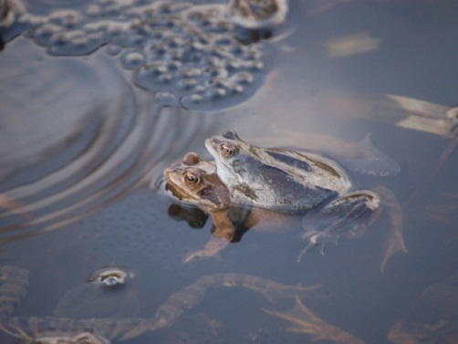

Breeding
As the amphibians gather, every male attempts to claim a female. In frogs and toads, the males will clamber on top of the female. This causes the female to lay her eggs – up to 5,000 of them – which are promptly fertilised by the male.

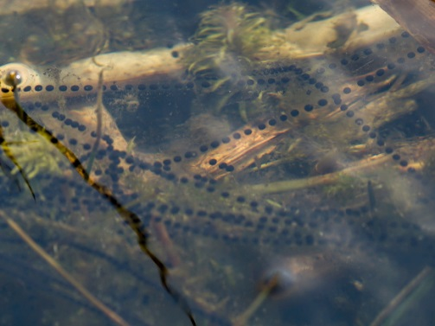
Hatching
In all amphibians, eggs hatch after one to three weeks (depending on water temperature). The resulting tadpoles initially live off the yolk that stays with them, but after a few days they need to feed. Frog and toad tadpoles feed on plant matter.

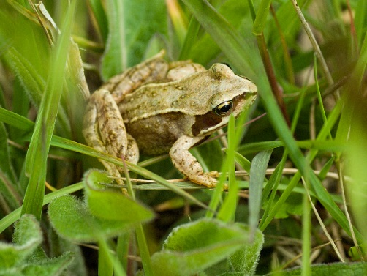

Metamorphosis
Tadpoles have to undergo huge physiological changes to survive on land. Their external gills become internalised, and their lungs develop. Eventually, the gill structures entirely vanish. This happens much earlier in frogs and toads than in newts. Limbs also form in this stage.

Juveniles
Due to a high predation rate, few tadpoles make it to this stage. If they do survive, they are developed enough to leave their nursery ponds. This usually happens around August, and all the survivors leave together. They then disperse across the countryside, ready to hibernate over winter.
Juveniles spend the next couple of years just eating and avoiding being eaten. Frogs reach sexual maturity at around three years old.

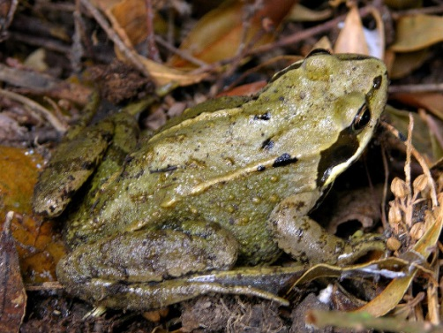
Adults
Fully grown individuals only return to ponds when they are ready to mate. This migration can start as early as September. They reach the spawning ponds in February, following their hibernation. At this point, it’s warm enough for them to mate successfully, and the life cycle begins again. On average, frogs will live eight years.
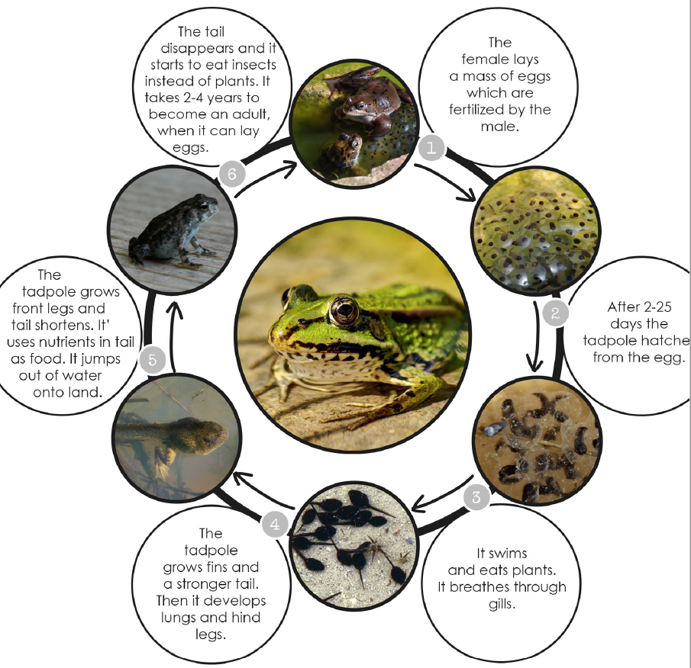

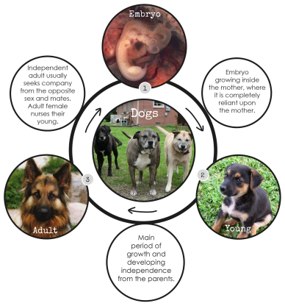
Mammal (dog)

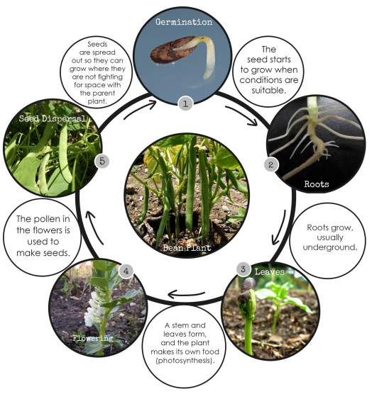
Flowering Plant (bean)

