Solutions
- What is our school canteen called? Corn on the Cobcroft 1 mark

- How goal posts are there on the field? Two goalposts 1 mark

- Name 4 of our school values. 4 marks

Appreciation
Compassion
Co-operation
Courage
Creativity
Determination
Encouragement
Freedom
Honesty
Humility
Kindness
Loyalty
Resilience
Resourcefulness
Respect
Responsibility
Thoughtfulness
Trust
- How many classes are there at Dobcroft? 14 (including cornerstone) 1 mark

- Name all the Y6 teachers- spelt correctly. 3 marks Mrs Conroy, Miss Taylor, Mr Harrison , Miss Harper

- What is on the display outside the Y6 toilets, above our coat pegs? 1 mark
The 3D rainforest display

- How many Y6 classrooms have sinks in them? 2 marks 2 classrooms

- What is the bench called on the front yard where people can sit if they feel a little lonely and would like a friend to play with? The Buddy Bench 1 mark

- What days are Y6 PPA days? Monday and Wednesday 2 marks

- What was the Y6 trip called where we were taught how to stay safe in different situations. Crucial Crew 1 mark
Paper 2
- Bounty
- Lion Bar
- Mars
- Double Decker
- Kit kat chunky
- Yorkie
- Mint Aero
- Boost
- Snickers
- Milky Way
- Fudge
- Toffee Crisp
- Cadbury Caramel
- Turkish Delight
- Picnic
- Crunchie

Paper 3
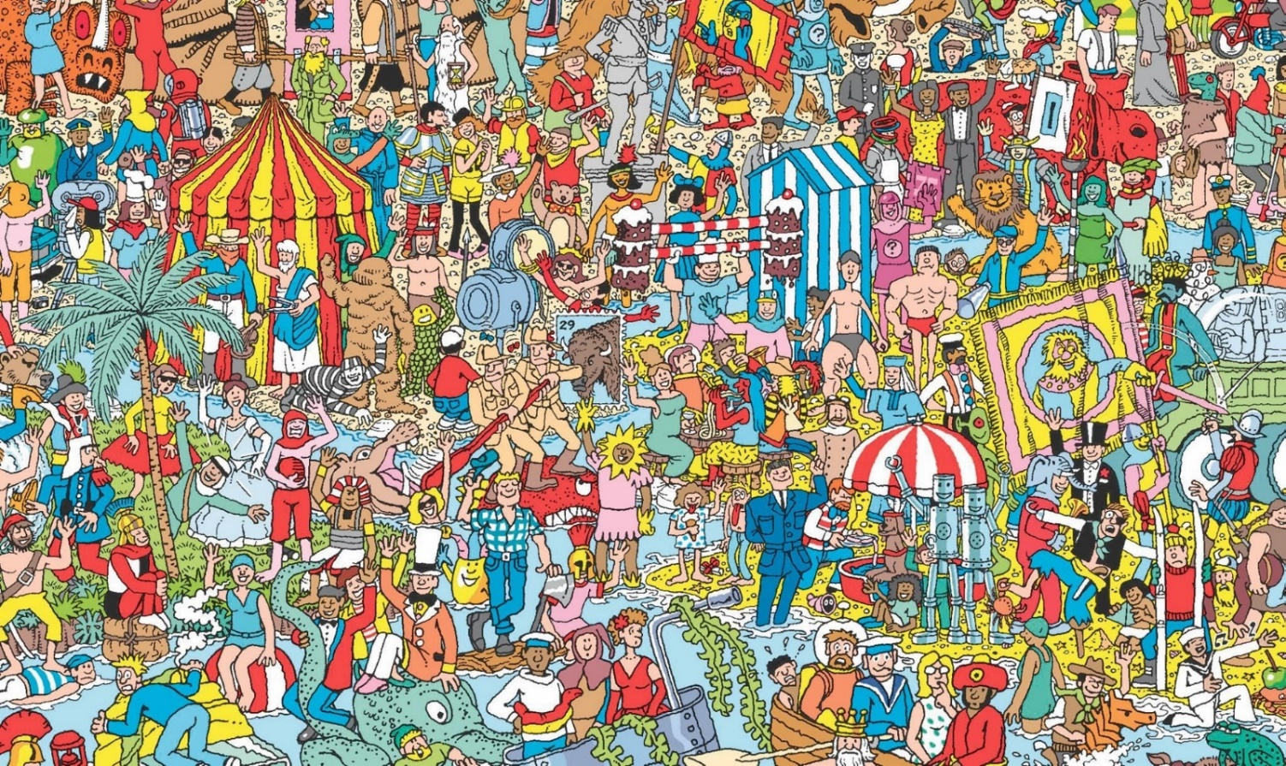

Paper 4
Mr Harrison - This teacher has run 15 half marathons
Miss Taylor- This teacher had performed at Glastonbury four times
Mrs Conroy - This teacher has ridden a zebra
Miss Harper - This teacher can solve a Rubik’s cube in a few minutes

Paper 5
Timed task

Paper 6
Art task

Paper 7
- You!
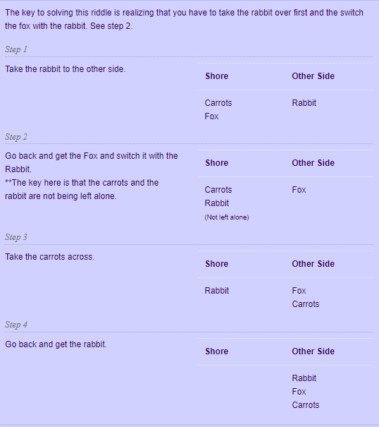

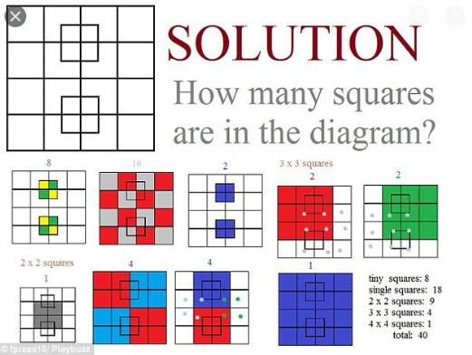

Paper 8 - Reading
- Cat in the hat
- The Hungry Caterpillar
- Matilda
- Green Eggs and Ham
- 3 Little Pigs
- Alice and Wonderland
- James and the Giant Peach
- Harry Potter
- Charlotte’s Web
- Charlie and the Chocolate Factory
- The Rainbow Fish
- Tiger came to tea
- Black Beauty
- We’re going on a bear hunt
- The lion, the witch and the wardrobe
Paper 9
Secondary schools – different answers

Paper 10
Celebration hairstyle task

