Using the timetable you created last week, work out the duration of each activity then have a go at answering these questions:
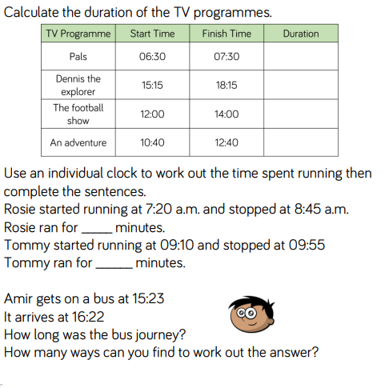

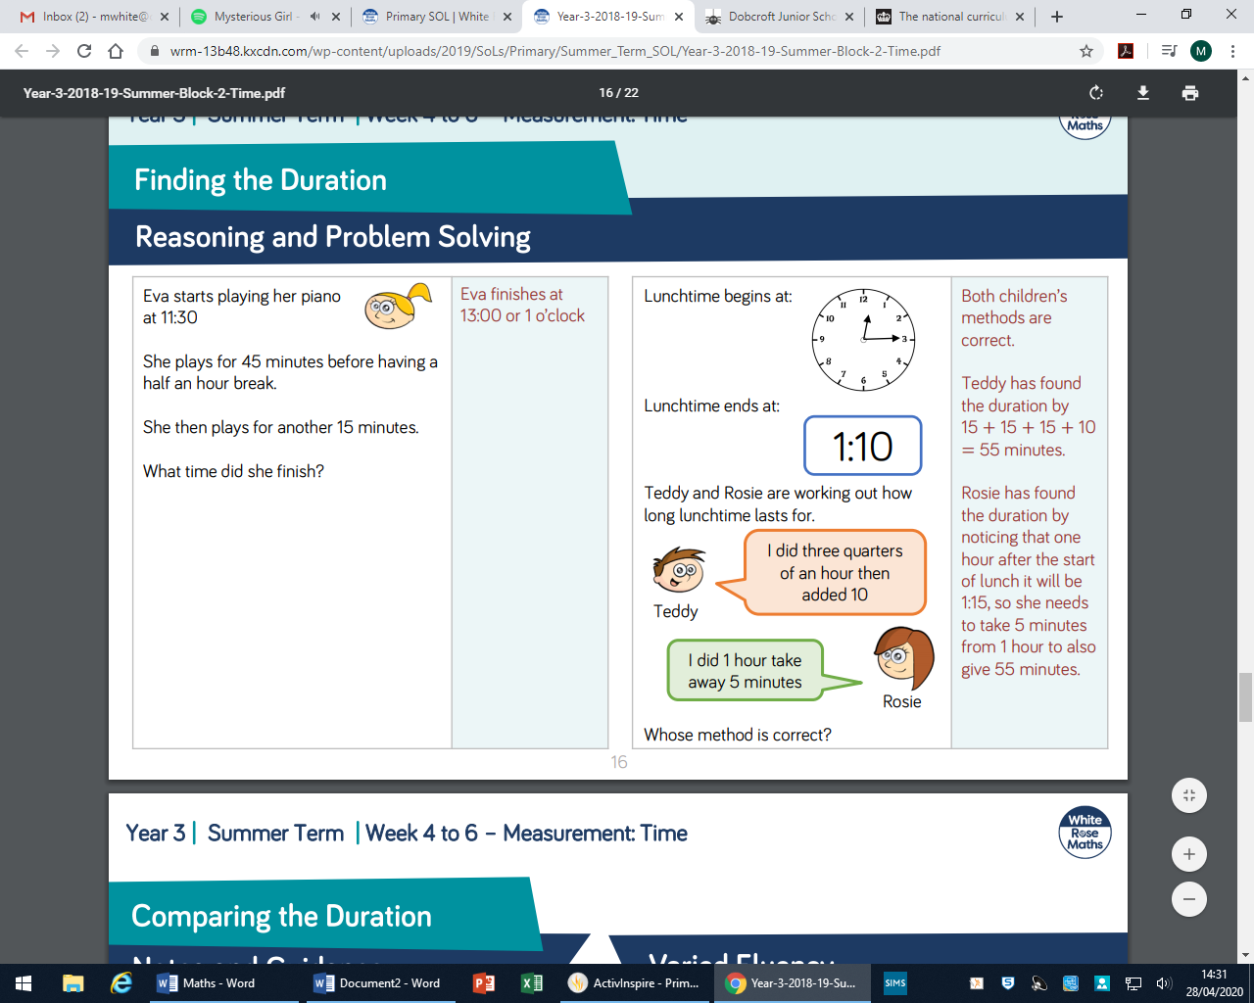
Challenge – Work out these problem solving and reasoning questions:

