Square

I have 4 equal sides.
I have 4 right angles.
I have 2 pairs of parallel sides.
I have 2 pairs of equal sides.
I have 4 right angles.
I have 2 pairs of parallel sides.
Rectangle

Rhombus

I have 4 equal sides.
I have 2 acute angles and 2 obtuse angles.
I have 2 pairs of parallel sides.
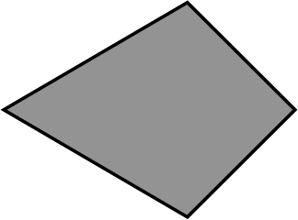
I have 2 pairs of equal sides.
My angles are not all the same.
I have no parallel sides.

Kite

Parallelogram

I have 2 pairs of equal sides.
I have 2 acute angles and 2 obtuse angles.
I have 2 pairs of parallel sides.

My 4 sides are not all the same.
My 4 angles are not all the same.
I have 1 pair of parallel sides.
Trapezium

