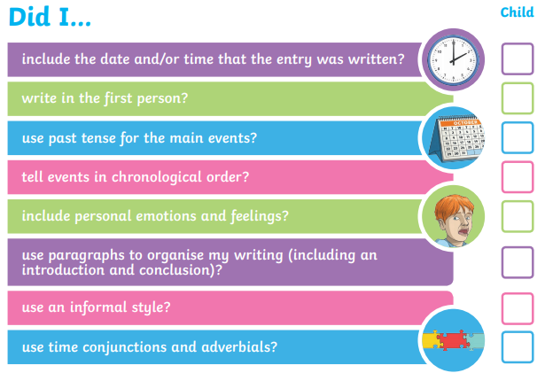

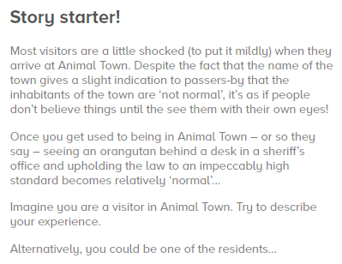
Writing task

Date:
Dear Diary,

In the last home learning, you came up with sentences using verbs and adverbs that you can use in your diary entry to give you a head start.

